How Do the Different Types of Maternal Diabetes during
Pregnancy Influence Offspring Outcomes?
Lina Eletri, MD, Department of Neonatology, Centre Hospitalier du Mans, 72037 Le Mans, France
Delphine Mitanchez, MD, PhD, Department of Neonatology, Bretonneau Hospital, Francois Rabelais University, 37000 Tours, France

Abstract

Background/Aim of the study: Exposure to maternal diabetes is considered one of the most common in- utero insults that can result in an increased risk of complications later in life with a permanent effect on the offspring health. In this study we aim to assess the level of risk associated with each type of maternal diabetes on cardiovascular diseases, obesity, glucose intolerance, and neurodevelopmental disorders in offspring.

Methods: we conducted a systematic review of the literature utilizing PubMed for studies published between January 2007 and March 2022. Our search included human cohorts and case control studies with at least 2 types of maternal diabetes clearly identified. Collected outcomes included prevalence, incidence, odds ratio, hazard ratio and risk ratio.

Results: Among 3579 published studies, 19 cohorts were eligible for inclusion in our review. The risks for overweight, obesity, type 2 diabetes(T2D), glucose intolerance, metabolic syndrome, and cardiovascular diseases (CVD) were increased for all types of maternal diabetes. The risk of overweight or obesity in infancy and in young adults was similar between gestational diabetes mellitus and type 1 diabetes (T1D). the risk for T2D or abnormal glucose tolerance was double for offspring from GDM(O-GDM) compared to offspring from T1D(O-T1D). In contrast, the risk for T1D in offspring at any age until young adulthood was increased when mothers had T1D compared to GDM and T2D. The Risk for CVD was similar for all types of maternal diabetes. The risk of ASD and ADHD was increased after in-utero exposure to preexisting T1D, followed by T2D.

Conclusion: offspring of diabetic mothers are at increased risk for multiple adverse outcomes with the highest risk detected among offspring from T2D mothers. Future work warrants large multiethnic prospective cohort studies to identify the risks associated with each type of maternal diabetes separately.
Image
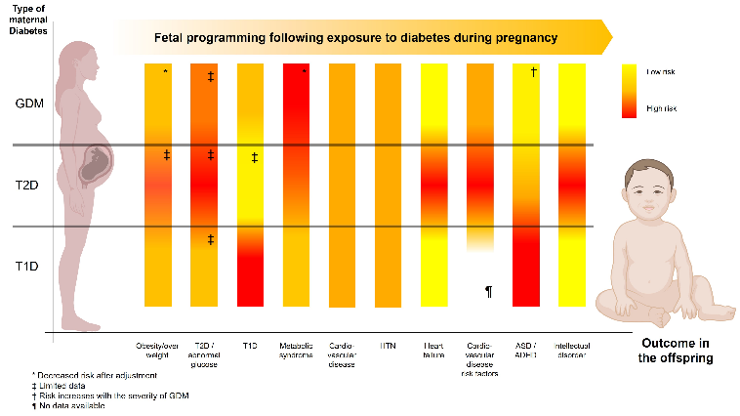
Figure 1: Offspring outcomes with different types of maternal diabetes during pregnancy.
ADHD: attention deficit hyperactivity disorders
ASD: autism spectrum disorders
CVD: cardiovascular disease
GDM: gestational diabetes mellitus
HTN: hypertension
T1D: type 1 diabetes
T2D: type 2 diabetes

Recent Publications
- Delphine Mitanchez, Sophie Jacqueminet, Said Lebbah, Marc Dommergues, David Hajage, Cécile Ciangura. Relative Contribution of Gestational Weight Gain, Gestational Diabetes, and Maternal Obesity to Neonatal Fat Mass. Nutrients. 2020; 12 (11):3434.
- Delphine Mitanchez, Cécile Ciangura, Sophie Jacqueminet. How Can Maternal Lifestyle Interventions Modify the Effects of Gestational Diabetes in the Neonate and the Offspring? A Systematic Review of Meta-Analyses. Nutrients. 2020; 12 (2):353.
- Anne-Aurelie Lopes, Valerie Champion, Delphine Mitanchez. Nutrition of Preterm Infants and Raw Breast Milk-Acquired Cytomegalovirus Infection: French National Audit of Clinical Practices and Diagnostic Approach. Nutrients. 2018; 10 (8):1119.
- Delphine Mitanchez, Pascale Chavatte-Palmer. Consequences of Maternal Obesity on Neonatal Outcomes and Cardio-Metabolic Health in Infancy. 2020; ():217-239.5.
- Delphine Mitanchez, Pascale Chavatte-Palmer. Consequences of Maternal Obesity on Neonatal Outcomes and Cardio-Metabolic Health in Infancy. . 2020; ():217-239.

Biography
Lina Eletri is a neonatologist at the Le Mans Hospital center in France. She is very involved in clinical research in neonatology, specifically in the fields of metabolomics and fetal programming.
Email: leletri@ch-lemans.fr

Notes/Comments:

Presenting author details
Full name: Lina Eletri
Contact number: +33 6 34 30 88 01
Mail id: linaetri@hotmail.com
Category: Oral presentation

