Human Gait Activity Recognition Machine Learning Methods
Jan Slemenšek*
University of Maribor

Abstract
Statement of the problem: In the later stages of the disease, PD patients experience special FOG episodes, where the patient is not able to move the lower limbs despite the clear intention, during which trembling of the lower limbs is often observed. FOG episodes are defined as rare, brief episodes (1–20 s), and typically occur when the patient’s focus is shifted from the gait itself. FOG episodes significantly increase falls and injuries.
Methodology & theoretical orientation: An experimental study showing the feasibility of Machine Learning gait recognition approach was performed. The experiment was conducted as follows: recognizing gait events for one subject, recognizing gait events for five subjects, and PD patient FOG episode's detection were carried out in a systematic and thorough manner
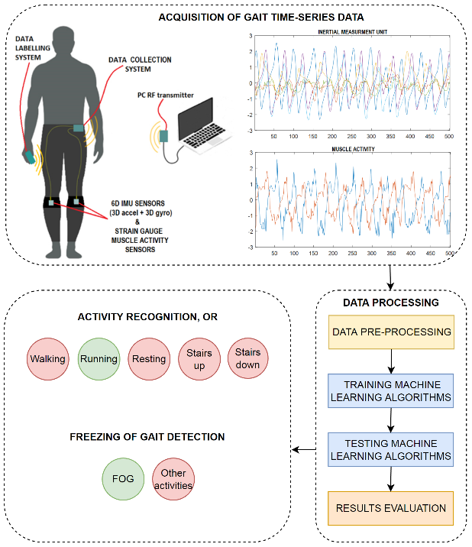
Figure 1. Sketch of proposed system
Findings: A feasible system capable of gait activity recognition was developed, tested and assessed. The following characteristics of the system can be exposed after our experimental work: •
- reliability,
- personalization,
- usability, and
- robustness.
Gait motion profiles can differ substantially between different humans, especially if movement disorders are present.
The ML algorithms in our experiment are trained and tested for each individual subject separately. This way, the algorithms can learn subject specific features and achieve complete personalization with only 3 min of recorded gait.
The proposed system could be upgraded to enable real-time ML algorithm deployment on the microcontroller. Upon also adding a cue feedback system, it would be possible to deliver cues ‘on demand’, when specific events are detected. Furthermore, the existing RF communication can be used to activate cue feedback systems wirelessly in real time. This feature has great potential in sports, robotics, Virtual Reality, medicine (FOG, rehabilitation), etc.

Conclusion:
With the proposed Machine Learning algorithms we demonstrated that the system is feasible to detect specific gait events reliably (accuracy = 98 - 99%). Both hardware (the gait motion data acquisition system) and software (various ML algorithms) solutions are tested, implemented and demonstrated.

References
- Paulo, J. S.; Joao, M. Knn Prototyping Schemes for embedded Human Activity Recognition with Online Learning. Computers 2020, 9, 96. DOI: 10.3390/computers9040096.
- Alharthi, A.S.; Yunas, S.U.; Ozanyan, K.B.; Deep Learning for Monitoring of Human Gait: A Review. IEEE Sensors Journal, 2019 19 (21) 9575-9591. DOI: 10.1109/JSEN.2019.2928777.
- Wang, K., He, J., Zhang, L. Attention-Based Convolutional Neural Network for Weakly Labeled Human Activities’ Recognition With Wearable Sensors. IEEE Sensors Journal 2019 19 7598-7604. DOI: 10.1109/JSEN.2019.2917225.
- Ukrami, H.; Nikaido, Y.; Kuroda, K.; Ohno, H.; Saura, R.; Okada, Y. Forward gait instability in patients with Parkinson’s disease with freezing of gait. Neuroscience research 2021, Volume 173, Pages 80-89. DOI: 10.1016/j.neures.2021.06.007.

Biography
Jan Slemenšek, a graduate of the University of Maribor's Mechatronics department (FERI), is pursuing a PhD in electronics at FERI. He is engaged in a multidisciplinary study that aims to develop a system capable of accurately detecting and cueing specific gait events in Parkinson's patients. In addition to his expertise in electronics and medicine, Jan also possesses a wealth of knowledge and experience in various technical fields, including 3D printing, CNC machining, UV lithography, 3D modeling, PCB design, microcontroller programming, laser scanning, and plastic extrusion.

