Insulin Topical Eye Drops for Treating Persistent Corneal Epithelial Defects
Ahmad Kunbaz^{1,2}, Ömer Faruk Yılmaz¹ , Halit Oğuz ^{1,2}
1 Goztepe Prof. Dr Süleyman Yalçin City Hospital, Eye clinic, Istanbul, Turkey
2 Istanbul Medeniyet University Faculty of Medicine, Department of Ophthalmology, Istanbul, Turkey

Abstract
Introduction and objective: Persistent corneal epithelial defects (PCED) are failure of re-epithelization and healing of corneal defects within 14 days of the initial injury. Different treatment approaches are used to treat PCED, such as bandage contact lenses, artificial tears, and amnion membrane transplantation (AMT). However, these treatments may fail to accomplish the required cure for PCED. In this study, we present a case series whose permanent epithelial defects did not respond to all other treatments but were treated with insulin eye drops.
Cases: A retrospective study includes three patients with PCED. These patients were treated with insulin eye drops of 1 U/mL three times a day for three weeks following the failure of other treatment modalities. The first patient is a healthy 45-year-old male. He had PCED after a foreign body removal. PCED did not close with autologous serum, AMT, and platelet-rich fibrin membrane transplantation. PCED was closed entirely in the 2nd-week after topical insulin therapy. (Figures A1 and B1). The second patient, a 52-year-old male, presented with peripheral ulcerative keratitis; He used antibiotic eye drops and non-preservative artificial tears for two weeks, but PCED did not improve. PCED entirely resolved in the 1st-week of topical insulin therapy. (Figures A2 and B2). The third patient is a 55-year-old woman with diabetes, rheumatoid arthritis, and glaucoma. Bilateral patch keratoplasty was performed for 1 year due to desmatocele. A non-healing ulcer developed in the corneal patch graft. Although all treatments, such as autologous serum, four times amniotic membrane, and bandage contact lens were applied in the patch graft, the ulcer did not heal. The ulcer closed on the 10th day with 1 U/mL insulin treatment 3 times daily. (Figures A3 and B3)
Results: Three of our patients had refractory PCED of different etiologies that did not close with all conventional treatments. With topical insulin eye drop therapy, PCED occurred in approximately 1-3 weeks. (Figure B1, B2, and B3)
Conclusion & Significance: Insulin formulated as 1 U/mL eye drops can be a safe and effective alternative for patients with persistent corneal defects. Nevertheless, further studies are needed to address the mechanisms beyond its effects and the possible long-term side effects of its usage.

Image
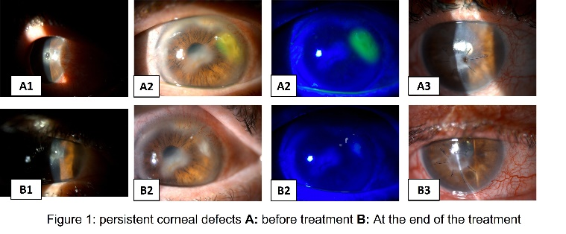

Recent Publications (minimum 5)
- Kunbaz A, Esen F, Turkyilmaz O, Aykut V, Durmus E, Oguz H. Acute iris transillumination following intracameral moxifloxacin injection. The Turkish Ophthalmology society`s 56th Annual Scientific Conference 2-6 November 2022.
- Kunbaz A, Durmus E, Aykut V, Esen F, Derin G, Oguz H. Corneal Topographic Changes Following Sutured and Sutureless 25 G vitrectomy: A comparison study. The Turkish Ophthalmology society`s 56th Annual Scientific Conference 2-6 November 2022.
- Kunbaz A, Yilmaz OF, Oguz H. Platelet-Rich Fibrin Membrane Pterygium Surgery. The 36th European Ophthalmology congress, London, England. Gen Med 2022, Volume 10.
- Beuschel B, Nayfeh T, Kunbaz A, et.al. A systematic review and meta-analysis of treatment and natural history of popliteal artery aneurysms. Journal of Vascular Surgery. 2021
- Soufi MK, Kunbaz A, et al. Solving A Riddle: Cardiac Sarcoidosis And Response to Prednisone. The American College of Cardiology's 71st Annual Scientific Conference 2-4 April 2022. Volume 79, Issue 9, suppl A - 10461 Conference poster365: 519-530.

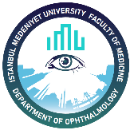
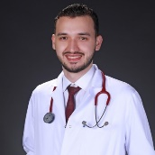

Biography
Dr Ahmad Kunbaz has completed his M.D. degree at Cerrahpasa faculty of medicine, Istanbul university.
He has published more than 20 scientific papers with more than 220 citations and is currently enrolled in
the faculty of medicine, at Istanbul Medeniyet University, department of ophthalmology, as an ophthalmology resident.
Email: Ahmad.Kunba z@gmail.com

Notes/Comments:
Presenting author details
Full name: Ahmad Kunbaz
Contact number: +905070509784
Mail id: Ahmad.Kunbaz@gmail.com
Category: (Oral presentation)

