The association between intravenous solution induced hyperchloremia, metabolic acidosis and new or progressive acute kidney injury among pediatric patients with Diabetic Ketoacidosis. A retrospective cohort study
Joan Christine S. Guina, MD
DPPS Philippine Children’s Medical Center, Philippines

Abstract

Statement of the problem: Diabetic Ketoacidosis (DKA) requires immediate fluid resuscitation. Excessive administration of high chloride containing IV fluids can cause hyperchloremia. Currently, there is scarcity of data associating hyperchloremia with acute kidney injury (AKI) and prolonged metabolic acidosis among children with DKA. This study aimed to investigate the association between intravenous solution- induced hyperchloremia, metabolic acidosis and AKI among DKA patients.

Methodology: This is a retrospective cohort study among cases of Diabetic Ketoacidosis. The serum chloride levels were reviewed, the total chloride infused was computed and compared per time interval by repeated measures ANOVA. Hyperchloremic cases were determined and were analyzed for the occurrence and association with acute kidney injury using Fisher exact test. The serum chloride, total chloride infused, total fluid input and urine output among those with and without AKI were evaluated. The length of DKA resolution was compared among the hyperchloremic and non-hyperchloremic group.

Results: There were 167 eligible cases of DKA. 158 (94.6%) of these developed hyperchloremia and 36 (21%) had AKI. The association between hyperchloremia and AKI is not statistically significant (P=0.21) but a significant decreased in urine output among the cases was proven (P=0.008). The length of DKA resolution by closure of anion gap has an average of 21.29 (±13.95) hours while the rise of pH has 25.51 (±14.77) hours and 29.7 (±14.89) hours for HCO3 level (Figure 1). Hyperchloremic group has longer duration of DKA resolution by pH (P= 0.0281) and bicarbonate (P= 0.0080) while no statistical difference was noted for the closure of anion gap between the two groups.

Conclusion: Hyperchloremia (95%) is common during fluid resuscitation. It causes prolonged metabolic acidosis and decreased urine output which leads to acute kidney injury. Recommendation: Lower chloride containing solutions must be used to prevent hyperchloremia especially in the critically ill to prevent its adverse effect.

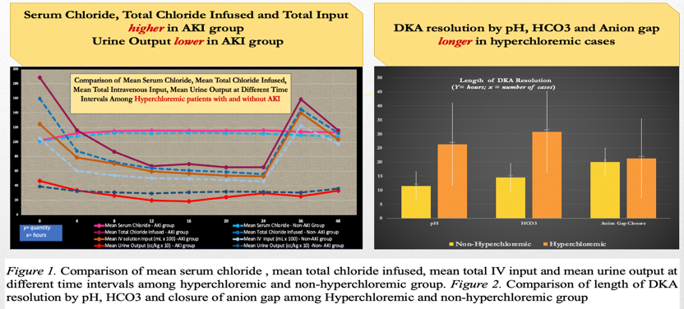

Recent Publications

- Goad NT, Bakhru RN, Pirkle JL, Kenes MT. Association of Hyperchloremia with Unfavorable Clinical Outcomes in Adults with Diabetic Ketoacidosis. Journal of Intensive Care Medicine. 2020;35(11):1307-1313.
- Kimura S, de la Hoz MAA, Raines NH, Celi LA. Association of Chloride Ion and Sodium-Chloride Difference with Acute Kidney Injury and Mortality in Critically Ill Patients. Crit Care Explor. 2020;2(12): e0247. Published 2020 Nov 24.
- Williams V, Jayashree M, Nallasamy K, Dayal D, Rawat A. 0.9% saline versus Plasma-Lyte as initial fluid in children with diabetic ketoacidosis (SPinK trial): a double-blind randomized controlled trial. Crit Care. 2020 Jan 2;24(1):1.
- Sangita Basnet, Preethi K Venepalli et al. Effect of Normal Saline and Half Normal Saline on Serum Electrolytes During Recovery Phase of Diabetic Ketoacidosis. Journal of Intensive Care Medicine 2014, Vol 29(1) 38-42
- Chowdhury AH, Cox EF, Francis ST, Lobo DN. A randomized, controlled, double-blind crossover study on the effects of 2-L infusions of 0.9% saline and plasma-lyte® 148 on renal blood flow velocity and renal cortical tissue perfusion in healthy volunteers. Ann Surg. 2012 Jul;256(1):18-2

Biography

Joan Christine Guina is a General Pediatrician who opted to undergo training in Pediatric Nephrology. She is now a diplomate and has recently started practicing as a Pediatric Nephrologist in the Philippines. She has always aimed to improve the health care delivery in their community and hopes to reach the underserved children with kidney diseases.

