From the flowers into the honeys; pollen and mineral content of four unifloral Hungarian honeys
*Marianna Kocsis, Katalin J. Csetneki, Mariann Merics, Krisztián Gaál and Ágnes Farkas
Department of Pharmacognosy, Faculty of Pharmacy, University of Pécs, Hungary

Abstract
Statement of the Problem: Honey is a complex food, which has played an important role in human nutrition and medicine since ancient times. Its main nutritional constituents are carbohydrates; while proteins, minerals and polyphenols are present in low amounts. Some of the proteins originate from the plant source’s pollen, which can be used as a reliable indicator of honey’s floral origin. Other plant derived constituents of honey are macro- and microminerals. Although they are minor components, they contribute to the specific nutritional value of honeys and can help discriminate unifloral honeys. Hungary is one of the biggest honey producers in the EU with several uni- and multifloral honeys, however, there is little information on their quality parameters. The aim of this study was to examine the pollen and mineral composition of four Hungarian honey types, in order to find their distinctive characters and to establish the unique nutritional value of each honey type.

Methodology & Theoretical Orientation: Samples included acacia (Robinia pseudoacacia), linden (Tilia ssp.), chestnut (Castanea sativa) and sunflower (Helianthus annuus) honeys. Their botanical origin was established by sensory characteristics, microscopic pollen analysis and spectrophotometric color determination. Macro- (K, Ca, P, S, Mg) and microelement (B, Cu, Fe, Mn, Zn) content was derived from ICP-AES measurements.

Findings: The results of the melissopalynological analysis confirmed that each honey type was unifloral. Linden honey had significantly higher K content than the light-colored acacia, and the darker sunflower honeys (Figure 1). Chestnut honey stood out from the studied honeys due to its extremely high Mn and Zn content.

Conclusion & Significance: Our results revealed that besides the traditionally used pollen profile, also minerals can be applied as markers to identify honey types. The unique mineral composition of acacia, linden, chestnut and sunflower honeys can contribute to their nutritional value.
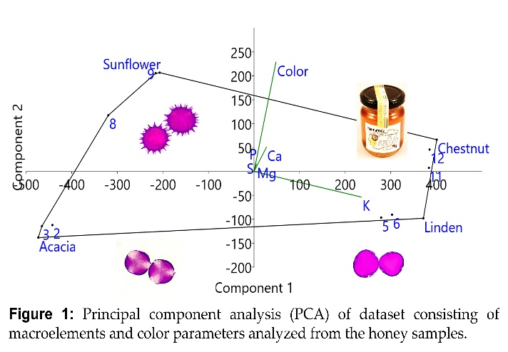

Recent Publications

- Farkas Á, Balázs VL, Kőszegi T, Csepregi R, Kerekes E, Horváth Gy, Szabó P, Gaál K, Kocsis M (2022) Antibacterial and Biofilm Degradation Effects of Hungarian Honeys Linked With Botanical Origin, Antioxidant Capacity and Mineral Content, Frontiers in Nutrition 9: 953470.
- Kocsis M, Bodó A, Gaál K, Farkas Á (2022) Summer Gifts from the Hive: Botanical Origin, Antioxidant Capacity, and Mineral Content of Hungarian Honeys, In: Muhammad, Imran; Muhammad, Haseeb Ahmad; Rabia, Shabir Ahmad (eds.) Honey - Composition and Properties [Working Title], IntechOpen.
- Kocsis M, Bodó A, Kőszegi T, Csepregi R, Filep R, Hoffmann Gy, Farkas Á (2022) Quality Assessment of Goldenrod, Milkweed and Multifloral Honeys Based on Botanical Origin, Antioxidant Capacity and Mineral Content, International Journal of Molecular Sciences 23: (2) 769.
- Bodó A, Radványi L, Kőszegi T, Csepregi R, Nagy DU, Farkas Á, Kocsis M (2021) Quality Evaluation of Light- and Dark-Colored Hungarian Honeys, Focusing on Botanical Origin, Antioxidant Capacity and Mineral Content, Molecules 26: (9) 2825.
- Bodó A, Radványi L, Kőszegi T, Csepregi R, Nagy DU, Farkas Á, Kocsis M (2020) Melissopalynology, antioxidant activity and multielement analysis of two types of early spring honeys from Hungary, Food Bioscience 35: 100587.

Biography

Marianna Kocsis as associate professor teaches plant anatomy, morphology and physiology. Her recent research is focusing on the plant derived compounds in honeys. She is devoted to prove and emphasize the nutritional and medicinal value of different honey types. The close cooperation with the colleagues and students at the Department of Pharmacognosy created the successfully operating honey research group. Their studies also cover the bioactivity of honey, e.g. the antioxidant capacity and antimicrobial effect of this natural product.

