Comparison of outcomes of Erythropoietin Beta and Erythropoietin Alpha for treatment of anemia in children with chronic kidney disease on maintenance hemodialysis; a Retrospective cohort study
Phoebe Anne M. Diño-Santos, MD
Rachelle C. Dela Cruz, MD
Caridad M. Santos, MD
Angelo Martin B. Catacutan, MD

Abstract (300 word limit)
Statement of the Problem: Anemia is a common complication of chronic kidney disease that can be treated with Erythropoietin. This study aims to compare the outcomes of erythropoietin alpha (EPO A) and erythropoietin beta (EPO B) in children on maintenance hemodialysis.
Methodology & Theoretical Orientation: This is a retrospective study involving hemodialysis patients aged 12 to < 19 years old with hemoglobin (Hb) >8 to <11g/dL. Patients were grouped according to the type of EPO they received. Successful treatment was defined as achievement of Hb>11g/dL within 3 months of treatment and successful maintenance as Hb>11g/dL for >3 months after successful treatment. The effectiveness and treatment cost using EPO A and EPO B were compared.
Findings: Thirty-two subjects were included, sixteen for each EPO group. A higher percentage of successful treatment (75% vs 31.2%, P=0.03; AOR 0.07 95%CI, 0.01-0.71) and maintenance (50% vs 40%,p=1.0) were observed in EPO B compared with EPO A. Lower doses of EPO B were required for successful treatment (208±151 vs 393±140, P=0.03) and maintenance (P=1.0). The median increase of Hb using EPO B was higher (P=0.002) after 1st month. Hypertensive episodes were similar in both groups. A lower cost of EPO B was computed for successful treatment (P=0.04) and maintenance (P=0.32).
Conclusion & Significance: This study has shown that EPO B is more effective than EPO A in the management of anemia among children on maintenance hemodialysis. Both EPOs have comparable safety profiles. This is the first study that directly compares EPO A and EPO B in children, and prospective studies may be done to reinforce these findings.

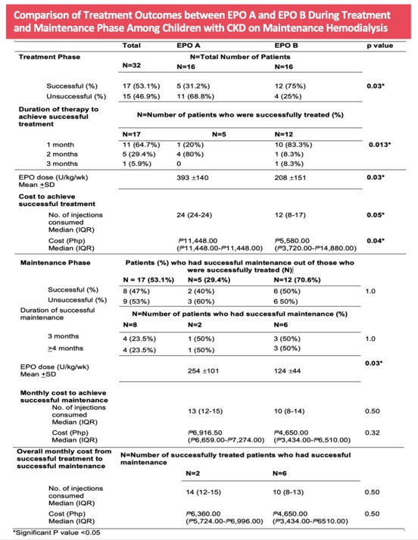
Recent Publications (minimum 5)
None





Biography (150 word limit)
Phoebe Anne M. Diño-Santos is a Diplomate in Pediatric Nephrology. Her passion for research writing led her to pursue further training in Clinical Research. She wishes to advance her knowledge in the field of research and write outstanding research papers that can contribute to the development and improvement of children’s health.
Email: phoebeanne18@yahoo.com

Notes/Comments:

Presenting author details
Full name: Phoebe Anne Diño-Santos
Contact number: (63) 917-3075386
Twitter account:
Linked In account:
Session name/ number:
Category: (Oral presentation/ Poster presentation) Oral presentation

