Efficient and easy physical co-immobilization procedure of cellulase and β-glucosidase into Wrinkled Silica Nanoparticles for the hydrolysis of cellulose extracted from agricultural waste

Aniello Costantini
University of Naples Federico II, Naples, Italy.

Abstract

The efficiency of cellulose hydrolysis is negatively affected by the low amount of -glucosidase (BG) contained in fungal cellulase enzyme cocktail. So, we implemented a strategy to physically co-immobilize -glucosidase and cellulase on wrinkled mesoporous silica nanoparticles (WSNs) to enhance glucose production. WSNs are nanoparticles with radial and hierarchical open pore structure, exhibiting smaller (WSN) and larger (WSN-p) inter-wrinkle distance depending on the synthesis strategy. The immobilization was carried out separately on different vectors (WSN for BG and WSN-p for cellulase), simultaneously on the same vector (WSN-p), and sequentially on the same vector (WSN-p) in order to optimize the synergy between cellulase and BG. The obtained results highlighted that simultaneous immobilization of BG and cellulase on the same vector (WSN-p) results in the best biocatalyst. In this case, the adsorption resulted in 20% yield of immobilization, corresponding to an enzyme loading of 100 mg/g of support. 82% yield of reaction and 72 mol/min∙g activity were obtained, evaluated for the hydrolysis of cellulose extracted from Eriobotrya japonica leaves. All reactions were carried out at a standard temperature of 50°C. The biocatalyst retained 83% of the initial yield of reaction after 9 cycles of reuse. Moreover, it had better stability than the free enzyme mixture in a wide range of temperatures, preserving 72% of the initial yield of reaction up to 90°C.
Image
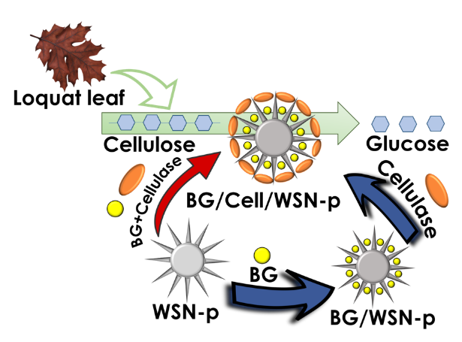
Figure 1. Graphical scheme of the whole process of glucose production from lignocellulosic biomass (Eriobotrya japonica leaves), highlighting the different strategies followed for enzyme co-immobilization.
Recent Publications
- Califano, V. et al. (2018) Wrinkled Silica Nanoparticles: Efficient Matrix for β-Glucosidase Immobilization. J. Phys. Chem. C 2018, 122 (15), 8373–8379.
- Venezia, V. et al. (2020) Mesoporous silica nanoparticles for β-glucosidase immobilization by templating with a green material: Tannic acid. Microporous and Mesoporous Materials, 302, 110203.
- Sannino, F. et al. (2020) Covalent immobilization of β-glucosidase into mesoporous silica nanoparticles from anhydrous acetone enhances its catalytic performance. Nanomaterials, 10(1), 108.
- Venezia, V. et al. (2020) Immobilization of β-Glucosidase over Structured Cordierite Monoliths Washcoated with Wrinkled Silica Nanoparticles. Catalysts , 10 (8), 889.
- Costantini, A. et al. (2020) Adsorption of cellulase on wrinkled silica nanoparticles with enhanced inter-wrinkle distance. Nanomaterials, 10(9), 1799.
- Pota, G. et al. (2021). Tailoring the hydrophobicity of wrinkled silica nanoparticles and of the adsorption medium as a strategy for immobilizing lipase: An efficient catalyst for biofuel production. Microporous and Mesoporous Materials, 328, 111504.
- Pota, G. et al. (2022) Co-immobilization of Cellulase and β-Glucosidase into Mesoporous Silica Nanoparticles for the Hydrolysis of Cellulose Extracted from Eriobotrya japonica Leaves. Langmuir. 238 (18), 5481–5493




Biography

Aniello Costantini is Professor of Chemistry since December 2004 in the Department of Chemical Engineering, Materials and Industrial Production at the University of Naples Federico II. He received his Master Science (Laurea) in Engineering with full marks and honours from the University of Naples Federico II. He received his PhD in Materials Engineering from the same University. Until January 2023, he appears as author in more than 111 publications in international high quality peer reviewed journals. His research work has been focused on the synthesis of glasses, ceramics, glass-ceramics and nanostructured hybrids. He is highly skilled in synthesis and functionalization of ceramic nanostructures through sol-gel method. Accurate design of process parameters has been exploited to produce ceramic and hybrid nanostructures, tuning size, shape and surface chemistry to obtain bioactive hybrids and nanocomposites, multifunctional coatings, smart drug delivery carriers, mesoporous silica materials as supports for enzyme immobilization.
Email: anicosta@unina.it

Presenting author details
Full name: Aniello Costantini
Contact number: +39 081 768 2596
Mail id: Piazzale Tecchio 80, 80125 Napoli, Italy
Category: Oral presentation

