Relation of post-stroke headache to cerebrovascular pathology and hemodynamics

Elsayed Abed^{1*}, Nabil Elagouz¹, Hussein M. Hussein¹, Sandra Ahmed², Ahmed H. Elsheshiny¹ and Mohamed H. Rashad¹

¹Al-Azhar University, Egypt
²Kasr Al-Ainy School of Medicine, Egypt

Abstract

Background: Despite the high prevalence of cerebrovascular stroke, headache attributed to ischemic strokes is often undertreated and overlooked. The aim is to detect the relation of a post-stroke headache to cerebrovascular pathology and changes in hemodynamics through a high-resolution duplex ultrasound examination.

Methods: This is a prospective case-control study that was conducted in Kasralainy hospital, Cairo University, and Al-Azhar University hospitals from January 2021 to August 2021.The study was conducted on 239 patients who presented with an acute ischemic stroke. Patients were subdivided into two groups; Group I included patients with headache attributed to ischemic stroke (cases) and Group II included headache-free stroke patients (controls). History included headache characteristics and risk factors. Clinical and radiological examination was performed to detect the type of stroke. Ultrasound duplex examination of the extracranial and intracranial cerebrovascular system was carried for both groups.

Results: Group I included 112 patients (mean age 57.66 ±6.59 years), Group II included 127 patients (mean age 57.73±7.89 years). Post-stroke headache was more frequent in patients with posterior circulation infarction (58%). Post-stroke headache was reported within 7 days post-stroke in (61.6%) of patients. Pre-stroke headache was an independent predictor for post-stroke headache occurrence (OR=28.187, 95%CI; 6.612-120.158, P<0.001). Collateral opening and various degrees of intracranial vascular stenosis were strong predictors of headache occurrence (OR=25.071, 95% CI; 6.498-96.722, P<0.001).

Conclusion: Post-stroke-headache is a common phenomenon especially in patients with pre-stroke headache, history of old stroke, posterior circulation infarction, and large artery disease. This headache was of moderate-intensity with clinical characteristics of tension-type. The intracranial cerebrovascular pathological changes including opening of the collateral channels and variable degrees of stenosis of cerebrovascular systems were implicated in the production of that headache.

Keywords: Post-stroke headache; cerebrovascular; hemodynamics; duplex ultrasound.

Statements and Declarations
The authors declare that there was no conflict of interest.

Results

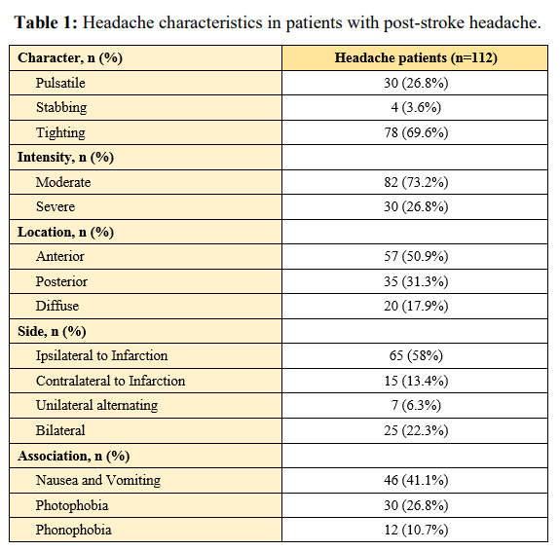

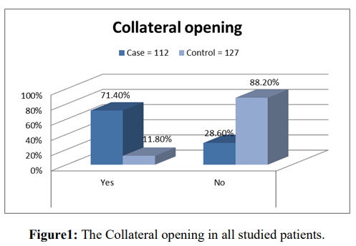

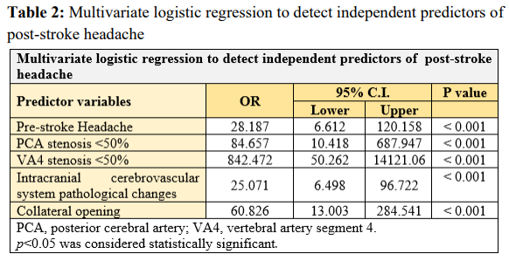

Recent Publications:
- Oliveira, F. A. A., & Sampaio Rocha‐Filho, P. A. (2019). Headaches attributed to ischemic stroke and transient ischemic attack. Headache: The Journal of Head and Face Pain, 59(3), 469-476.
- Harriott, A. M., Karakaya, F., & Ayata, C. (2020). Headache after ischemic stroke: a systematic review and meta-analysis. Neurology, 94(1), e75-e86.
- Abed, E., Mohammed, N. H., Elsheshiny, A. H., Ahmed, S., & Rashad, M. H. (2022). Relation of post-stroke headache to cerebrovascular pathology and hemodynamics. Folia Neuropathologica, 60(2), 221-227.
- Feigin, V. L., Stark, B. A., Johnson, C. O., Roth, G. A., Bisignano, C., Abady, G. G., ... & Hamidi, S. (2021). Global, regional, and national burden of stroke and its risk factors, 1990–2019: A systematic analysis for the Global Burden of Disease Study 2019. The Lancet Neurology, 20(10), 795-820.
- Lee, M. J., Lee, C., & Chung, C. S. (2016). The migraine–stroke connection. Journal of stroke, 18(2), 146.

Biography:
Abed completed a three-year residency program in Al-Azhar University hospitals; one of the leading medical teaching institutes in his country. Through which, he obtained his Master degree in Neuropsychiatry, Al-Azhar University, excellent degree, Nov 2019. Also, he spent a full year of good training in the neurology department at Maadi Military Hospital, now he work as assistant lecturer at neurology department, Al-Azhar University, Cairo, Egypt. Despite his clinical competency, Dr. Abed is an ambitious neurologist who is still keeping learning and gaining new skills in the field of Neurology. During his years of work, he was consistent, dedicated, enthusiastic and exhibiting great care of his work. He has incredible creative energies and a refreshing idealism tempered only enough to accomplish what needs to be done. Moreover, he achieved many academic degrees, much international publication in different fields of neurology.

