Gastrocnemius and soleus skeletal muscle proteomic changes of type 2 diabetes mellitus (T2DM) after exercise interventions in db/db mice
Authors: Monika Renuka Sanotra1 #, Yen-Chun Huang2 #, Ting-Yu Chen3, Yi-Ju, Hsu2, Chi-Chang Huang2, Chen-Chung Liao4,*,
1. Division of Cardiology, Taipei Veterans General Hospital, Taiwan
2. Graduate Institute of Sports Science, National Taiwan Sport University, Taiwan
3. Marker Exploration Corporation, Biotechnology Industry, Taiwan
4. Office of Research and Development, National Yang Ming Chiao Tung University, Taiwan
# These authors collaborated equally to this work.
* Corresponding authors: Chen-Chung Liao, Proteomics Research Center, National Yang-Ming Chiao Tung University, No.155, Sec.2, Linong Street, Taipei, 11221, Taiwan, Tel.: +886-2-2826-7382 E-Mail: ccliao@ym.edu.tw

Objective: Exercise is a modifiable risk factor that may affect the gastrocnemius and soleus muscle protein level in the T2DM mice model. To investigate this hypothesis, we performed blood examination and proteomics analysis of the skeletal muscle of wild-type mice and diabetic mice with and without exercise training.
Method: Inclusion criteria for control and diabetic mice were four male ICR mice per group aged 8 weeks. The three groups consist of 1) wild type (WT), 2) sedentary control diabetic mice (SED) without exercise, and 3) diabetic mice with exercise training (ET) for six weeks. Body weight, HbA1c level before and after exercise intervention, weekly blood glucose monitoring, fatigue test (forelimb grip strength), organs or tissue weight, and biochemical tests. Gastrocnemius and soleus muscles were further used for proteomic analysis by using liquid chromatography and tandem mass spectrometry after tryptic digestion. Proteomic data interpretation was performed by using Peaks7 software and bioinformatics tools.
Result: Blood glucose and HbA1c level were decreased significantly in the ET mice group than in SED. Grip strength was reduced in the ET group compared to the WT group, which indicates it may be due to exercise tiredness. Muscle weight and biochemical tests were recorded after sacrificing mice. Insignificant gastrocnemius muscle gain was seen in ET mice more than in SED. Various differential expression proteins (DEPs) were observed in proteomics data having biological functions related to free radical scavenging, skeletal-muscular disorders, metabolic disease, and lipid metabolism. Due to exercise intervention, intermediate products and enzymes involved in metabolic activity level change in skeletal muscle could be potential biomarkers for T2DM disease prevention, mitigation, and treatment.
Conclusion: As per our research data, we successfully established a diabetic mice model for skeletal muscle proteomic analysis, which mimics human pathological conditions. We also found lists of DEPs that significantly affect T2DM symptomatic improvement.
Keywords: Exercise training, proteomics, skeletal muscle, type 2 diabetes mellitus (T2DM).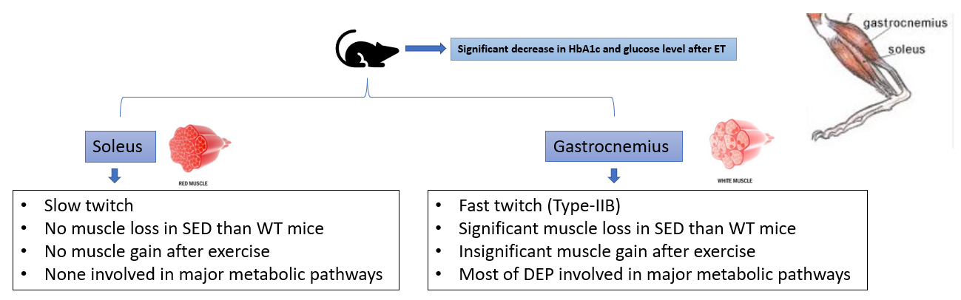
Figure 1: Effects of exercise intervention on gastrocnemius and soleus muscle of db/db mice.

Presenting author details
Full name: Monika
Contact number: +886 905058614
Mail id: Monika@marker-x.com
Category: (Oral presentation/ Poster presentation)

Logos:
Marker Exploration Corporation | National Yang Ming Chiao Tung University | National Taiwan Sport University | TVGH
 |  |  | 

