From local stress amplification in heterogeneous solid earth materials to hybrid ultra-piezoelectric nano-graphene polymer blends for energy harvesting
Anthony N. Papathanassiou¹, Theodora – Ilektra Katsigianni¹, Eirini Kolonelou¹ and Elias Sakellis²
¹National and Kapodistrian University of Athens, Greece
²Institute of Nanoscience and Nanotechnology, National Center for Scientific Research ''Demokritos", Greece

Abstract
The compression of a structurally or compositionally heterogeneous solid dictates a non-uniform internal stress field. Computer simulation on solid earth materilas have proven that far-field stresses applied on different type and degree disorder earth materials yields a spatial fluctuation of the internal stress field: the stress field is locally amplified (compared to the pressure applied on the whole system)¹. This idea inspired us to develop polymer blends (polyvinyl acetate polyvinyl alcohol( PVAc) consisting of a polymer matrix hosting a fraction of piezoelectric polyvinylidene fluoride (PVDF) and dispersed nano-graphene platelets (NGPs. Devices based on these materials are promising ones affordable, non-toxic and simply prepared energy harvesters and sensors ²⁻⁵. Hard and sharp NGPs are likely to amplify the local stress applied onto the surface of individual piezoelectric polymer grains and, as a result, the effective electro-mechanical coupling of the overall material may be enhannced compared with that of neat piezoelectric PVDF. The value of the piezoelectric coefficient, which is a measure of the efficiency of a piezoelectric material to transform mechanical energy to electric one, is, in principle, a percentage of the value that neat PVDF exhibits. We present a simple strategy to augment the total effective electromechanical coupling by dispersing NGPs. Our experimental findings indicate that , by increasing th NGP mass fraction, the value of the overall piezoelectric coefficient is boosted by 150 % per weight fraction of NGPs and becomes superior to values reported for neat electro-active PVdF [2]. The synergy of the large total effective surface area available by the PVdF micro-grains and the amplification of local stresses on the piezo-active surface is by the sharp and hard NGPs dispersed in the polymer blend, is likely to optimize the electro- mechanical coupling⁵.
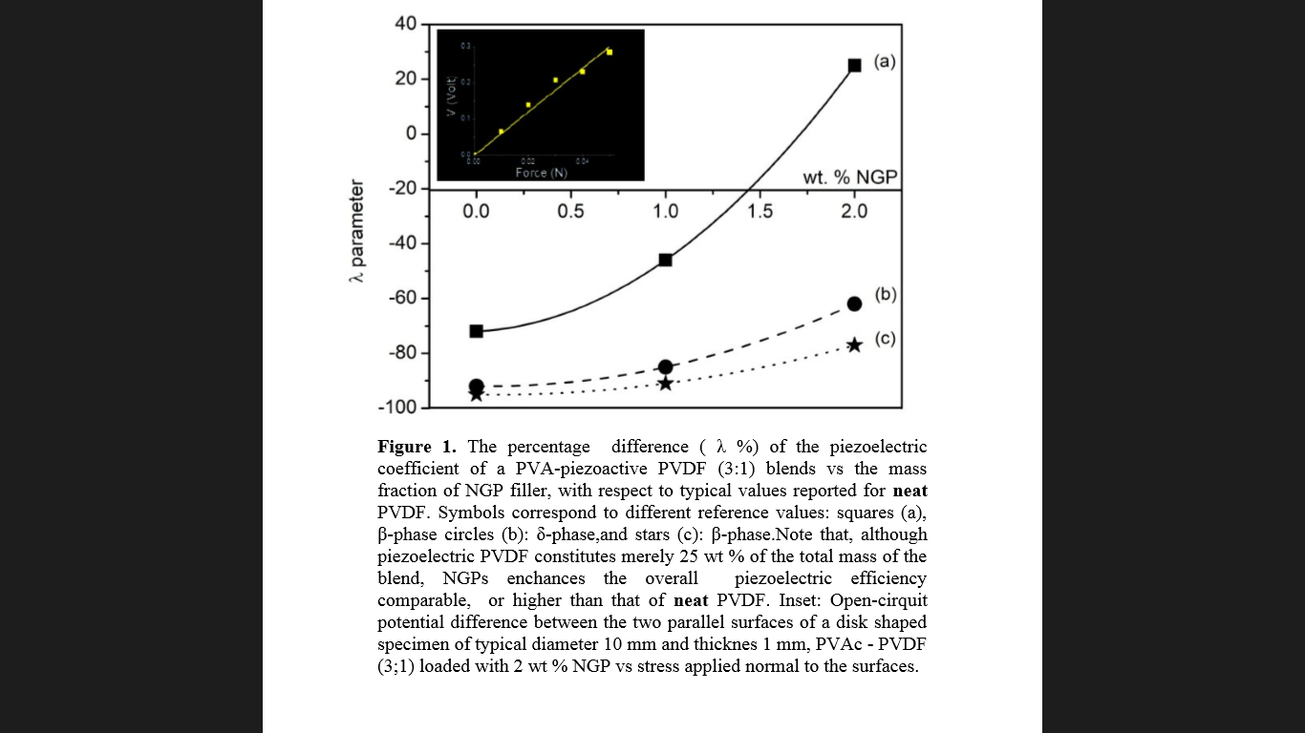

Recent Publications
1. Lei D., Ke G.. (2018) 52nd US Rock Mechanics/Geomechanics Symposium. OnePetro.
2. Mahapatra S.D. t al. (2021) Materials for Energy Harvesting and Sensing Applications: Roadmap for Future Smart Materials. Adv Sci (Weinh).
3. Ahmed A. et al, (2021) Nano Converg., 8(1), 37022.
4. Aldahiry D.A., t al. (2022Appl. Phys 9.3 (2017): 95-99.
5. Valadorou D., Papathanassiou A.N., Kolonelou E. and Sakellis E. (2022) J. Phys. D: Appl. Phys. 55 295501.
Biography
Anthony Papathanassiou is an Assistant Professor of Experimental Solid State Physics. He got his BSc in Physics from NKUA, MSc in Condensed Matter and Materials Science fron Demokritos National Centre for Scientific Research and PhD in Condensed Matter Physics from NKUA. He worked as Research Associate at various National and European projects in NKUA and Universitat Bayreuth, as research staff in NKUA and Research Scholar at Harvard University. Since 2013, as an academic member in NKUA, he is directing the Broadband Dielectric Spectroscopy and High Pressure Laboratory. His research focuses on both fundamental condensed matter physics and innovative materials science, related to non-equilibrium statistical mechanics, relaxation and phase transitions, especially, at extreme states.
.

