Density Functional Theory and Molecular Dynamics Simulation Support Newly Designed Reversible Tyrosine Kinase Inhibitors Targeting Double Mutant Epidermal Growth Factor Receptor (EGFR)
Dorra Driss, Fakher frikha & Mohamed Sami Aifa, Tunisia.

Abstract (300 word limit)

Non-small cell lung cancer (NSCLC) is a leading cause of death in the world. Epidermal growth factor receptor (EGFR) is a well-characterized oncogene that was shown to be implicated in the development of NSCLC via the acquisition of the L858R activating substitution. In this work, we aimed to identify novel reversible double mutant EGFR TKIs via an in silico approach. First, a compound library containing more than 150000 kinase inhibitor analogs was subjected to an initial filtering step. The remaining molecules were tested via high-throughput virtual screening that was carried out to identify the best inhibitors. Following this, a total of 15 hits were retained and their binding interactions and ADMET properties were determined. Finally, molecular dynamic studies were performed for the top 10 scoring compounds. Simulation analysis revealed that both molecules possessed interesting characteristics in terms of RMSD, RMSF, radius of gyration and hydrogen bonds formation. Of note, this study evaluated and established a library of compounds, top ranked virtual hit compounds binding reversibly to the double mutant EGFR enzyme can act as potent newly designed EGFR inhibitors in management of mutations of non-small cell lung cancer.

Image
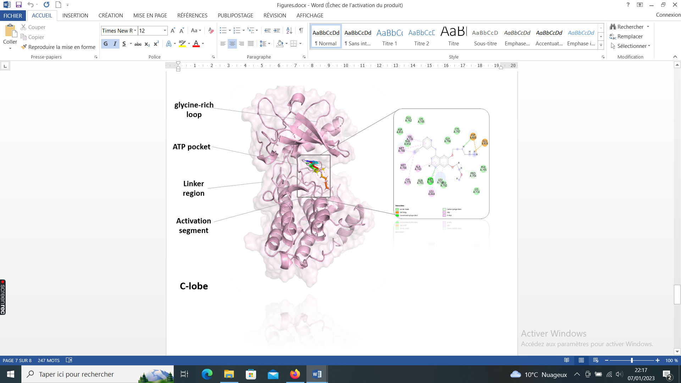
Simulation interaction diagram (2D) of best hit with the protein. Interactions that occur more than 30.0% of the simulation time in the selected trajectory (0.00 through 100.00 nanosecond).

Recent Publications (minimum 5)
- Amal Souissi, Dorra Abdelmalek Driss, Imen Chakchouk, Mariem Bensaid, Ikhlas Ben Ayed, Mohamed Ali Mosrati , Ines Elloumi , Abdelaziz Tlili, Sami Aifa , Saber Masmoudi. Molecular insights into MYO3A kinase domain variants explain variability in both severity and progression of DFNB30 hearing impairment. Journal of Biomolecular Structure & Dynamics-ID TBSD-2021-0419.R1. July 2021.
- Taehee Kim, Vinayak G. Parale, Hae-Noo-Ree Jung, Younghun Kim, Dorra Abdelmalek Driss, Abdallah Bouabidi, Souhir Euchy and Hyung-Ho Park. Facile Synthesis of SnO2 Aerogel/Reduced Graphene Oxide Nanocomposites via in Situ Annealing for the Photocatalytic Degradation of Methyl Orange. Nanomaterials 2020.
- Min-Hee Hong , Haryeong Choi , Younghun Kim , Taehee Kim, Hyung Hee Cho , Zied Driss, Dorra Abdelmalek Driss , Abdallah Bouabidi, Souhir Euchy , Hyung-Ho Park. Ti doping effects on the Seebeck coefficient and electrical conductivity of mesoporous ZnO thin film. Materials Chemistry and Physics. Volume 235, 1 September 2019, 121757. DOI:10.1016/j.matchemphys.2019.121757.
- Haryeong Choi, Vinayak G. Parale, Kyu-Yeon Lee, Ha-Yoon Nah, Zied Driss, Dorra Abdelmalek Driss, Abdallah Bouabidi, Souhir Euchy, and Hyung-Ho Park. Polypropylene/Silica Aerogel Composite Incorporating a Conformal Coating of Methyltrimethoxysilane-Based Aerogel. Journal of Nanoscience and Nanotechnology Vol. 19, 1376–1381, 2019.
- Sami Mnif, Marwa Jardak, Imen Grait, Salwa Abid, Dorra Abdelmalek Driss, Najla Kharrat. The novel cationic cell-penetrating peptide PEP-NJSM is highly active against Staphylococcus epidermidis biofilm. Int j of Biomol. December 2018.

Biography (150 word limit)
Dorra Driss is currently working as an assistant Researcher at Centre of Biotechnology of Sfax CBS-Sfax, University of Sfax. Dorra does research in Engineering, Biochemistry Computer Science and Signaling pathways science. Its current projects are; project1 : Targeting EGFR family kinases: development of new molecules: design, synthesis and in vitro assays and project 2: Genertaing Active Human Kinases (ERBB family) Using Pichia Pastoris As A Host For Functional Assays And For Drug Discovery Purposes Investigating Possible Inhibitors That Can Be Used As Anticancer Agents.
Email: dorra.driss@cbs.rnrt.tn; dorra.driss11@gmail.com

Notes/Comments:
Presenting author details
Full name: Dorra Abdelmalek Driss
Contact number:+21622859615
Linked In account: https://www.linkedin.com/in/dorra-abdelmalek-b8183570/
Session name/ number:
Category: (Oral presentation)

