The Efficacy and Safety of Combined Phacoemulsification and Trabeculectomy in Late Advanced Stage of Primary Glaucoma: A 12 Months Follow Up

Widya Artini Wiyogo
University of Indonesia, JEC Eye Hospitals and Clinics, Jakarta, Indonesia

Abstract
Purpose
To evaluate the efficacy and safety, described in intraocular pressure (IOP) and vision-threatening complication, respectively, after combined phacoemulsification and ab interno trabeculectomy in adults with late-advanced stage primary glaucoma in Indonesia
Methods
The medical records of selected patients were retrospectively reviewed. Data collection included IOP, visual acuity, visual field, optic disc ratio, retinal nerve fiber layer thickness, and IOP lowering medication used preoperatively and through up to 12 months post operatively. Complications, if any, were also noted. Paired T test and Wilcoxon tests were utilized to analyze the result.
Results
Data from 47 eyes of 40 subjects were analyzed. Majority of the subjects were male (52.5%/47.5%) with mean age of 62.60 ± 9.95 years and most had primary open angle glaucoma compared to primary angle closure glaucoma (62.5% vs 37.5%).
The mean visual field deviation (dB) was -22.68 ± 6.90 at baseline and -23.32 ± 7.04 post operatively. Mean IOP (mmHg) was 29.08 ± 11.39 at base line and 15.11 ± 6.40 after mean follow up of 12 months. IOP reductions of ≥ 20% were achieved in 41/47 eyes (87.2%) with mean IOP reduction of 43%. Mean medication use declined from 3.91 ± 1.25 medications per eye at baseline to 1.38 ± 1.21 at last follow-up (p<0.0001) and mean IOP lowering medication reduction of 66% after mean follow-up of 12 months. Sixteen out of 47 eyes (34%) were medication-free at last follow-up. No vision-threatening complications were observed.

Conclusions
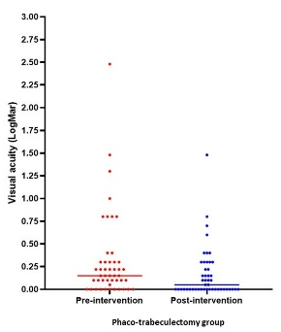
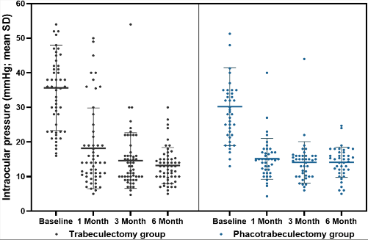
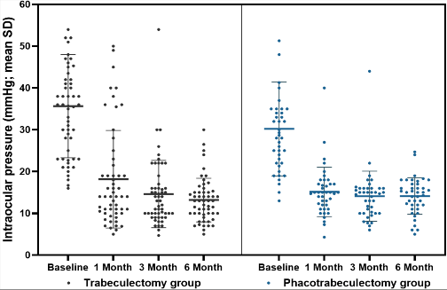
Combined phacoemulsification and ab interno trabeculectomy is a safe procedure to perform in late-advanced stage of primary glaucoma. This procedure provides statistically and clinically significant reduction of IOP and medication use with no wipe-out complication has been reported.
Fig 2. BCVA (in logMAR units) at baseline and follow-up
Fig 1. IOP at baseline and follow-up
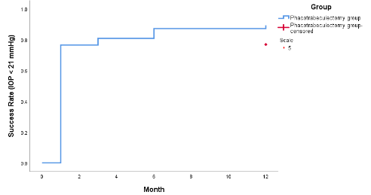

Fig 3. Kaplan-Meier survival curve of surgical outcome

Recent Publications
1. Ahmadzadeh A, Kessel L, Subhi Y, Bach-Holm D. Comparative Efficacy of Phacotrabeculectomy versus Trabeculectomy with or without Later Phacoemulsification: A Systematic Review with Meta-Analyses. J Ophthalmol. 2021;2021. doi:10.1155/2021/6682534
2. Murthy SK, Damji KF, Pan Y, Hodge WG. Trabeculectomy and phacotrabeculectomy, with mitomycin-C, show similar two-year target IOP outcomes. Can J Ophthalmol. 2006;41(1):51-59. doi:10.1016/S0008-4182(06)80067-0
3. Choy BNK. Comparison of surgical outcome of trabeculectomy and phacotrabeculectomy in Chinese glaucoma patients. Int J Ophthalmol. 2017;10(12):1928-1930. doi:10.18240/ijo.2017.12.23
4. Ansari E, Loganathan D. 12-month clinical outcomes of combined phacoemulsification and ab interno trabeculectomy for open-angle glaucoma in the United Kingdom. PLoS One. 2021;16(6 June):1-8. doi:10.1371/journal.pone.0252826
5. Elghonemy HM, Dewedar AS, Nader M, Shaban NH. Trabeculectomy outcomes for patients with advanced glaucoma. Published online 2020:10-14. doi:10.4103/JMISR.JMISR
6. Baser EF, Seymenoglu G, Mayali H. Trabeculectomy for advanced glaucoma. Int Ophthalmol. 2011;31(6):439-446. doi:10.1007/s10792-011-9494-0
7. Wang M, Fang M, Bai YJ, et al. Comparison of combined phacotrabeculectomy with trabeculectomy only in the treatment of primary angle-closure glaucoma. Chin Med J (Engl). 2012;125(8):1429-1433. doi:10.3760/cma.j.issn.0366-6999.2012.08.013



 Biography

Widya Artini Wiyogo is currently Head of the Glaucoma Center at JEC Eye Hospital &

Clinics Jakarta, Indonesia and Professor of the Department of Ophthalmology, Faculty of

Medicine, University of Indonesia. She has completed residency in ophthalmology and

doctoral degree at University of Indonesia. She has also taken fellowship in glaucoma at the

Lion Eye Institute, Perth, Australia and National University of Singapore, also fellowship in

cataract and glaucoma at Boston University, USA. She has written numerous publications and

books on ophthalmology, both as first author and co-author. Some of the awards she has

received were the Editorial Board of Glaucoma Award Certificate and the Presidential Doctor

Team in 2014. She is a member of IDI, PERDAMI, AAO, ASCRS, APAO, APGS, IGS.

