Life Satisfaction and Academic Engagement in Chileans Undergraduate Students of the University of Atacama
Carmen Burgos Videla * Ricardo Jorquera

Department de Education Basic Universidad de Atacama

Abstract
Statement of the problem: The growing problem of mental health in the university population, as a consequence of the COVID-19 pandemic, has generated the need to consider positive variables to address this situation. Life satisfaction and academic engagement are two constructs that emerge as conceptual tools oriented in this direction. The present study sought to describe the effect of academic engagement on life satisfaction in a sample of Chilean university students. A cross-sectional co-relational design was used. A total of 370 university students participated, 72.4% female and 27.6% male, aged beitive effect of engagement on life satisfaction was demonstrated, where the dimensions vigor (β = 0.462; p < 0.01) and dedication (β = 0.465; p < 0.01) acted as significant predictors (χ2 = 87.077, gl = 32, p < 0.01; χ2/gl = 2.721; CFI = 975; TLI = 0.964; RMSEA = 0.068). The proposed model showed factorial invariance according to sex. The usefulness of employing these constructs as a way to manage the well-being and mental health of students in university institutions is discussed.
Methodology & theoretical orientation: The design used in this research was consistent with the objective of the study, which was to describe the effect of academic engagement on life satisfaction in Chilean university students from Copiapó. For this purpose, non-experimental research of a cross-sectional correlational type was considered. It should be noted that in non-experimental research there is no deliberate manipulation of the variables, and the phenomena are only observed in their natural environment and then analyzed. On the other hand, the present research was cross-sectional–correlational, since a description of the study variables was sought by establishing the relationship between them at a single point in time.
The stages were mainly based on a data analysis process and included the following:
- Data preparation: at this stage, a descriptive analysis of the data was carried out, in which basic statistics were obtained. Then, correlational analyses were carried out, and the proposed predictive model was verified using the AMOS 21 program.
- Model generation and evaluation: the adjustment of the proposed structural model was verified, considering life satisfaction as a criterion variable and engagement and its dimensions as predictors. At the same time, the factorial invariance of the hypothesized model was estimated according to sex.
- Analysis of results: the results obtained from the techniques described in the data analysis section were analyzed.

Findings:
The results showed that life satisfaction correlated positively and significantly with the three dimensions of academic engagement. These relationships ranged from 0.454 to 0.508, all of which were significant at the p < 0.01 level. Let’s look at table below. The mean comparisons of the variables studied according to sex and educational level. According to sex, no significant differences were observed in life satisfaction (t = 0.41, p = 0.68), vigor (t = −1.04, p = 0.30), dedication (t = −0.80, p = 0.43), and absorption (t = −1.86, p = 0.06).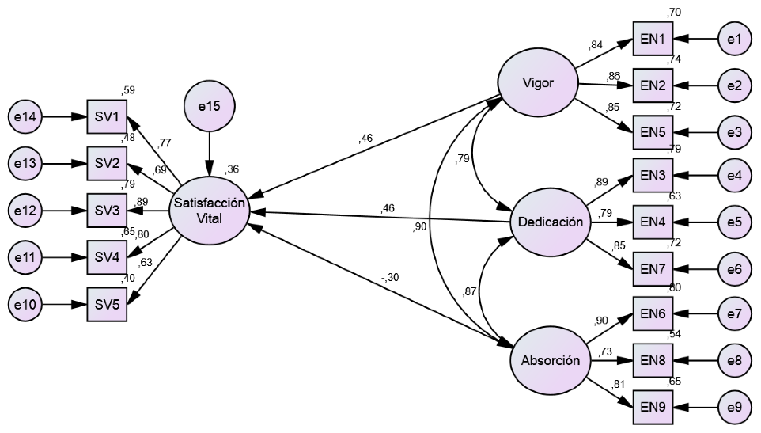
Figure 1. . Structural Model of Life Satisfaction and Academic Engagement.
Conclusion: This study allowed verifying the impact of academic engagement on life satisfaction in Chilean university students. With the above, it can be confirmed that this is a relevant theoretical–conceptual tool for the promotion of mental health and the prevention of mental health issues in higher education institutions, based on a positive approach.
One of the limitations of the present study regards its sample, which was limited to only one higher education institution. Therefore, future studies should focus on the behavior of these variables in other higher education institutions, both public and private, and in other geographical areas of the country, in order to evaluate the possible generalization of the results to different institutional and academic realities. It also remains a challenge for further studies to observe the impact of its application in interventions in educational organizations.

References
- Bakker, S. UWES Utrecht Work Engagement Scale; Utrecht University: Utrecht, The Netherlands, 2002. [Google Scholar]
- Salanova, M.; Schaufeli, W.B. El engagement de los empleados: Un reto emergente para la dirección de recursos humanos. Estud. Financ. 2004, 261, 109–138. [Google Scholar]
- Schaufeli, W.B.; Salanova, M. Efficacy or inefficacy, that’s the question: Burnout and engagement and their relationships with efficacy beliefs. Anxiety Coping Stress 2007, 20, 177–196. [Google Scholar] [CrossRef] [PubMed]
- Salanova, M.; Schaufeli, W.B. El Engagement en el Trabajo. Cuando el Trabajo se Convierte en Pasión; Alianza: Madrid, Spain, 2009. [Google Scholar]
- Murillo, J.; Alonso, F.M. La satisfacción vital: Su relación con el prejuicio, la identidad nacional, la autoestima y el bienestar material, en inmigrantes. Acta Colomb. Psicol. 2012, 15, 99–108. [Google Scholar]
Biography
Carmen Gloria Burgos-Videla is a teacher of basic general education. She has a master's degree in competency-based curriculum design and is a Doctor in Educational Sciences. She is a member of different research networks and director of the Research Institute in Social Sciences and education of the University of Atacama and of the Observatory on Education and Culture Society. Editor-in-chief Propulsion Magazine. Her lines of research are pedagogical and curricular theory, creativity, and vivid curricula.

