Light-harvesting Cu and Metal Sulfide Hybrid Nanocomposites for Photocatalytic Oxidative Coupling Reactions
Kang Hyun Park, Pusan National University, Busan, Republic of Korea

Abstract
Recently, photocatalysis has attracted considerable interest, leading to opportunities for using renewable energy sources. A Cu:Ni metal–organic framework (MOF) modified with graphene oxide (GO) was fabricated by a facile and convenient process. Subsequently, the Cu:Ni sulfide encapsulated on porous C with reduced GO (Cu2S:NiS2@C/rGO) as a core–shell nanostructure was achieved using a MOF (Cu:Ni-BTEC/GO). Cu2S:NiS2@C/rGO with a hybrid structure showed superior photocatalytic activity for producing N-substituted derivatives through three kinds of oxidative coupling reactions. Moreover, the MOF-derived photocatalyst exhibited good reusability and stability. The excellent photocatalytic behavior of MOF-derived bimetallic chalcogenides would channel further interest in the design, synthesis, and modification of MOFs as photocatalysts for diverse applications.
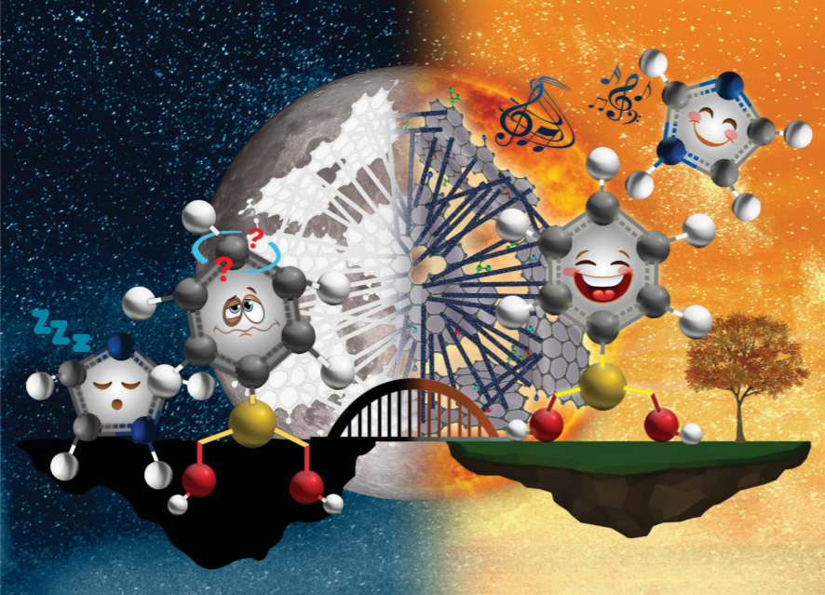

Recent Publications (minimum 5)
- Yusuf, M., Hira, S. A., Park, K. H. (2022) Light-Harvesting Novel Hierarchical Porous Cu9S5–MnWO4 Hybrid Structures in Photocatalytic Oxidative Homocoupling of Alkynes and Amines. ACS Appl. Mater. Interfaces, 14, 13.
- Nagappan, S., Duraivel,M., Hira,S. A., Prabakar, K., Ha, C., Joo, S. H., Nam, K. M., Park, K. H. (2022) Heteroatom-Doped Nanomaterials/Core–Shell Nanostructures Based Electrocatalysts for Oxygen Reduction Reaction. Journal of Materials Chemistry A, 10, 987-1021.
- Jang, S., Jung, S., Song, S., Lee, S., Lee, H., Cho, E.,Lee, H.J., Park, S., Youn, B., Park, K. H. (2021) Preparation and characterization of multifunctional nanofibers containing metal–organic frameworks and Cu2O nanoparticles: particulate matter capture and antibacterial activity, Environmental Science: Nano, 2021, 8, 1226-1235.
- Annas, D., Lee, H., Hira, S. A., Park, J. C., Park, K. H. (2021) A new synthesis of highly active Rh–Co alloy nanoparticles supported on N-doped porous carbon for catalytic C–Se cross-coupling and p-nitrophenol hydrogenation reactions", New Journal of Chemistry, 45, 7959.
5. Yusuf, M., Hira, S. H., Lim, H., Song, S., Park, S., Park, K. H. (2021) Core–shell Cu2S:NiS2@C Hybrid Nanostructure Derived from a Metal–Organic Framework with Graphene Oxide for Photocatalytic Synthesis of N-substituted Derivatives. Journal of Materials Chemistry A, 9, 9018-9027.


Biography
Kang Hyun Park is a Professor at the Department of Chemistry and Chemistry Institute for Functional Materials, Pusan National University, Korea. His research interests include the development of new transition metal-nanoparticles catalyzed reactions. Currently, his research interest focused on the development of multifunctional nanohybrid materials for electrocatalysis, especially on the synthesis of multifunctional nanohybrid electrodes for fuel cell and battery applications.
Email: chemistry@pusan.ac.kr

Presenting author details
Full name: Kang Hyun Park
Contact number: +82-51-510-2238
Homepage: www.chemistry.or.kr
Google Scholar: https://scholar.google.co.kr/citations?user=4ZlrIWAAAAAJ&hl=en
Session name/ number:
Category: Keynote presentation

