Synthesis of Polyaniline–Calcium Titanate perovskite Nanocomposites
Ariba Bibi and Abdul Shakoor
Institute of Physics, Bahauddin Zakariya University Punjab, Pakistan
Abstract
This paper reports hybrid composites based on polyaniline and calcium titanate (CaTiO 3 )  perovskite as a nanofiller synthesized by in-situ polymerization technique. Their structure and  morphology were investigated by X-ray diffraction analysis and scanning electron  microscopy. The XRD analysis shows that the addition of CaTiO 3 in polyaniline reduced the  amorphous structure of polyaniline transforming it into semi–crystalline nature, which agrees  well with the higher conductivity. Scanning electron microscopy of composites showed the  more compact and homogenous structure with uniform distribution of CaTiO 3 in polymer  matrix. Dielectric parameters such as dielectric constant, loss factor, and dielectric loss, real  and imaginary parts of electric modulus were measured and evaluated as a function of  found to decrease with temperature and CaTiO 3 content and increase with frequency. | 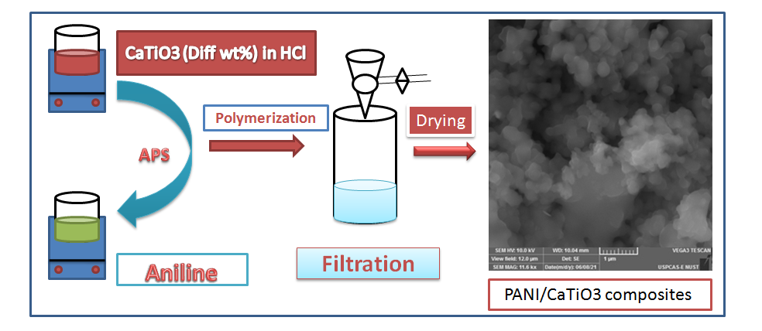  1.A.Shakoor, N.Niaz, Ariba, Nadeem Anwar Irfan, G. Ali (2022)  Polymer Bulletin 79 (8), 6581-6600  2. N Anwar, A Shakoor, G Ali, H Ahmad, NA Niaz, A Mahmood (2022)  Journal of Energy Storage 55, 105446  3. A Bibi, A Shakoor, NA Niaz, S Haider, MS Akhtar  (2022) Polymer Bulletin, 1-17  4. A Bibi, A Shakoor, NA Niaz (2022)  Polymers and Polymer Composites 30, 09673911221102287  5. A Bibi, A Shakoor (2022)  Polymer Science, Series A 63 (5), 585-590

