FORMULATION AND EVALUATION OF SUSTAINED RELEASE TABLETS OF MANGIFERIN:NATURAL COMPOUND

Badri Nagarani * ¹, Venkata Radha Gadela ²

¹ Department of Pharmaceutics, Srikrupa Institute of Pharmaceutical Sciences,
Velikatta, Siddipet-502277, Telangana State, India.
² Department of Pharmaceutics, GITAM Institute of Pharmacy, GITAM (Deemed to be University),
Rushikonda, Visakapatnam-530045, Andhra Pradesh, India.

Abstract (300 word limit)
Analysis of extraction method using various solvents for efficient yield of biologically active compounds from natural source is very essential because there is large importance for the natural compounds in food, pharmacy and other allied industries. Mangiferin which is a xanthone compound present in high quantity in mango leaves and is endow to have anti diabetic activity along with other pharmacological activities. In present study an attempt was made to develop sustained release matrix tablets of Mangiferin using HPMC (K15M & K100M) and eudragit (RS 100 & RL 100) and Protanal as release retardant polymers. The Mangiferin matrix tablets were prepared by wet granulation method using lactose as a diluent. Formulations of different polymer percentages were formulated. The formulations were optimized on the basis of acceptable weight variation, thickness, hardness, % friability, % drug content and in vitro drug release. The in vitro release studies were performed using USP type II apparatus using 6.8 pH phosphate buffer as a dissolution medium, showed that optimized formulation F8 consisting of eudragit RL with 20% of the polymer was found to sustain the release of Mangiferin over a period of 12 h. The formulation exhibited highest correlation (R) value in case of Hixson-Crowell model and the release kinetic study proved that the formulation showed erosion process, and shown to follow zero order kinetics. It was concluded that eudragit RL can be used for the preparation of sustained release tablet of ibuprofen.
Key words: Mangiferin, extraction, isolation, sustained release tablets.

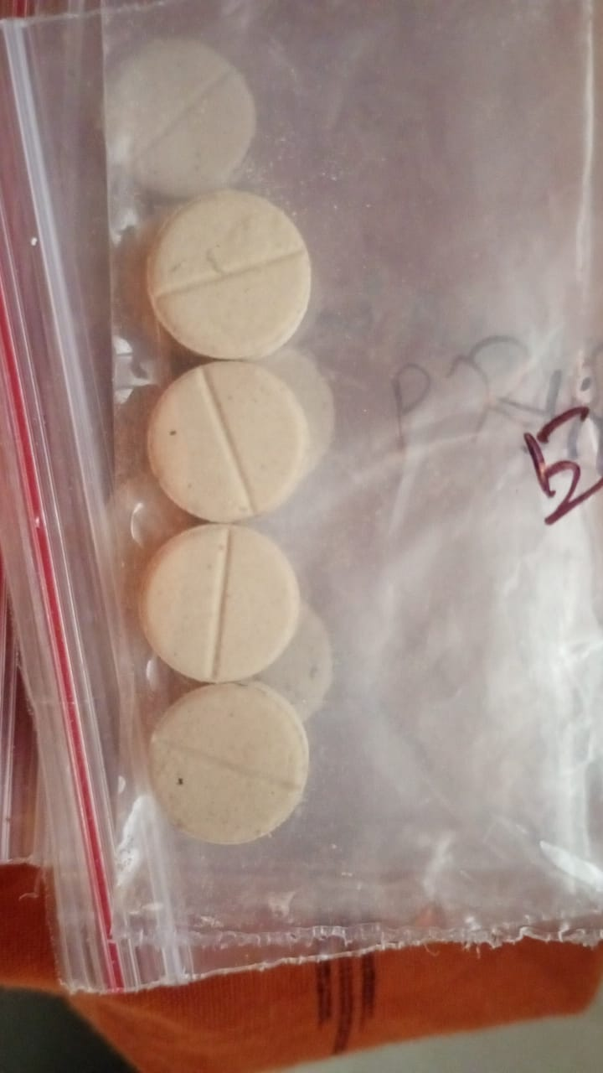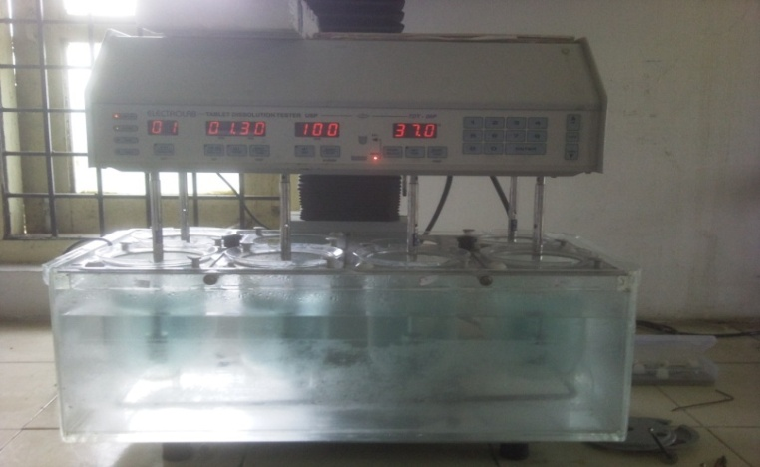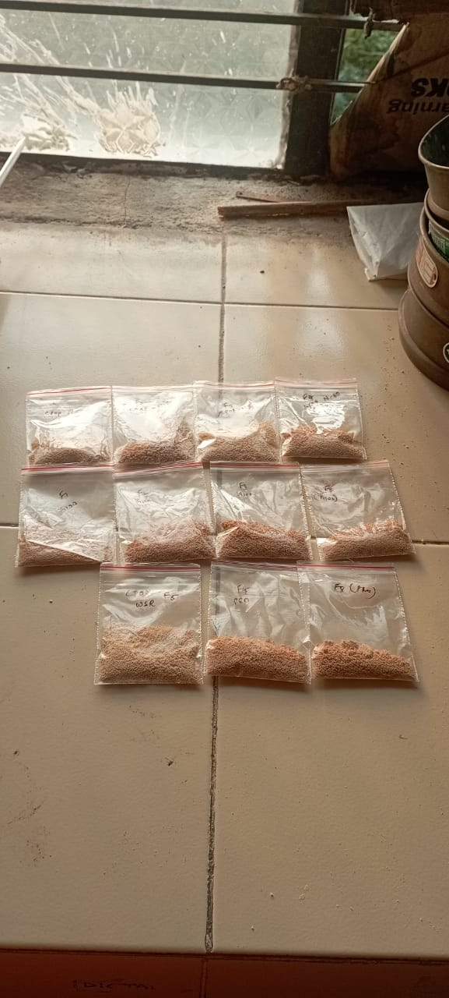

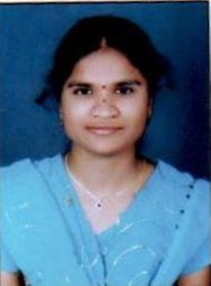Biography (150 word limit)
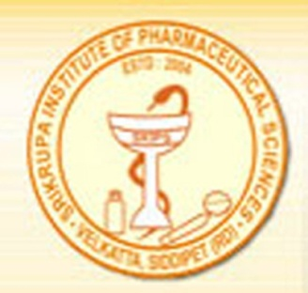re
B.NAGARANI working as Assistant professor in Srikrupa Institute of Pharmaceutical Sciences in the department of Pharmaceutics, Velikatta.She has awarded the Bachelor’s degree from Srikrupa Institute of Pharmaceutical Sciences (Osmania University), Master’s degree from Srikrupa Institute of Pharmaceutical Sciences (Osmania University), Velikatta.She has more than 8 years experience in teaching and research. She is doing PhD in Gitam University;vizag.She has published 20 articles in national and international journals. She presented poster and oral presentations in national and international conferences. She received gold medal for her Excellency in M.Pharmacy.She has two patents in anti diabetic area. she published four text books named Physical pharmacy-I and Industrial pharmacy-II.she published two book chapters.She is the lifetime member of APTI and registered with Telangana state Pharmacy council. She received international researcher award from International research Association,UK.she received young scientist award from INSO in 2022 at Chennai.

Email: badri.naga33@gmail.com

Notes/Comments:

Presenting author details
Full name: BADRI NAGARANI
Contact number:7702793370
Twitter account:
Linked In account:
Session name/ number: ORAL
Category: (Oral presentation/ Poster presentation)

