A Case of MEWDS Following COVID-19 Infection

Research on post-COVID cases of this white dot syndrome may lend insight into its pathogenesis and the work-up of COVID-19 patients with visual symptoms.
By Travis Peck, MD; Obadah Moushmoush, MD; and Arthi Venkat, MD, MS

Multiple evanescent white dot syndrome (MEWDS) is a typically acute-onset, unilateral syndrome that manifests with decreased vision, scotomas, photopsias, or a combination of all three. On fundoscopy, numerous gray, white, or yellow-white dots can be seen at the level of the outer retina or retinal pigment epithelium, most often in the posterior pole. A mild anterior chamber reaction and vitritis may also be noted in some patients. The etiology remains unclear, and no hereditary predilection has been reported; however, the syndrome most commonly affects healthy women from 15 to 50 years of age.¹ When there is suspicion for MEWDS, multiple imaging modalities can help elucidate the syndrome. For example, fluorescein angiography (FA) can reveal a wreath-like pattern of punctate, hyperfluorescent dots, as well as late-leakage and staining of the optic nerve head.
Approximately one-third of patients with MEWDS report a viral prodrome prior to onset of visual symptoms. The underlying pathogenesis of MEWDS may involve an immune response to viral antigens that have gained access to retinal receptor cells. In the literature, there has been one case report of atypical MEWDS following infection with COVID-19, as well as multiple case reports of MEWDS after COVID-19 vaccination.² Here, we report a case of MEWDS shortly following infection with COVID-19 and review the literature surrounding MEWDS and other retinal conditions related to COVID-19.

1. Borruat FX, Herbort CP, Spertini F, Desarnaulds AB. HLA typing in patients with multiple evanescent white dot syndrome (MEWDS). Ocul Immunol Inflamm. 1998;6(1):39-41.
2. De Salvo G, Meduri A, Vaz-Pereira S, Spencer D. An uncommon cold of the retina. Preprint. Published online August 22, 2021. Surv Ophthalmol.
3. Tavallali A, Yannuzzi LA. MEWDS, common cold of the retina. J Ophthalmic Vis Res. 2017;12(2):132-134.
4. Gass JDM, Agarwal A, Scott IU. Acute zonal occult outer retinopathy: a long-term follow-up study. Am J Ophthalmol. 2002;134(3):329-339.
5. Jampol LM, Becker KG. White spot syndromes of the retina: a hypothesis based on the common genetic hypothesis of autoimmune/inflammatory disease. Am J Ophthalmol. 2003;135(3):376-379.
6. Rabinovitch T, Ben-Arie-Weintrob Y, Hareuveni-Blum T, et al. Uveitis after the BNT162b2 mRNA vaccination against SARS-CoV-2 infection: a possible association. Retina. 2021;41(12):2462-2471.
7. Inagawa S, Onda M, Miyase T, et al. Multiple evanescent white dot syndrome following vaccination for COVID-19: A case report. Medicine (Baltimore). 2022;101(2):e28582.
8. Marinho PM, Marcos AAA, Romano AC, Nascimento H, Belfort Jr R. Retinal findings in patients with COVID-19. Lancet. 2020;395(10237):1610.
9.Wu P, Duan F, Luo C, et al. Characteristics of ocular findings of patients with coronavirus disease 2019 (COVID-19) in Hubei Province, China. JAMA Ophthalmol. 2020;138(5):575-578.
10. Bolletta E, Iannetta D, Mastrofilippo V, et al. Uveitis and other ocular complications following COVID-19 vaccination. J Clin Med. 2021;10(24):5960.

Obadah Moushmoush, MD
- Resident, West Virginia University School of Medicine, Morgantown, West Virginia
- obadah23@gmail.com
- Financial disclosure(s): None

Travis Peck, MD
- Surgical Vitreoretinal Fellow, The Retina Group of Washington, Washington, DC
- travispeckj@gmail.com
- Financial disclosure(s): None

Arthi Venkat, MD
- Retina Specialist, The Retina Group of Washington, Washington, DC
- arthi.venkat@gmail.com
- Financial disclosure(s): Consultant - Apellis

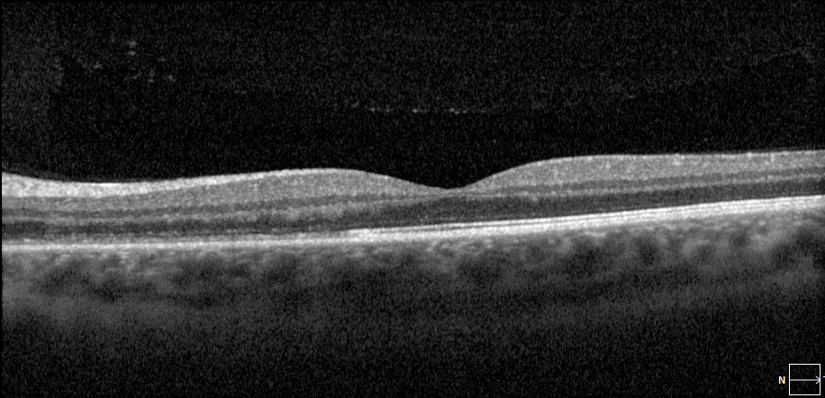
Figure 1. At presentation, the patient’s left eye OCT revealed attenuation at the levels of the ellipsoid and interdigitation zones nasally.

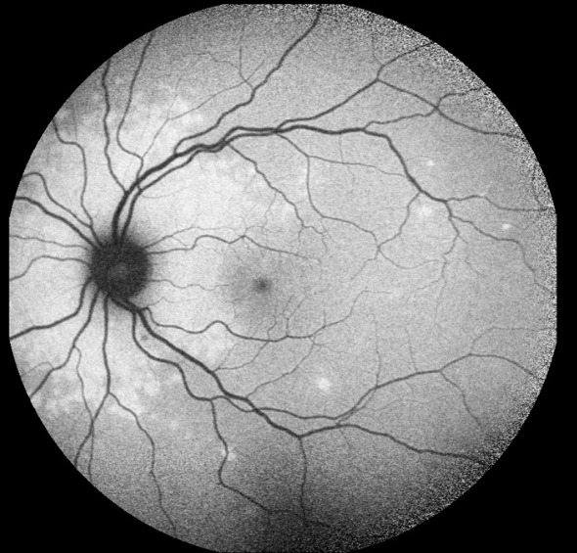
Figure 2. On initial presentation, the left eye demonstrates a ring of circumpapillary hyperautofluorescence and surrounding, scattered smaller foci of hyperautofluorescence on FAF.

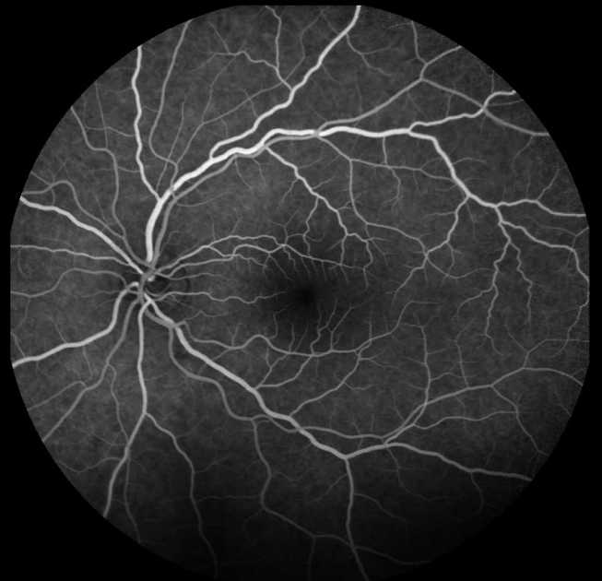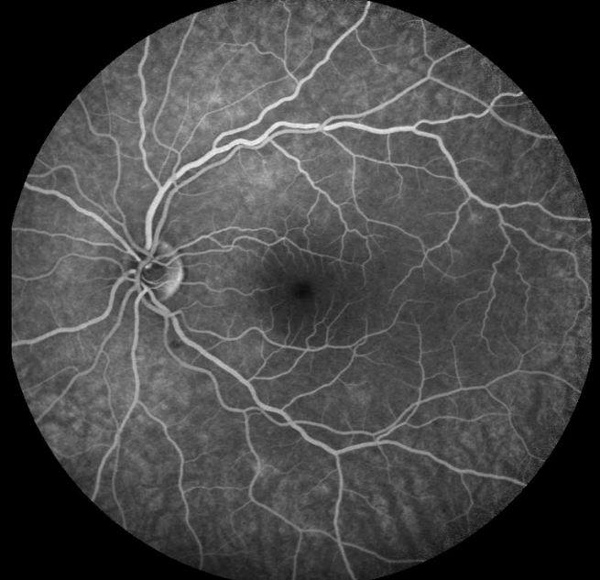
Figure 3. Peak (A) and late (B) phase FA at initial presentation in the left eye demonstrate circumpapillary hyperfluorescence with smaller hyperfluorescent lesions throughout the macula, corresponding to the areas seen on autofluorescence.

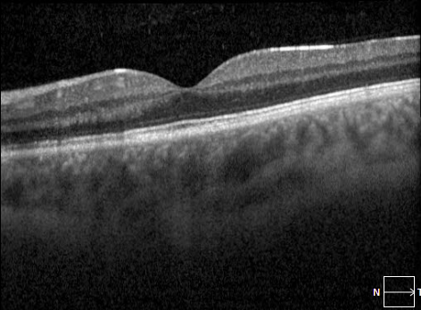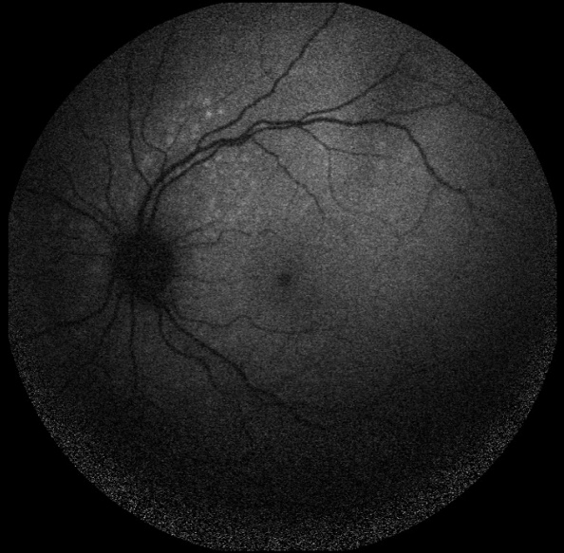
Figure 4. At the 2-month follow-up, the left eye presented with reconstitution and partial recovery of the ellipsoid zone on OCT (A), as well as decreased intensity of hyperautofluorescence on FAF (B).

