Corona virus disease (Covid-19): Drugs treatment and management

Dr. Sanad Alonezi, PhD, PSMMC, KSA

Abstract

Coronavirus pandemic disease (COVID-19) is caused by severe acute respiratory syndrome coronavirus that is accounted as global pandemic health concern. The most commonly COVID-19 symptoms include fever, dry cough, sore throat, and fatigue. Severe illness is more likely in elderly patients and those with certain underlying medical conditions. Treatment of COVID-19 is primarily supportive and the role of antivirals treatments (COVID-19 vaccines) have been approved. There are anti-COVID-19 drugs and vaccine. This review focuses on method of treatment COVID-19 and vaccine. Treatments methodology included antiviral drugs, monoclonal antibodies, symptom control and traditional medicine such as medicinal plant extracts. A COVID-19 vaccine is used to provide protection against variant strain(s) of severe acute respiratory syndrome coronavirus 2 (SARS-CoV-2), the virus that causes coronavirus disease 2019. The combination of nirmatrelvir plus AIDS drug ritonavir is approved by FDA to treat and post-exposure prophylaxis of COVID-19. Nirmatrelvir is a peptidomimetic inhibitor of the SARS-CoV-2 main protease. Ritonavir is a human immunodefciency virus type 1 (HIV-1) protease inhibitor. Mild cases, supportive care includes medication such as paracetamol or Non-steroidal anti-inflammatory drugs (NSAIDs) to relieve symptoms (fever, body aches, and cough), adequate intake of oral fluids and rest. Good personal hygiene and a healthy diet are also recommended. Moreover, traditional medicine such as medicinal plant extracts has been used in many countries for inhibition, and treatment of the COVID-19. Although, suppression of viral proliferation is considered as general mechanism of herbal extracts, however some studies suggested that traditional herbal medicinal products can interact with key viral proteins which are associated with virus virulence and transmission. However, the effectiveness of these traditional medicines remains uncertainly.
Image
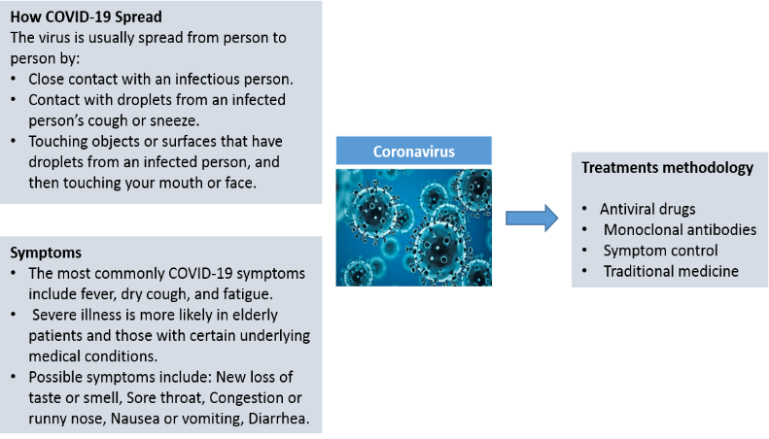
Figure 1: Shows the Symptoms and treatment methodology of COVID-19

Recent Publications
- Yvette N (2022) Nirmatrelvir Plus Ritonavir: First Approval. Drugs 82:585–591.
- Demeke C, Woldeyohanins A, Kifle Z (2021) Herbal medicine use for the management of COVID-19: A review article. Metabolism Open 12:100141.
- Mirzaie A, Halaji M, Dehkordi F, Ranjbar R, Noorbazargan H (2020) A narrative literature review on traditional medicine options for treatment of corona virus disease 2019 (COVID-19). Complementary Therapies in Clinical Practice 40:101214.
- Hassine I (2022) Covid‐19 vaccines and variants of concern: A review. Medical virology 32:e2313.
5. Rogliani P,Chetta A, Cazzola M, Calzetta L (2021) SARS-CoV-2 Neutralizing Antibodies: A Network Meta-Analysis across Vaccines. Vaccines (Basel). 9(3): 227.

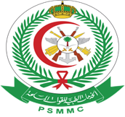

Biography

Dr. Sanad Alonezi received his PhD degree in Pharmaceutical sciences from university of Strathclyde in 2017 (UK). He is currently working as a consultant pharmacist at prince sultan military medical city (PSMMC). He has a strong interest in areas of research involve metabolomics and pharmaceutical analysis.

Email: phd-sanad@hotmail.com

Notes/Comments:
Presenting author details
Full name: Sanad Mohammed Alonezi
Contact number: 00966559007428
Mail id: phd-sanad@hotmail.com
Category: Poster presentation

