Nano chromatography and nano capillary electrophoresis: Need of this century
Prof. & Dr. Imran Ali
Department of Chemistry
Jamia Millia Islamia (Central University), Jamia Nagar, New Delhi - 110025, India.
Phone and WhatsApp: 0091-9211458226

Abstract (300-word limit)
Statement of the Problem:

Despite the remedial properties of the drugs, these remain in our body tissues at very low amounts for a long time; leading to various serious side effects. Similarly, some environmental contaminants exist at very low concentrations in the earth’s ecosystem. The routine analytical instruments are not proficient to detect them due to their high detection limits. Hence, these low amounts of drugs and contaminants are considered absent, which is a deception to scientists and society. The amounts of some hormones, RNAs, DNAs, antibodies, and other proteins are very low. Also, the availability of infant plasma and cerebrospinal fluids is very poor. The genomics and proteomics researches are extremely difficult and need miniaturization of the separation techniques. Besides, the growing economic pressure of expensive chemicals is a big issue globally nowadays. Most importantly low waste (hazardous organic solvents) realizing techniques are needed due to climate issues. Due to these facts, there is a big mandate for micro or nano-scale separations with low detection limits. Therefore, the micro-total-analysis system (µ-TAS) is gaining attention in most laboratories of the world. These are nano-liquid chromatography (NLC) and nano-capillary electrophoresis (NCE) techniques. The proposed lecture will highlight the significance of these techniques with special stress on the fabrication of microchip, instrumentation of NLC and NCE, detection, sample preparation, analyses, and future perspectives.
Keywords: Nano-separations, Nano liquid chromatography, Nano capillary electrophoresis, Future perspectives.

Recent Publications (minimum 5)
- Imran Ali, Syed Dilshad Alamb, Rupak Rajab, Vikas Shirsath, Arvind K. Jain, Kareem Yusufd, Ahmed muteb Aljuwayidd, Mika Sillanpää, (2022) Chiral separation of β-blockers by supercritical fluid chromatography using Chiralpak-IG and Chiralpak IBN 5 columns, Chirality, 34: 848-855.
- Imran Ali, Rupak Raja, Syed Dilshad Alam, Arvind Kumar Jain, Kareem Yusuf, Ahmed muteb Aljuwayid and Mika Sillanpääe (2022) Rapid chiral separation of potential antibiotics using supercritical fluid chromatography, Chirality, 34: 1383-1388.
- Imran Ali, Mohammed El Amin Zaid, Nasser Belboukhari, Khaled Sekkoum, Wahidah H. Al-Qahtani, Abdulnasser Mahmoud Karami, Marcello Locatelli (2022) Chiral HPLC separation and simulation studies of two chiral centered bis-imino flavans (Schiff base), Microchem. J., 178: 107429.
- Imran Ali, Rupak Raja, Syed Dilshad Alam, Vikas Shirsath, Arvind K. Jain, Marcello Locatelli, and Victor David (2021) A comparison of chiral separations by supercritical fluid chromatography and high-performance liquid chromatography, J. Liq. Chromatogr. & Rel. Technol., 44: 550-563.
- Imran Ali, Nadia Boumoua, Khaled Sekkoum, Nasser Belboukhari, Ayman Ghfar, Mohamed Ouladsmane and Bayan Ahmed AlJumah (2021) A comparison of chiral resolution of antifungal agents on different polysaccharide chiral columns under various mobile phase modes: Application in the biological samples, J. Chromatogr. B., 1175: 122738.

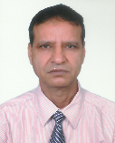Biography (150-word limit)
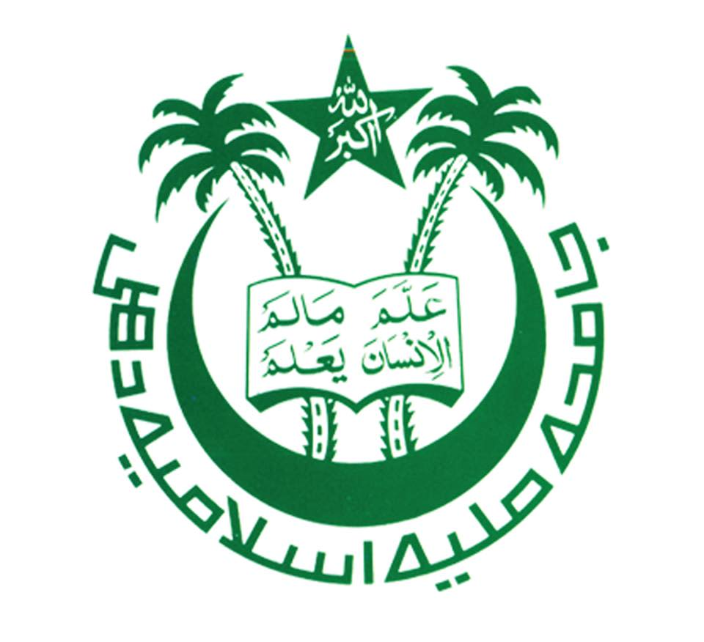
Prof. Imran Ali, Ph.D., FRSC, C Chem, London (UK), Highly Cited Researcher, Clarivate, USA and with 11 Global ranks in Analytical Chemistry (Chromatography), as per the Stanford University, USA (Global list of top 2% scientists); is a world-recognized academician and researcher. He completed his Ph.D. at the Indian Institute of Technology Roorkee, Roorkee, India. Prof. Ali is known globally due to his great contribution to pharmaceutical analysis by chromatography and capillary electrophoresis, the development of anticancer drugs, nanotechnology for water treatment, and water splitting for hydrogen green fuel generation. He has published more than 500 papers in reputed journals including papers in Nature and Chemical Reviews of more than 72 impact factors. He has also written six books published by Marcel Dekker, Inc., USA; Taylor & Francis, USA; John Wiley & Sons, USA; John Wiley & Sons, UK; Elsevier, The Netherlands, and Springer, Germany. His total citation is 35,000 with an h-index of 101 and i10-index of 312. He is a member of various scientific societies globally. He has been co-chair of a conference on the application of graphene, chaired many conference sessions, and delivered several keynote lectures. He is a widely traveled person enjoying various visiting Professor/Consultant positions in many Universities around the world.
Email: imran.drimran.chiral@gmail.com

Notes/Comments:

Presenting author details
Full name: Prof. & Dr. Imran Ali
Contact number: 0091-9211458226
Twitter account: -
Linked In account: https://www.linkedin.com/in/imran-ali-82589117/
Session name/ number: Chip-Based Chromatography Separations
Category: Oral presentation

