Manufacturing of large area solid-state nanopore array
Jufan Zhang, University College Dublin, Ireland
Hongshuai Liu, University College Dublin, Ireland

Abstract
Nanopore brings extraordinary properties for a variety of potential applications in various industrial sectors. Since manufacturing of solid-state nanopore was firstly reported in 2001, solid-state nanopore has become a hot topic in the recent years. An increasing number of manufacturing methods have been reported, with continuously decreased sizes from hundreds of nanometres at the beginning to approximate one nanometre until recently. To enable more robust, sensitive, and reliable devices required by the industry, researchers have started to explore the possible methods to manufacture nanopore array which presents unprecedented challenges on the fabrication efficiency, accuracy and repeatability, applicable materials, and cost. As a result, the exploration of fabrication of nanopore array is still in the fledging period with various bottlenecks. This presentation introduces an efficient and cost-effective manufacturing process chain for fabricating large area solid state nanopore array. The authors successfully fabricated the 20 nm nanopore array in a 15 mm × 15 mm area, with relatively uniform pore shape and size. The experiments also indicated a possible way to reduce the pore size down to 1nm simultaneously modify the geometry of nanopore channel, which would be a breakthrough to facilitate the high-resolution DNA sequencing. Some representative applications of nanopore array include DNA/RNA sequencing, energy conversion and storage, water desalination, nano-sensors, nanoreactors and dialysis.

Image
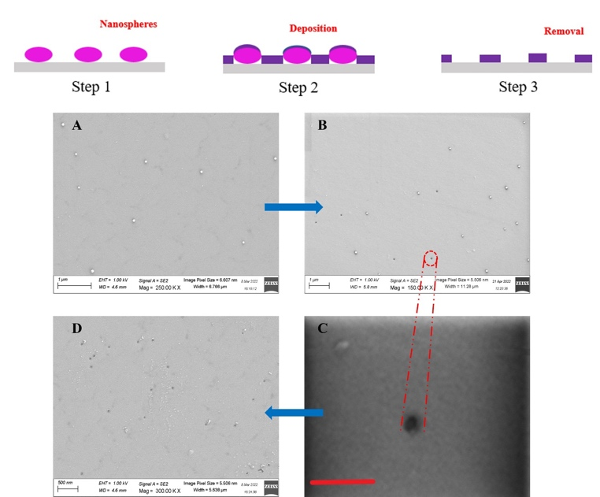

Figure 1. The nanopore array fabricated by the hybrid method. Top: the schematic flow plot of process chain. A. Nanospheres around 20 nm in diameter distribute on the substrate, then with 4nm Pt film deposited; B. SEM images after ultrasound for 5 min; C. SEM images of one nanopore zoom-in (magnified 500 K; scale bar: 300 nm); D. SEM image of nanopores after ultrasound for 15 min. [1]

Recent Publications
Hongshuai Liu, Qin Zhou, Wei Wang, Fengzhou Fang, Jufan Zhang*. Solid-State Nanopore Array: Manufacturing and Applications. Small, 2022, DOI: 10.1002/smll.202205680.
- Yao Zhou, Jufan Zhang*, Fengzhou Fang. Design of a dual-focal geometrical waveguide near-eye see-through display. Optics and Laser Technology, 2022, Volume 156, https://doi.org/10.1016/j.optlastec.2022.108546LiX,
- Gang Shen, Jufan Zhang*, David Culliton, Ruslan Melentieva, Fengzhou Fang. Tribological study on the surface modification of metal-on-polymer bioimplants. Frontiers of Mechanical Engineering, 2022, 17(2): 26. https://doi.org/10.1007/s11465-022-0682-6
- Matthew McCormack, Fengzhou Fang, Jufan Zhang*. Numerical Analysis of Microchannels Designed for Heat Sinks. Nanomanufacturing and Metrology, 2021, 10.1007/s41871-021-00118-2.5.
- Gang Shen, Jufan Zhang*, Chengwei Kang, Fengzhou Fang. Study on surface texture patterns for improving tribological performance of bioimplants. Surface & Coatings Technology, 2021, 422, 127567, https://doi.org/10.1016/j.surfcoat.2021.127567

Biography
Jufan Zhang, Assistant Professor and Lecturer in School of Mechanical and Materials Engineering, Principal Investigator in Centre of Micro/Nano Manufacturing Technology, University College Dublin, Ireland. He leads the research in manufacturing of solid state nanopore array and corresponding biomedical applications by collaborating with academic and industrial partners. He has chaired 10+ research funding, and made 50+ peer-reviewed publications and 7 patents on nanomanufacturing, ultra-precision machining, biomedical devices and optics. He has given over 10 keynote/invited talks in the recent one year on nanomanufacturing and biomedical research. He is the Member of Irish Manufacturing Council, Member of International Academy of Engineering and Technology, Member of International Society for Nanomanufacturing. He is the Chair of Organizing Committee of the 8th International Conference on Nanomanufacturing and the 4th AET Symposium on ACSM and Digital Manufacturing.

