Application of Transthoracic lateral Single-Hole Non-Liposuction Endoscopy to Immediate Prosthetic Breast Reconstruction in Early Breast Cancer
Abstract
​The quest for beauty is never-ending for women with breast cancer, so to ensure a successful treatment of the tumour, traceless surgical incisions are a consideration for surgeons. Endoscopic or robotic minimally invasive surgery may be the perfect solution to this problem, but currently endoscopic surgery is rarely performed in breast surgery for a variety of reasons, such as lack of natural space in the breast, immature technology, and excessive length of operation.The objective of this study was to investigate the efficacy of transthoracic lateral single-hole non-liposuction endoscopy in nipple sparing mastectomy (NSM) with immediate prosthesis breast reconstruction (IPBR). Methodology：The clinicopathologic data of 42 patients with EBC who underwent endoscopic NSM and IPBR in the Department of Breast Surgery of our hospital from February 2020 to July 2022 were collected, and the success rate of surgery, operation time, intraoperative conditions, postoperative complications, aesthetic effect of breast reconstruction and short-term oncology safety were analyzed. Finding: All the 42 patients successfully completed the operation, with a success rate of 100%. 12 patients were completed operation with (210.17±9.87) minutes in the first year after the original procedure began, and 30 patients with (155.36±2.42) minutes after the first year, and there was a difference between the two groups. There were also differences in intraoperative blood loss and postoperative drainage volume between the two groups, but no difference in extubation time. The postoperative complications and the aesthetic effect of breast reconstruction were not different. The 42 patients were average follow-up of 18.8 months. None of the patients had a recurrence or distant metastasis.Conclusions:Transthoracic lateral single-hole non-liposuction endoscopy technique for IBPR of EBC: (1) high success rate of surgery, fewer postoperative complications, good aesthetic effect and high safety of oncology; (2) Skillful practice can shorten the operation time, improve intraoperative conditions and improve surgical efficiency.

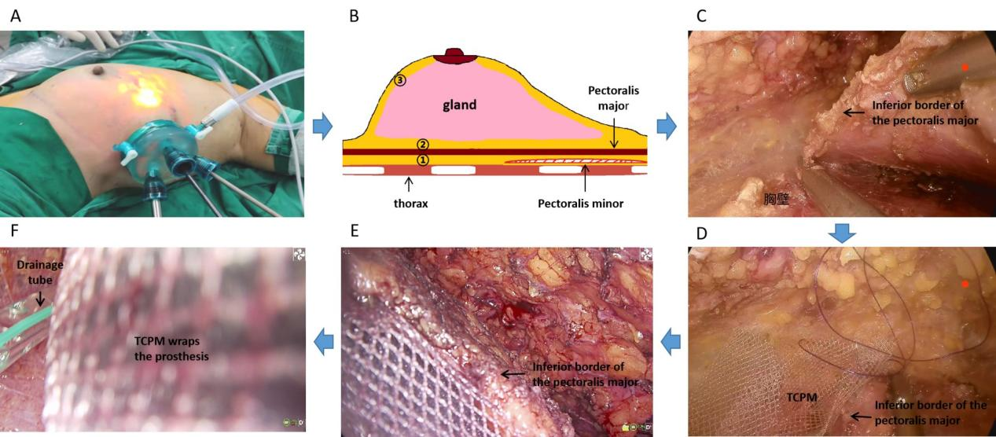
Figure 2. Flow charts of NSM and immediate breast reconstruction (A→F). Figure A shows the patient's position and lateral thoracic single-hole incision with disposable endoscopic dilator for surgery; Figure B: Schematic diagram of the surgical sequence of the NSM "reverse method":①posterior space of the pectoralis major→② posterior space of the breast→③free flap; Figure C: The lower margin of the major pectoralis is surgically severed. Figure D shows the lower margin of pectoralis major and TCPM suture forming a "pouch". Figure E: Here is a "pouch" covering prosthesis of the pectoralis major combined with TCPM. Figure F: TCPM fully wrapped prosthesis with a drainage tube underneath.
Recent Publications
- Feng Y, Wen N, Liang F, (2022) Endoscopic Nipple- or Skin-Sparing Mastectomy and Immediate Breast Reconstruction with Endoscopic Harvesting of the Latissimus Dorsi Flap: A Preliminary Experience of an Innovative Technique. Breast J. 2022:1373899.
- Park HS, Lee J, Lai HW, (2022) Surgical and Oncologic Outcomes of Robotic and Conventional Nipple-Sparing Mastectomy with Immediate Reconstruction: International Multicenter Pooled Data Analysis. Ann Surg Oncol. 29:6646-6657.
[3] Huang Z, Chen K, Zhu L,(2018) [Effectiveness of endoscopic nipple-sparing mastectomy combined with immediate breast reconstruction via axillary incision]. Zhongguo Xiu Fu Chong Jian Wai Ke Za Zhi. 32:1458-1462.
[4] Lai HW, Lin SL, Chen ST, (2018) Single-Axillary-Incision Endoscopic-Assisted Hybrid Technique for Nipple-Sparing Mastectomy: Technique, Preliminary Results, and Patient-Reported Cosmetic Outcome from Preliminary 50 Procedures. Ann Surg Oncol. 25:1340-1349.
[5] Chen Y, Xu J, Liang Y, (2020) A challenging therapeutic method for breast cancer: Non-lipolytic endoscopic axillary surgery through periareolar incisions. Oncol Lett. 19:4088-4092. ​

Biography

Dr. Chengcai Yao is the director and academic leader of the Department of Breast Surgery at the Sixth Affiliated Hospital of South China University of Technology, PRC. He is also a member of the breast disease branch of the Guangdong Medical Association, the breast surgery branch of the Guangdong Medical Association and the breast cancer branch of the Guangdong Anticancer Association. He is also a youthful and middle-aged editorial member of the "Chinese Journal of Breast Diseases (electronic edition)" and the "Chinese Journal of General Surgery". He is primarily engaged in basic and clinical breast cancer research, with a particular focus on minimally invasive laparoscopic surgery for early-stage breast cancer and mechanisms of drug resistance to chemotherapy.​

Email:744875674@qq.com

Presenting author details
Full name: Chengcai Yao
Contact number: (+86) 18188733158
Twitter account:
Linked In account:
Session name/ number: Breast Cancer Surgery
Category: (Oral presentation/ Poster presentation): Poster presentation

