Discovery of new antibacterial mechanisms of influence of magnetite nanoparticles (MCS-B)

Andrey Belousov,
Yulia Voyda, Ekateryna Belousova

Laboratory of Applied Nanotechnology of Belousov, Ukraine

Abstract

The influence of basic physical factors caused by magnetite nanoparticles (constant magnetic field and sorption) on microorganisms by examining the reactions of the intensity of free radical lipid peroxidation (FRLP) and bacteriostatic action was studied. It was well established that the magnetite nanoparticles (MCS-B) caused unequal reaction in intensity of FRLP on different groups of microorganisms. It was determined that the most significant factor that influenced on the ultimate indicator of the intensity of luminescence on candida albicans, escherichia coli and pseudomonas aeruginosa was constant magnetic field which induced by nanoparticles. On the contrary, sorption was the most significant factor on staphylococcus aureus. It was found that the rate of consumption of free radicals lipid reduced reliably on all microorganisms after their processing by magnetite nanoparticles (MCS-B). The results of microbiological studies of escherichia coli, klebsiella pneumoniae and staphylococcus aureus showed that bacteriostatic effect was detected after exposure by magnetite nanoparticles. Visually, it was detected by decreasing the number of colonies on the nutritious medium in comparison with the control (Fig.1). It was revealed an interesting fact that saline NaCl, which had previously been processed by magnetite nanoparticles also significantly had a marked bacteriostatic effect on the studied microorganisms. This effect could be explained by mechanism of change the polarization structure water of microorganisms by magnetite nanoparticles (MCS-B).
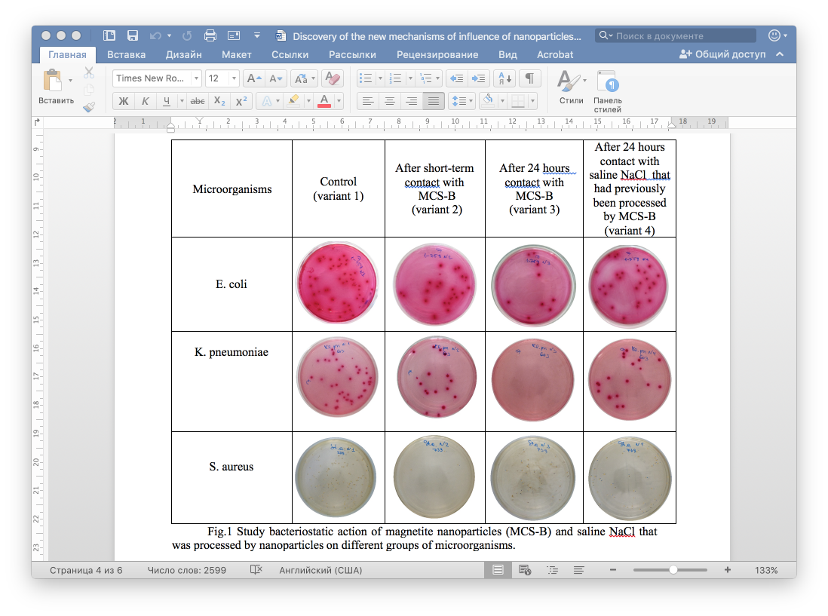

Fig.1 Study bacteriostatic action of magnetite nanoparticles (MCS-B) and saline NaCl that was processed by nanoparticles on different groups of microorganisms.
It was discovered that degree of expression of bacteriostatic action which induced by magnetite nanoparticles had correlation with marks of reactions intensity of FRLP. Maximum bacteriostatic effect on staphylococcus aureus was expressed in second variant application of magnetite nanoparticles where mechanism of sorption was more significant than action of the magnetic field. On the contrary, maximum bacteriostatic effect on escherichia coli and klebsiella pneumoniae was revealed in third variant, where time exposition of contact with microorganisms nanoparticles and, consequently, action of a constant magnetic field was determinative.

Recent Publications:
- Belousov A., Malygon E., Yavorskiy V., Belousova E. Use of nanotechnology to increase the lifetime of blood's donor by stabilizing the molecular structure of the proteins and lipids bonds of membranes of preserved erythrocytes. Clinical Case Reports and Reviews. Open Access Text. London, UK. 2019. V.5. P.1-8. DOI:10.15761/CCRR.1000444. ISSN: 2059-0393
- Belousov A. A New Promising Method of Hepatitis Treatment at the Level of Ultrastructure of the Liver by Standardized Powder form of Magnetite Nanoparticles (Micromage-B). Journal of Pharmacology & Clinical Research 6(1): JPCR.MS.ID. 555676 (2018) Juniper Publishing Group.US. ISSN: 2473-5574. DOI: 10.19080/JPCR.2018.06.555676
- Belousov A. Nanotechnology as a New Direction in the Creation of Antimicrobial Drugs. SAJ Pharmacy and Pharmacology. ScholArena. USA. 2018. V5. Issue 2. ISSN: 2375-2262
- Belousov A. The Role of Magnetite Nanoparticles (ICNB) in Discovery New Factor Which Influence on Permeability of Erythrocytes and Eryptosis. OALib Journal is an all-in-one open access journal (ISSN Print: 2333-9721, ISSN Online: 2333-9705) DOI: 10.4236/oalib.1101055, pp. 1-6.
- Belousov A. Inhibition of Eryptosis by Means of Magnetite Nanoparticles (MCS-B). International Journal of Advance in Medical Science (AMS) Volume 2, 2014. ISSN: 2327-7238. P. 19-23.

Biography

Prof. Andrey Belousov is Doctor of Medicine. Author a new medecine products – nanotechnology preparations based on magnetite nanoparticles (Fe₃O₄) of the size 6-12 nm: the peroral form - Micromage-B (the biologically active additive officially registration in Ukraine); Magnet-controlled sorbent brand of MCS-B for extracorporal detoxication of biological liquids (officially registration in Ukraine and was allowed for medical practice); Nanobiocorrector for intravenous application – ICNB (intracorporal nanosorbent). The published more 240 scientific works on results application of nanotechnology preparation in experimental and practical medicine. A. Belousov - the Head of Laboratory Applied Nanotechnologies of Belousov in Ukraine, DM, Professor of Department Anesthesiology, Intensive Care, Transfusiology and Hematology Kharkov Medical Academy of Postgraduate Education.

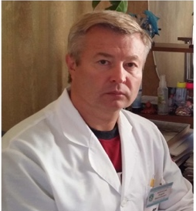
Full Name: Andrey Belousov
Contact number: +380-50-915-18-89
Web site: www.nanolab.com.ua
Linked In account:
https://www.linkedin.com/in/andrey-belousov-8688595a/
ORCID: https:// orcid.org/0000-0003-0770-8274
Category: Video presentation
Date of Birth: 09.07.1965

