WPW syndrome : a mimicker for Ventricular tachycardia

Indrajeet Mahata MD, FACC, FHRS,
University of Missouri, USA

Abstract 289 words:
The accurate diagnosis and initial evaluation of Wide complex tachycardia (WCT) has been a clinical dilemma. The differential diagnosis includes ventricular tachycardia (VT), supraventricular tachycardia (SVT with aberration and SVT with pre-excitation. Identifying the etiology of a WCT is important to provide appropriate therapy.

We are presenting a case of 69-year-old female who presented with cardia arrest. She had a past medical history of morbid obesity, sleep apnea, hypertension, and diabetes. She was found to have wide complex tachycardia, she had resuscitation per ACLS protocol with shock . She was transferred to our hospital for a defibrillator evaluation. Her echo showed left ventricular ejection fraction of 50%, which is low normal but otherwise normal. Coronary angiography revealed non obstructive coronary artery disease.
Her electrocardiography (ecg) showed Sinus rhythm with a short PR and a delta wave(image). Further, review of sentinel event suggested WCT but that there was beat to beat variation. Further the QRS duration varied from beat to beat. These findings suggested Atrial fibrillation with pre-excitation. This was called “Wolf Parkinson white syndrome in the past. She was subsequently taken for a electrophysiology study (EPS). During her EPS she was found to have anterograde conduction from the atrium to the ventricular through a accessory pathway. Meticulous 3D mapping localized the accessory pathway to be in infero-septal region. Radiofrequency ablation was performed at this region to eliminate the accessory pathway. Subsequently she did not develop any wide complex tachycardia.

Conclusion
The differential diagnosis of WCT might be challenging and includes both ventricular and supraventricular tachycardias. The awareness of this ecg finding needs to be spread in practicing physicians. If the initial ecg poses a diagnostic challenge then an EP study should be offered before ICD implantation .
====================================================================================

Image :
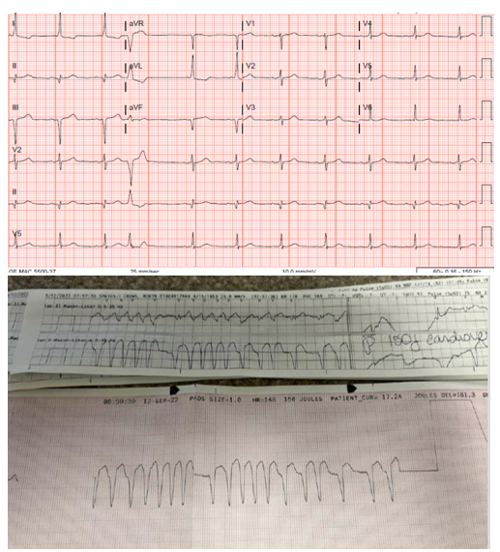

6 publication
- The incidence, risk factors, and chronobiology of acute myocardial infarction ten years after Hurricane Katrina JC Moscona, MN Peters, R Maini, P Katigbak, B Deere, H Gonzales, ... Disaster medicine and public health preparedness 13 (2), 217-222
- Painful left bundle branch block syndrome treated with his bundle pacing JF Viles-Gonzalez, I Mahata, E Anter, A d'Avila Journal of electrocardiology 51 (6), 1019-1022
- Initial Diagnostic Evaluation of Stable Coronary Artery Disease: The Need for a Patient‐Centered Strategy IM Robert C. Hendel, Ahmad Y. Jabbar Journal of the American Heart Association 6 (7)
- Cardiovascular outcome studies with glucagon-like peptide 1 receptor agonists—what will REWIND add? KC Ferdinand, I Mahata Annals of Translational Medicine 5 (23)
- Prognostic implications of diastolic dysfunction in patients with acute pulmonary embolism JH Cho, R Kaw, J Chhabra, S Kola, I Mahata, S Shahani, AG Kocheril BMC Research Notes 7 (1), 1-5
- Direct His bundle pacing using retrograde mapping in complete heart block and L-transposition of the great arteries I Mahata, SL Macicek, DP Morin HeartRhythm Case Reports 5 (6), 291-293

Biography of presenting author
Dr Indrajeet Mahata is a Assistant Professor at University of Missoui , MO, USA. He has been in academics for the last 15 years. He completed his Medicine residency at University of Illinois , he completed a fellowship in cardiology at Tulane University and then went on to pursue a fellowship in Electrophysiology in Ochsner medical Centre/University of Queensland. He has been teaching students since . he is a full member of Sigma XI. Also he holds a FACC and FHRS certification. He is passionate about SVT and atrial fibrillaton and the diagnosis and treatment of the same.

Details of presenting author to be mentioned in certificate:
Name: Indrajeet Mahata
Affiliation: University of Missouri
Country: USA

Other Details:
Presentation Category: Poster
Session Name: clinical vignette
Email: Imahata87@gmail.com
Alternative Email:doctormahata@yahoo.com
Contact Number:5043018571
Whatsapp Number: 5043018571
Twitter: Indrajeet.Mahata@

Recent Photograph: (High Resolution)



