Related factors of bleeding events in ticagrelor-treated elderly patients with coronary artery disease
Shizhao Zhang, MD, Medical School of Chinese PLA, Chinese PLA key institute for Geriatrics, The Second Medical Center & National Clinical Research Center for Geriatric Diseases, Chinese PLA General Hospital, China
Tong Yin, MD PhD, Medical School of Chinese PLA, Chinese PLA key institute for Geriatrics, The Second Medical Center & National Clinical Research Center for Geriatric Diseases, Chinese PLA General Hospital, China

Abstract

Objective: To analyze the related factors of bleeding events in ticagrelor-treated elderly patients with coronary artery disease.

Method: Patients aged ≥65 years diagnosed with coronary artery disease and treated with ticagrelor were enrolled. All patients were followed up to observe the occurrence of Bleeding Academic Research Consortium (BARC) ≥ 2 requiring clinical intervention within 1 year. Patients were divided into bleeding group (n=55) and bleeding-free group (n=328) according to the occurrence of BARC≥ 2 bleeding events. Multivariate regression analysis was applied to analyze the related factors of bleeding events during ticagrelor treatment.

Results: A total of 383 patients with coronary artery disease were recruited in this study, with 39 cases (10.18%) diagnosed with stable coronary artery disease, 344 cases (89.82%) diagnosed with the acute coronary syndrome, and 37 cases (9.66%) received PCI. The serum level of hemoglobin and ratio of used β-blockers and calcium ion channel blocking agents were significantly lower while the platelet count, incidence of type 2 diabetes and ratio of used proton pump inhibitors were significantly higher in bleeding group than in bleeding free group. Among the eligible patients, 55 (14.36%) had BARC≥2 bleeding events, and 10 patients (2.61%) had BARC ≥3 bleeding events during a 1-year follow-up. Gastrointestinal bleeding was the most common bleeding event (47.27%, n=26). Multivariate regression analysis found that decreased hemoglobin content (OR:0.98, 95% CI :0.96-1.00, P=0.02), type 2 diabetes (OR: 2.46, 95% CI: 1.29-4.69, P=0.01), application of proton pump inhibitors (OR: 4.53, 95% CI: 1.62-12.72, P<0.01) and application of β-blockers (OR: 0.42, 95% CI: 0.20-0.89, P=0.02) were independently associated with BARC ≥2 bleeding events.

Conclusions: Hemoglobin, diabetes, and concomitant medications are associated with the bleeding events in ticagrelor-treated elderly patients with coronary artery disease.

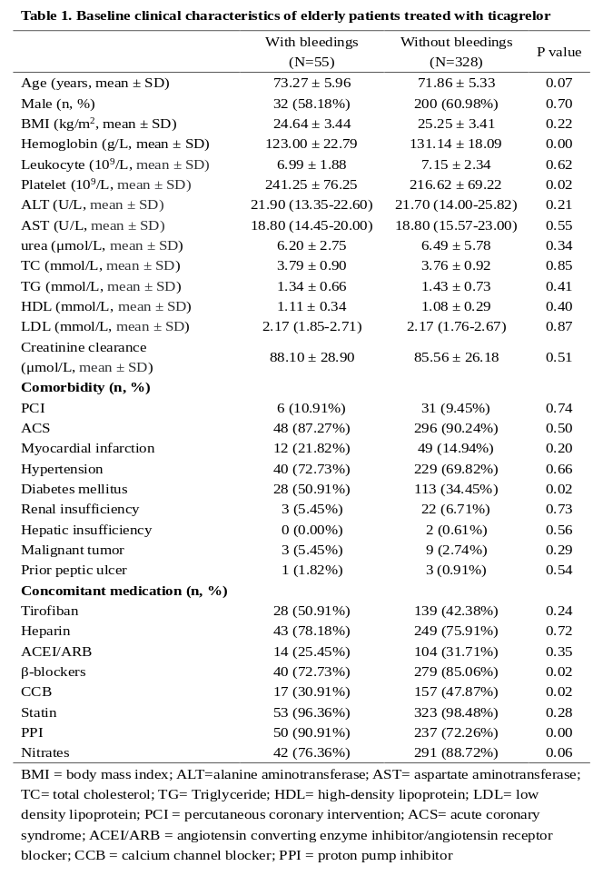
Image
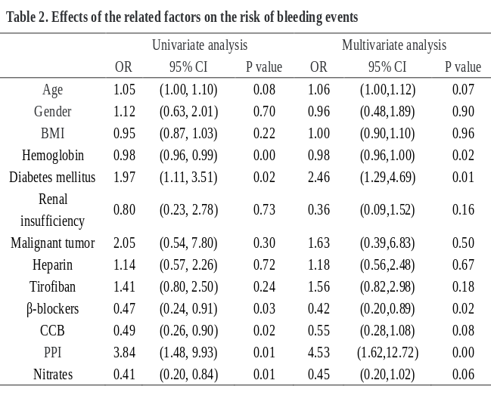
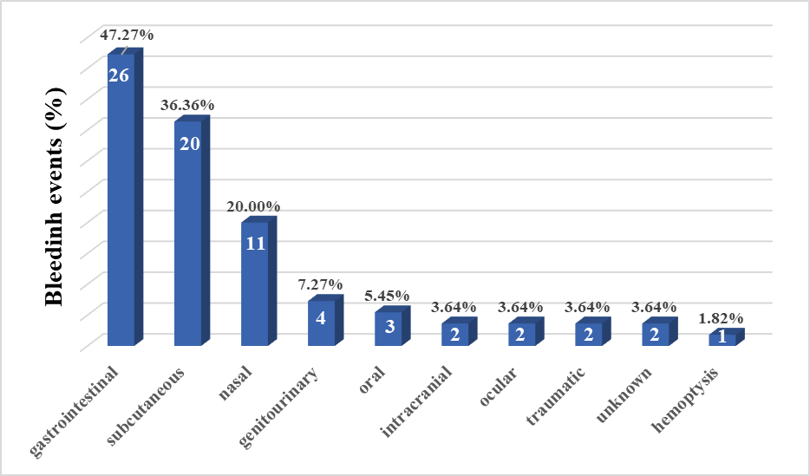
Figure 1. Site of bleeding with Bleeding Academic Research Consortium (BARC) ≥ 2 bleeding events

Recent Publications
- Zhang X, Wu Y, Lv C, Zhang S, Liu H, Wang Y, Zou Y, Qin L, Zhang J, Yin T (2022) Efficacy and safety of oral anticoagulants in elderly patients with stable coronary artery disease and atrial fibrillation. Thromb J. 2022 Oct 31;20(1):66.
- Wu Y, Liu H, Qin L, Wang Y, Zhang S, Wang Z, Zou Y, Yin T (2022) Efficacy and Safety of Antithrombotic Therapy with Oral Anticoagulants in Real-World Elderly Patients with Acute Coronary Syndrome and Atrial Fibrillation. Front Cardiovasc Med. 2022 Jun 29;9:923684.
- Zou Y, Wang Y, Wu Y, Zhang S, Liu H, Yin T (2022) Prediction of residual ischemic risk in ticagrelor-treated patients with acute coronary syndrome. Thromb J. 2022 Apr 21;20(1):21.
- Jin Y, Ma J, Wang Z, Zou Y, Wang G, Wu Y, Wang Y, Liu H, Yin T, Ye P (2022) Performance of the ABCD-GENE Score for Predicting Clinical Outcomes in Clopidogrel-Treated Patients with ACS. J Cardiovasc Transl Res. 2022 Apr 18.
- Wu Y, Wang G, Dong L, Qin L, Li J, Yan H, Guo W, Feng X, Zou Y, Wang Z, Du R, Zhang Y, Ma J, Yin T (2021) Assessment of the CHA2DS2-VASc Score for the Prediction of Death in Elderly Patients With Coronary Artery Disease and Atrial Fibrillation. Front Cardiovasc Med. 2021 Dec 24;8:805234.



Biography
Shizhao Zhang has his expertise in evaluation and passion in investigating precision medicine for elderly patients diagnosed with coronary artery disease. He has formulated individualized polypharmacy for elderly patients based on the effect of gene mutations, so as to prevent potential drug–drug–gene interactions and improve the clinical outcomes.
Email:zhangshizhao1997@163.com

Notes/Comments:

Presenting author details
Full name: Shizhao Zhang
Contact number: 86+13180587397
Twitter account:
Linked In account:
Session name/ number:
Category: Poster presentation

