Efficacy of β blockers on clinical outcomes in real-world patients with essential hypertension and coronary artery disease
Liu Haiping, MM, Medical School of Chinese PLA, Chinese PLA General Hospital, Institute of Geriatrics, The Second Medical Center and National Clinical Research Center for Geriatric Diseases, China
Yin Tong, PhD, Medical School of Chinese PLA, Chinese PLA General Hospital, Institute of Geriatrics, The Second Medical Center and National Clinical Research Center for Geriatric Diseases, China

Abstract (300 word limit)
To investigate the efficacy of β-blocker therapy on the clinical outcomes of patients with essential hypertension combined with coronary artery disease (CAD) in the real world. Patients who diagnosed with essential hypertension and CAD during hospitalization from December 2015 to February 2017 were recruited consecutively. All patients were followed up for 5 years, and major adverse cardiovascular events (MACE, defined as s a composite of all-cause mortality, non-fatal stroke, non-fatal myocardial infarction or heart failure) and blood pressure [uncontrolled blood pressure: systolic blood pressure ≥140mmHg and/or diastolic blood pressure ≥90mmHg] were observed. A total of 615 patients were enrolled, including 418 males and 197 females, aged 37~92 (64.14±10.32) years, of whom 441 patients (71.71%) were received β-blocker therapy throughout the 5 years follow up period. Compared to non-β-blocker treated patients, the β-blocker treated patients were younger, with higher rates of myocardial infarction history and medication of nitrates and statins, lower rates of chronic bronchitis and renal insufficiency. There were no significant differences in sex category, smoking history, diuretics, angiotensin converting enzyme inhibitors, angiotensin receptor antagonists, and calcium channel blockers between β-blocker treated patients and untreated patients. Multivariate logistic regression analysis found that use of β-blocker can reduce the risk of 5-year MACE in patients with hypertension and CAD (9.75% vs. 20.11%, P=0.019). The blood pressure uncontrolled rate is significantly reduced in β-blocker treated patients (45.13% vs 48.85%, P=0.044). Age subgroup analyses showed a significant reduction of the risk of MACE in patients ≥ 65 years with β-blocker therapy (11.43% vs 28.72%, P=0.014), while the benefit of β-blockers on systolic blood pressure control was observed only in patients < 65 years (29.70% vs 33.75%, P=0.034). β-blockers could reduce the risk of MACE and blood pressure uncontrolled rate in patients with essential hypertension and CAD, and the benefits are affected by age.

Image
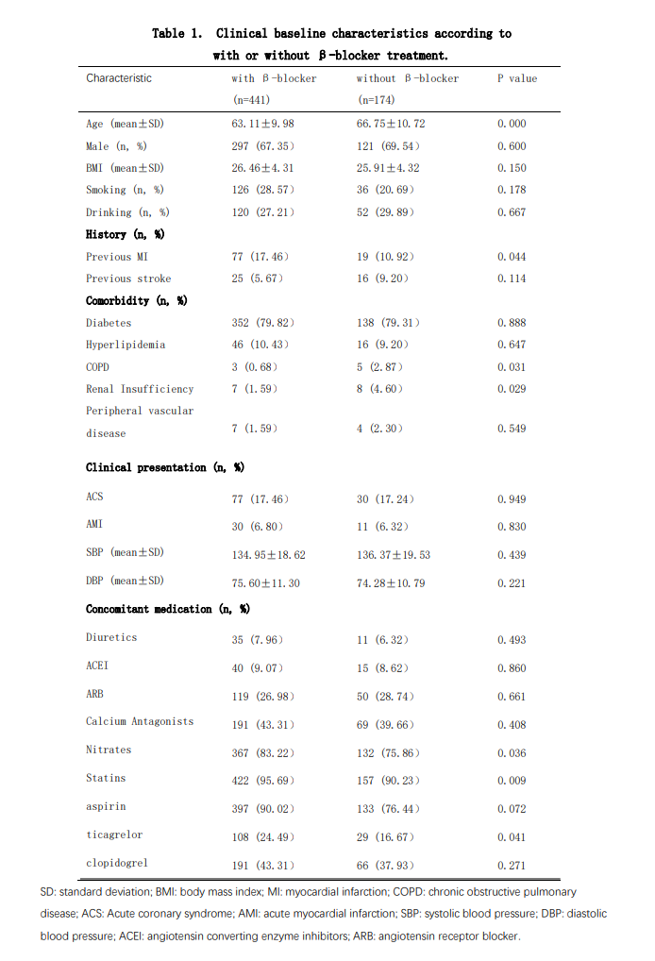
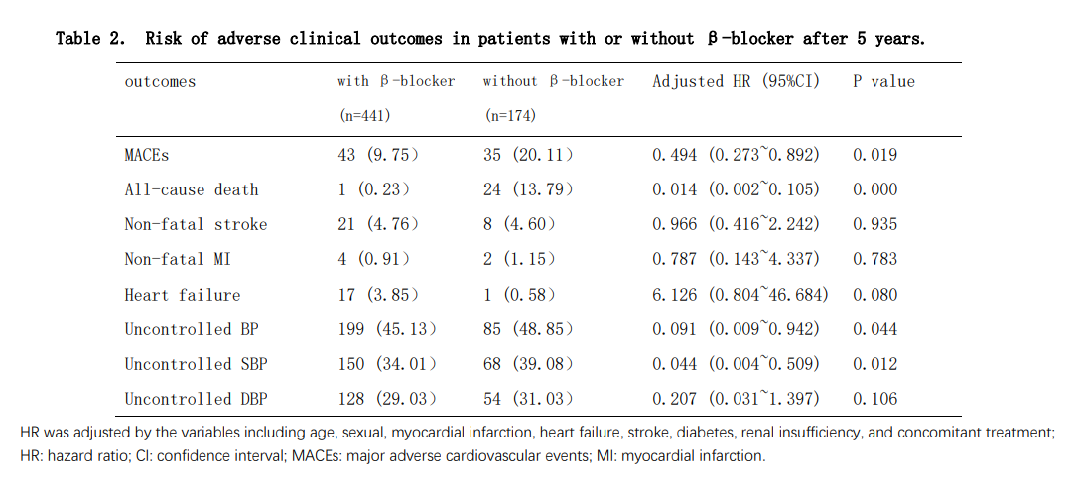
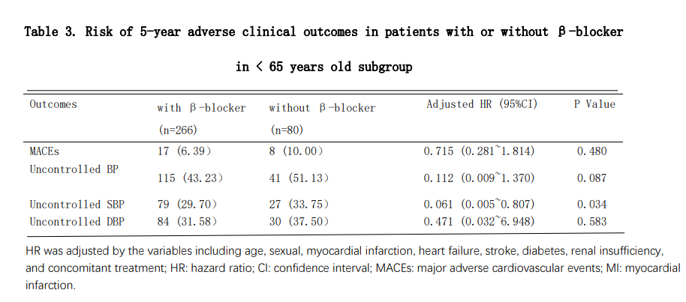
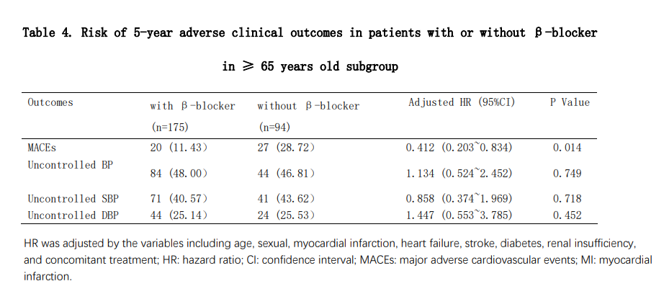
Recent Publications (minimum 5)
- WU Y, LIU H, QIN L, et al (2022) Efficacy and Safety of Antithrombotic Therapy With Oral Anticoagulants in Real-World Elderly Patients With Acute Coronary Syndrome and Atrial Fibrillation. Frontiers in cardiovascular medicine 9: 923684.
- ZHANG S, WANG Z, WU Y, ZOU Y, WANG Y, LIU H, JIA J , YIN T (2022) Bleeding events-related factors in elderly CHD patients receiving ticagrelor treatment. Chinese journal of geriatric heart brain and vessel diseases 24(06):583-586
- WANG Z, ZOU Y, DU R, WU Y, WANG G, LIU H, WANG Y, WANG X, YIN T (2021) De-escalation of antiplatelet therapy in patients with acute coronary syndrome or undergoing percutaneous coronary intervention: a real world clinical outcomes analysis. Chinese Journal of Multiple Organ Diseases in the Elderly 20(12):946-951.
- JIN Y, MA J, WANG Z, ZOU Y, WANG G, WU Y, WANG Y, LIU H, YIN T, YE P (2022) Performance of the ABCD-GENE Score for Predicting Clinical Outcomes in Clopidogrel-Treated Patients with ACS. J Cardiovasc Transl Res 10255-8
- ZOU Y, WANG Y, WU Y, WU Y, ZHANG S, LIU H, YIN T (2022). Prediction of residual ischemic risk in ticagrelor-treated patients with acute coronary syndrome. Thrombosis journal 20(1): 21.
6. ZHANG X, WU Y, LV C, ZHANG S, LIU H, WANG Y, ZOU Y, QIN L , ZHANG J , YIN T (2022). Efficacy and safety of oral anticoagulants in elderly patients with stable coronary artery disease and atrial fibrillation [J]. Thrombosis journal 20(1): 66.

Biography (150 word limit)

Liu Haiping has her expertise in evaluation and passion in investigating precision medicine for patients diagnosed with hypertension. Her open and contextual evaluation model based on the effects of gene mutations on the efficacy and adverse reactions of antihypertensive drugs. She has formulated individualized antihypertensive drug regimen for patients, so as to improve the blood pressure compliance rate and reduce the risk of cardiovascular adverse events.
Email: 18845751147@163.com

Notes/Comments:

Presenting author details
Full name: Liu Haiping
Contact number:18845751147
Twitter account: non
Linked In account:
Session name/ number:
Category: Poster presentation

