Cost-effectiveness of human papillomavirus vaccines for preadolescent girls in Mozambique: a static cohort model

Esperança Lourenço Guimarães, MSc - Instituto Nacional de Saúde, Mozambique.
Assucênio Chissaque, BSc - Instituto Nacional de Saúde, Mozambique.
Clint Pecenka, PhD – PATH, Seattle, United States of America
Frédéric Debellut, MSc - PATH, Geneva, Switzerland.
Basília Vaz, MSc - Ministry of Health, Mozambique.
Arlindo Banze, MD - Ministry of Health, Mozambique.
Ricardina Rangeiro, MD – Maputo Central Hospital – Mozambique.
Arlete Mariano, MD - Maputo Central Hospital – Mozambique.
Cesaltina Lorenzoni, PhD, Maputo Central Hospital – Mozambique.
Carla Carrilho, PhD, Department of Pathology, Eduardo Mondlane University – Mozambique.
Maria do Rosário Oliveira Martins, PhD - Global Health and Tropical Medicine, Instituto de Higiene e Medicina Tropical, Universidade Nova de Lisboa, Portugal.
Nilsa de Deus, PhD – Instituto Nacional de Saúde, Mozambique.
Andrew Clark, PhD Department of Health Services Research and Policy, London School of Hygiene & Tropical Medicine, United Kingdom.

Statement of the Problem: Mozambique has one of the highest rates of cervical cancer in the world. Human papillomavirus vaccination was introduced for pre-adolescent girls in November 2021. This study evaluated the health and economic impact of the current HPV vaccine (GARDASIL-4) and two other vaccines (CECOLIN and CERVARIX) that could be used in the future. Methodology & Theoretical Orientation: A proportionate outcomes static cohort model was used to estimate the lifetime costs and benefits of vaccination with CECOLIN, CERVARIX and GARDASIL-4 in 10 cohorts of girls aged 9 years (2022-2031) and 5 cohorts of girls aged 10-14 years in the year 2022. The primary outcome measure was the incremental cost per disability-adjusted life-year (DALY) averted from a government perspective. Each vaccine was compared to no vaccination and to each other. We assessed uncertainty through deterministic and probabilistic sensitivity analyses. Findings: Without cross-protection all three vaccines had similar health benefits (48% reduction in cervical cancer cases and deaths). With cross-protection CERVARIX could have substantially more health benefits than the other two products (62% versus 48% reduction). Without Gavi donor support, discounted vaccine program costs were $43m for CECOLIN, $61m for GARDASIL-4 and $69m for CERVARIX. With Gavi donor support all vaccines had similar discounted vaccine program costs (US$ 27 million). In scenarios without cross-protection CECOLIN was dominant; CECOLIN was cost saving with Gavi support and still very cost-effective without Gavi support. In scenarios with cross-protection and Gavi support CERVARIX was dominant and cost-saving. With cross-protection and no Gavi support, CECOLIN had the most favorable cost-effectiveness. Conclusion & Significance: At a threshold of US175 (35% of the national GDP per capita), HPV vaccination is cost-effective for preadolescent girls in Mozambique. The optimal choice of vaccine depends on influential cross-protection assumptions. CERVARIX is worth consideration, particularly while its cost is heavily subsidized by Gavi.

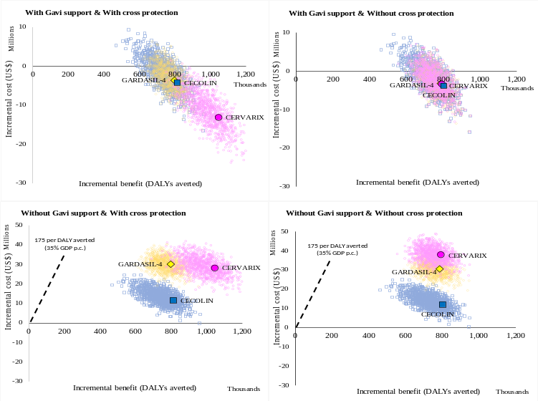
Figure 1. Cost-effectiveness plane showing the incremental costs and benefits of vaccination with CECOLIN, CERVARIX and GARDASIL, considering Gavi support, cross protection and no cross protection, compared to no vaccination.
Recent Publications (minimum 5)
Guimarães EL., Chissaque A. et al. Cost-effectiveness of rotavirus vaccination in Mozambique. Vaccine. 2022 Aug 3;S0264-410X(22)00940-9. Doi: 10.1016/j.vaccine.2022.07.044.
Chissaque A., Burke R., Guimarães E.L. Effectiveness of Monovalent Rotavirus Vaccine in Mozambique, a Country with a High Burden of Chronic Malnutrition. Vaccines (Basel). 2022 Mar 15;10(3):449. Doi: 10.3390/vaccines10030449.
Chissaque A; Bauhofer A, Cossa-Moiane I… Guimarães, E. L. Rotavirus A infection in pre- and post-vaccine period: Risk factors, genotypes distribution by vaccination status and age of children in Nampula Province, Northern Mozambique (2015-2019). PLoS One, 2021 Aug 6;16(8):e0255720. doi: 10.1371/journal.pone.0255720. eCollection 2021.
Cossa-Moiane I, Cossa H, Bauhofer AFL, Chilaúle J, Guimarães EL. High Frequency of Cryptosporidium hominis Infecting Infants Points to A Potential Anthroponotic Transmission in Maputo, Mozambique. Pathogens. 2021 Mar 4;10(3):293. doi: 10.3390/pathogens10030293.
Bauhofer AFL, Cossa-Moiane ILC, Marques SDA, Guimarães EL.. …de Deus N. Intestinal protozoa in hospitalized under five children with diarrhoea in Nampula – a cross-sectional analysis in a low-income setting in northern Mozambique. BMC Infect Dis. 2021 Feb 23;21(1):201. doi:10.1186/s12879-021-05881-7.

Biography (150 word limit)

Esperança is Veterinarian by training, Master in Animal Science (focus in Epidemiology) and PhD candidate in Tropical Diseases and Global Health by . Works at National Institute of Health (INS) as Project Assistant of a capacity building project, Researcher in the fields of Enteric Infections, Immunization and Health Economics and as member of the Institutional Review Board.

Email: espeguima@hotmail.com

Presenting author details
Full name: Esperança Lourenço Alberto Mabandane Guimarães
Contact number: +258 841189815
Session name/ number: Health Economics Modelling/ 10
Category: (Oral presentation)

