Diclofenac Potassium-Induced Anaphylaxis with an Allergic Acute Coronary Syndrome and Premature Ventricular Contractions; Outpatient Clinic Management-A Case Report

Yasser Mohammed Hassanain Elsayed
PGDip Cardiology (Middlesex University, RILA)
Researcher, Critical Care Physician, and Cardiologist, Egyptian Ministry of Health (MOH), Egypt

Abstract
Rationale: Drug-induced disease is a common clinical entity. Drug-inducing anaphylaxis is a serious adverse effect. Several cases of allergic acute coronary syndrome or Kounis syndrome were reported. Premature ventricular contractions are the most frequent cardiac arrhythmia with or without structural heart diseases. A premature ventricular contraction is a sign of decreased oxygenation to the myocardium and anxiety but is also found in a healthy heart. Patient concerns: A middle-aged married male patient presented to the physician outpatient clinic with syncope within one hour after ingested one tablet of diclofenac potassium (50mg). Diagnosis: Diclofenac potassium-induced anaphylaxis and Kounis type I syndrome with premature ventricular contractions Interventions: Electrocardiography, oxygenation, monitoring for vital signs, and echocardiography. Outcomes: The dramatic disappearance of anaphylactic shock, Kounis type I syndrome, coronary artery spasm, and premature ventricular contractions after the traditional treatment of anaphylaxis had happened. Complete clinical and electrocardiographic recovery had achieved. Lessons: The identification of drug-induced disease is a pivotal step in the diagnosis decision making of any medical problems. Diclofenac potassium can induce anaphylactic shock, Kounis type I syndrome, coronary artery spasm, and premature ventricular contractions. Kounis type I syndrome, coronary artery spasm, and premature ventricular contractions can be reversed with treatment of the cause without using anti-ischemic or ant-arrhythmic measures. Reassurance was the recommended regards diclofenac potassium-induced both coronary artery spasm and premature ventricular contractions that accompanied by anaphylaxis.

Keywords; Diclofenac potassium, Drug-induced, Anaphylaxis, allergic angina, Kounis-Zavras syndrome, Premature ventricular contractions
Image
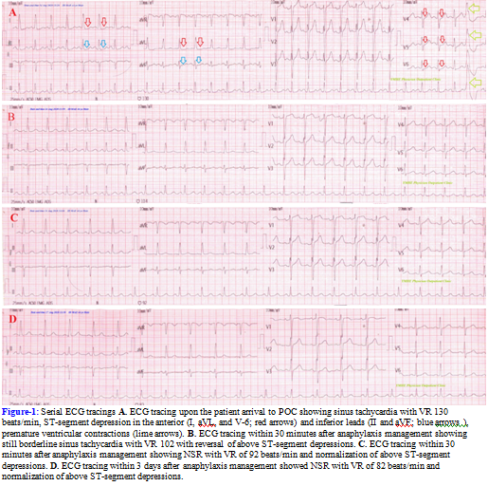
Recent Publications
1. Memon S, Chhabra L, Masrur S, Parker MW. Allergic acute coronary syndrome (Kounis syndrome). Proc (Bayl Univ Med Cent). 2015;28(3):358-62.
2. Rodrigues MC, Coelho D, Granja C. Drugs that may provoke Kounis syndrome. Braz J Anesthesiol. 2013;63(5):426–428.
3. Elsayed YMH. Anti-shock Measures relieved Bee-Sting Anaphylaxis- Induced Kounis Type I Syndrome: A case Report. BJSTR. 2019;MS.ID.003819..
4. Winkens RAG, Höppener PF, Kragten JA, Verburg MP, Crebolder HFJM. Are premature ventricular contractions always harmless?, The European Journal of General Practice. 2014;20(2):134-138.
5. Jazra1C, Wazni O, Jaroudi W. Are premature ventricular contractions in patients without apparent structural heart disease really safe?. ICFJ. 2015;2:32-36.
6. Kanwar G, Kumar N, Dewangan K. A review: Detection of Premature Ventricular Contraction Beat of ECG. IJAREEIE. 2015;4(2):939-424. 7. Elsayed YMH. Premature Ventricular Contractions from Benign to Seriousness - A Narrative Updating Review. Archives of Emergency Medicine and Intensive Care 2019;2;2:1-21.


Biography
Dr. Yasser Mohammed Hassanain Elsayed is a Critical care physician, cardiologist, and researcher (Egyptian Ministry of Health). He obtained MBBch (Al-Azher University) and a PGDip Cardiology (Middlesex University). The researcher has (112) articles and (4) medical books. He has (9) innovative issues; (3) innovative "Signs", (4) "Phenomena", (1) "Modification", and (1) " Maneuver". He has peer-reviewed (145). He was a Speaker at (16) International Conferences. He is an instructor; (6) lectures. He is an editorial member (about 152 medical journals). He was honored for research by several institutes. Research Interest: Critical Care, Emergency, Cardiology, Internal Medicine, Pharmacology, and Toxicology.

Mobile number: 00201141292365 (also, WhatsApp) -00201021297353
Email: dryaser24@yahoo.com
yhasanen1@gmail.com

Details of presenting author to be mentioned in certificate:
Name: Dr. Yasser Mohammed Hassanain Elsayed
Affiliation: Egyptian Ministry of Health (MOH).
Country: Egypt
Funding: There is no funding or financial institutional support.
Other Details:
Presentation Category: Oral.
Session Name: Cardiology Case Reports
Email: dryaser24@yahoo.com
Alternative Email: yhasanen1@gmail.com
Contact Number: 00201141292365 (also, WhatsApp) -00201021297353
Whatsapp Number: 00201141292365
Twitter account: Yhasanen Ymhe (@YYmhe) / Twitter
LinkedIn: linkedin.com/in/yasser-mohammed-hassanain-elsayed-b81a8420b
Suggestion of speakers to be invited: Dr. Salwa Samir Anter is a suggested speaker for your 38th World Cardiology Conference, March 27-28, 2023, London, UK (Contact details; Gmail; salwaantermd@gmail.com, mobile number and Whats ap; 00201067324010).

