Socioeconomic Vulnerabilities of Urban Water Pollution: A case study of Bariga, Lagos
By
Titilola Bright-Oridami¹, Franca Attoh¹, James Akanmu¹ and Ezechiel Longe¹
¹ Civil & Environmental Engineering Department, University of Lagos
²Department of Sociology, University of Lagos
Corresponding author: jakanmu@unilag.edu.ng
: fattoh@unilag.edu.ng
Abstract
Lagos, the fastest growing city in Africa is currently facing a water management crisis which has affected the poor urban communities in the state. Due to poor planning, lack of adequate infrastructure, insufficient funds, and a poor governance and regulatory framework, the scarcity of water and impact of pollution on available water bodies in the state is a major problem as only 10% of the population in Lagos is being served by the public water utility, Lagos Water Corporation. The rest of the population gain access to water either from private boreholes or from informal private sector participants such as water vendors.
Citizens experience water shortages, water pollution, inadequate sanitation and wastewater treatment, and water injustice and inequality. This situation is further worsened by certain factors such as rapid population growth, unreliable electricity, inadequate enforcement, and water pipe leakages which exacerbates the situation. Using data generated from respondents through in-depth interviews (IDI) in Bariga community, the paper draws a nexus between water pollution and social economic challenges on the vulnerable category in Bariga, Lagos, Nigeria. The paper concludes that sustainability could only be achieved through the deployment of the adaptive systemic approach (ASA) as a tool to make community members critical stakeholders in the provision and sustainability of a natural resource.

Introduction
Clean and safe drinking water is vital for human health and can reduce the burden of common illnesses, such as diarrhoea, especially in young children. Unfortunately, in 2010, it was estimated that 1.8 billion people globally access unsafe water (Hutton, 2016). Polluted water can stall economic growth, reduce productivity, exerbate poverty and worsening health conditions of any community. Lagos is littoral to the Atlantic Ocean and its topography consists of lying coastal beaches, extensive inland lagoons, marshes, creeks, and mangrove wetlands at elevations of 0 to 2 meters, and upland areas with moderately drained soils and an elevation range of 2 to 50 meters above sea level (Fasona,2005).
Lagos is also blessed with abundant groundwater from the Coastal Plain Sands Aquifer that gets amply recharged as it experiences an average annual rainfall of about 2 meters. With the rapid population growth rate of Lagos, the Lagos Water Cooperation has not been able to meet the growing demand for water.
As with many fast-growing cities, the influx of so many people into Lagos and the proliferation of slums have put a strain on the government’s ability to provide basic services. Traditionally, the provision of water supply in the state is regarded as a responsibility of the government, through the Lagos State Water Corporation. However, the Lagos State Water Corporation has performed below expectation in this regard. Increasing population has put a strain on providing and sharing of available resources, especially water, leading to a situation where too many people place too much demand on too few resources. The provision of adequate supplies of water to the growing number of urban residents in Lagos, especially the urban poor, is one of the biggest challenges facing the government and local authorities. In addition, the rapid population growth rate hampers the quality of water bodies in Lagos, due to large generation of wastewater and sewage and more instances of waste dumping and open defecation.
Water pollution is defined as the contamination of streams, lakes, seas, underground water, or oceans by substances, which are harmful for living beings. If the concentration of substances naturally present in water increases then also the water is said to be polluted.
This paper therefore examines the socioeconomic vulnerability of urban water pollution on the inhabitants of Bariga community in Lagos state, Nigeria. (a) It investigates the impact of water pollution on the vulnerable class especially women and children and (b) the resultant health and socioeconomic constraints from the search for clean water for domestic use. The data used for the paper were generated by interviewing fifteen (15) respondents living in the Bariga community using the indepth interview method (IDI). The data generated are embedded in the body of the paper to provide clarity.
Sources of water in urban areas (multiple perspectives on water sources in urban area)
The common sources of water that are available to local communities in Nigeria are fast being depleted by several anthropogenic factors, of which pollution remains the most dominant problem. In urban areas, there exists multiple sources of water for inhabitants to get their water for daily use. Among these sources are rivers, lakes, wells, streams, boreholes or even reserved fresh water in homes and industries. According to a 28-year-old woman in Bariga “hmmm, we have borehole and the river. Some people use the river water for washing (Basically, laundry), While the borehole is for drinking, cooking. These various sources help to provide water for urban residents in different urban centers. In Lagos state, the state is blessed with various water bodies all over the state and this is supposed to be a major source of water for the residents of the state. Various communities or areas within the state have different sources of water the major of which is borehole and government supplied water which is barely available. Some residents of the state also utilize rainwater as their main source of water as this is only available during the raining season. Some communities within the state still make use of shallow well water for their daily use. Ultimately, different communities within the Lagos metropolis have multiple sources of water for their daily use.
Pix 1: One of streets in Bariga
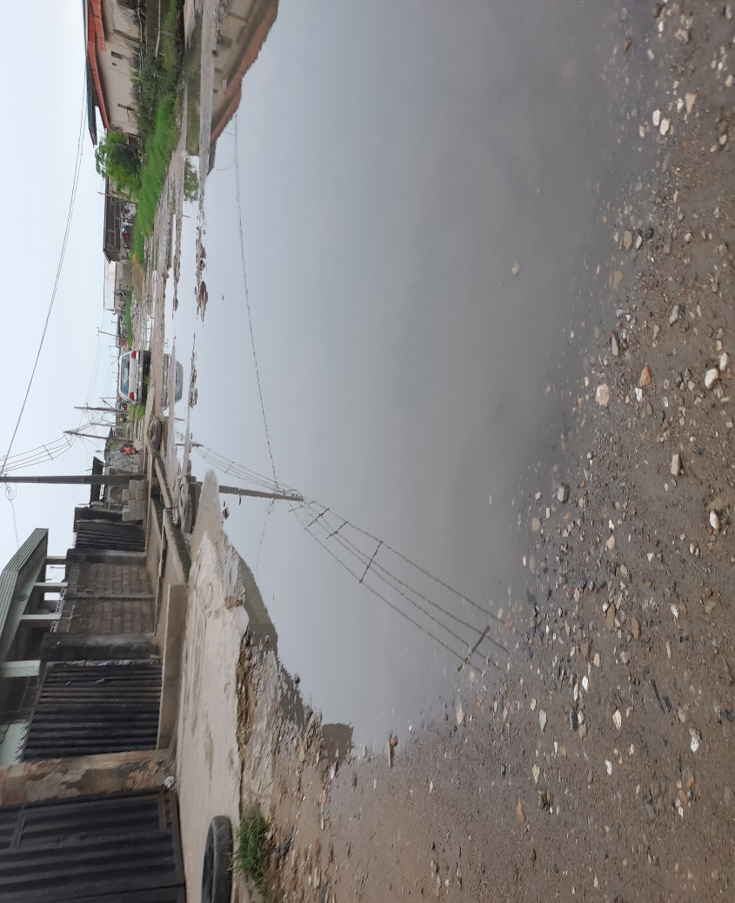

The availability of good and clean water within the state is becoming increasingly difficult as many residents find it difficult to access unpolluted water that is fit for consumption. The non-availability of clean and portable water for residents has a lot of socioeconomic implications for the citizens especially for women and children who may have to source for water anywhere possible and which may include travelling for miles in search of clean water while being exposed to other hardships in the process. According to a 42 year old female respondent, “We walk to the next street to get it. It is not that easy”. In the words of another respondent who is a 17 year old resident of the community “Water is scarce. We go through a lot to get water. Every morning I go in search of water. Another female respondent is also quoted as saying “Women go through enough trouble for water. Some women even fight each other sometimes because of water”. A 15 year old female respondent said “Water is very scarce. Even the one we have, the location is far. And, sometimes they don’t have water. So we have to just buy Pure water (Sachet Water), that is what we do in this part of Lagos”. Almost all members of the community that participated in the study reported that the scarcity of potable water within the community means they must travel for kilometres to get water or sometimes they will have to pay water vendors to supply them water for use. A 16 year old female respondent affirmed the fact that water is scarce within Bariga. In her words, “We walk far places, and when we go for water most times, the place is always crowded. If we search for water and we didn’t get, we will call mallam to fetch for us, and it is usually expensive”.
The non-availability of pipe born water or the lack of access to clean water within this community has a lot of social impact on the vulnerable residents who are majorly women and children. A 15 year old respondent said “Water is quite difficult to get in this neighborhood. We walk very far to get water every day. This has become the reality of many residents of this area as they have to put in several hours every day in search of water which is not readily available. The exposure of this vulnerable class invariably create a lot of hardship for them as they go about in search of water. These vulnerable members of the society experience a form of neglect from the government who should provide access to clean pipe-borne water.
The epileptic supply of electricity to the area and the state in general also makes access to water more difficult as those with borehole water cannot pump the water for use. This situation which can sometimes last for days means that residents of this area will have to travel to other communities in search of water. According to a 30 year old female respondent “When there is no light, water is usually scarce”. Another respondent who is a 15-year-old female resident said water is not available also due to shortage of power supply to the community. She is quoted as saying “No, sometimes, we have to wait for PHCN to bring light (Power Holding Company of Nigeria, PHCN)”. Fig.1 showed one the researcher interviewing some respondents

Fig.1: One the researcher interviewing some respondents in the community
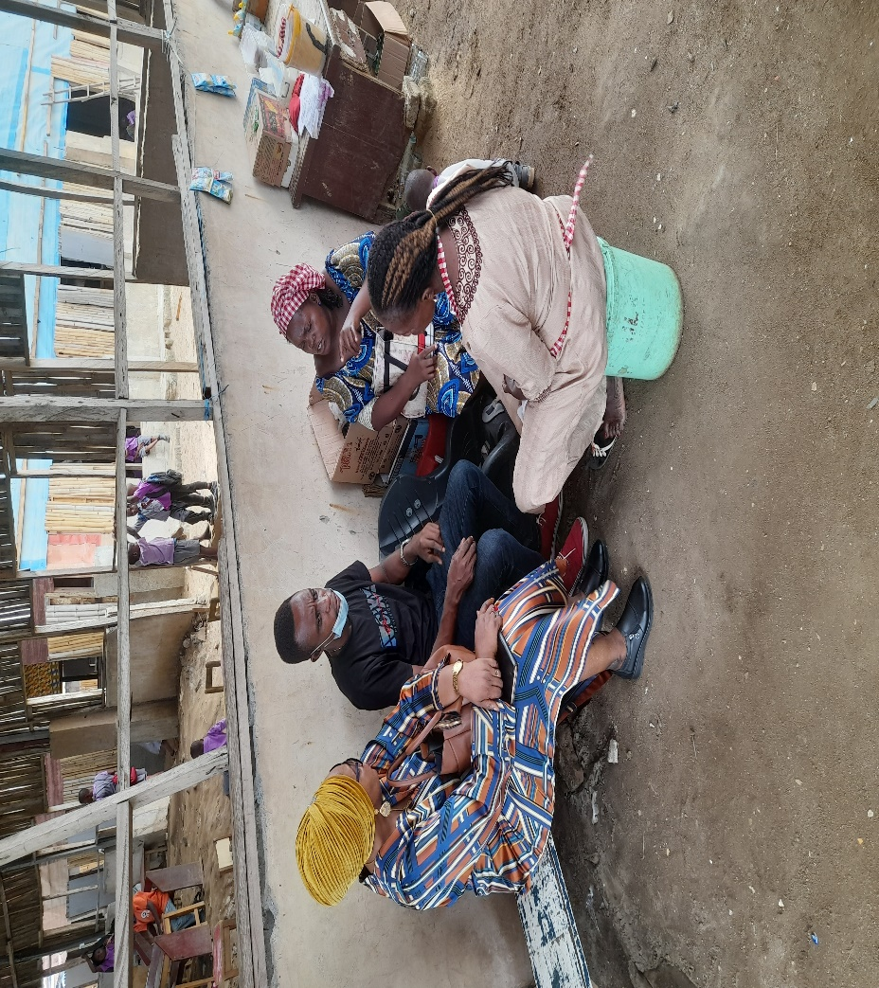
According to some residents interviewed in the Bariga axis of Lagos state, there is no presence of government supplied water in the area even though they are surrounded by large body of water from the Lagos lagoon, they lack access to water within the community. A 28-year-old female respondent said “No. it is not constant. To fetch water you have to go a long way. You have to go to the next street. So, the water from the river is not clean and many of the boreholes” are not treated. Another respondent who is a 42-year-old resident of the community is quoted as saying “Water is scarce. We dey always fight here to get water, especially weekends. People contest to get water. Water dey, try but it hard to get. (Water difficult to get here o. chai! (Water is very difficult to get in our community)”
The major sources of water within this community is the dug borehole by a few household which the entire community depend on. Borehole water is the major sources of getting water within this community and not all the available water are treated as the residence also have to deal with polluted water from the available borehole. Water pollution which occurs when unwanted materials with potentials to threaten human and other natural systems find their ways into water is another major problem the community have to contend with as available water is highly polluted.
The failure of the government to ensure that all residents of the state have unhindered access to safe potable water has led many Lagos residents to fend for themselves and most often depend on other sources of water than pipe borne water to meet their needs because of the inadequate water infrastructure in Lagos.

Water pollution in urban areas (integrated water sources and pollution)
Water pollution is a consequence of solid and liquid wastes disposal on land and surface water. The most important wastes are sewage, industrial effluent, agricultural produce and chemicals. Sewage consists of substances demanding oxygen for the process of degradation and living matters such as microalgae, bacteria, protozoan and parasites as well as chemicals. The remarkable increase in industrial activities within the last few decades and the release of detestable industrial effluents into the environment have created great concern to the populace and environmental scientists. Heavy metal concentration in drinking water is useful in understanding the role of pollutant and nutrient elements (Tamasi and Cini, 2004; Ogoko and Emeziem, 2018).
Lagos has often been referred to as one of the dirtiest cities in the world (Rosenthal, 2014) and LASEPA reports that all water bodies in Lagos, both surface and ground water, are polluted. Saltwater intrusion, human wastes, leachate from waste disposal sites, maritime and industrial waste, leakages from sewer lines and agricultural runoff all pose water quality challenges. The pollutants are usually pathogens, silt and suspended solid particles such as soils, sewage materials, disposed foods, cosmetics, plastics, automobile emissions, construction debris and eroded banks from rivers and other waterways. Some of these pollutants are decomposed by the action of micro-organisms through oxidation and other processes.
Land disposal of solid waste creates an important source of ground water pollution. The problem of pollution from refuse heaps is greatest where high rainfall and shallow water table occur.
Pix 3: this street leads directly to the lagoon
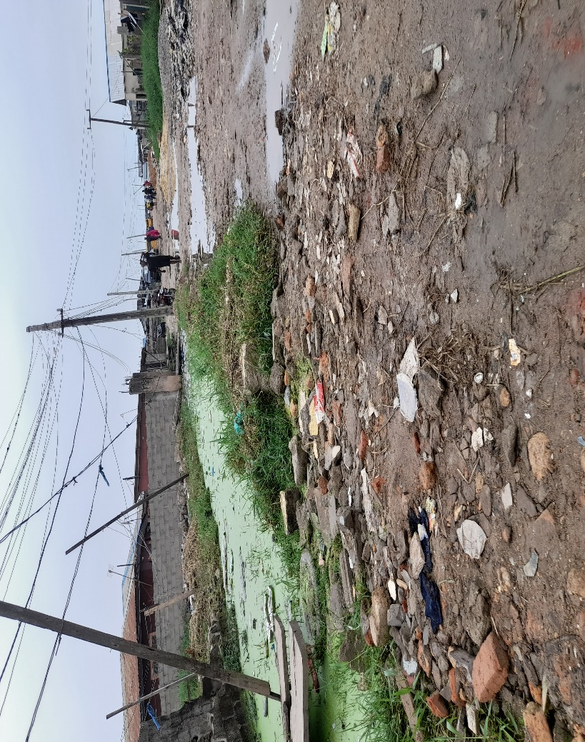

The quality of water has been adversely affected by the rapid increase in population within the state which is currently over 20 million residents. With increased use of water, comes increased wastewater, which drains into canals that empty into water bodies. In addition, Lagos is particularly susceptible to water pollution because the water table is very high, sometimes only three meters from the surface and the relatively loose and easily permeable soil allows the infiltration of contaminants. Lagos lacks an effective waste collection service and has no central system for treating sewage and industrial effluent. More than 10% of the estimated 4,000-6000 tons of solid waste generated each day in Lagos are dumped directly into open spaces or municipal drainage systems, blocking drainage during heavy rains (Rosenthal, 2014). Lagos health and environment officials acknowledge that most of the rubbish and sewage collected by private operators, as well as the industrial effluent, end up in the lagoons and creeks Untreated sewage pollutes the lagoon and destroys marine and aquatic life including the quality of water in the Lagos (UN, 2014), thus, creating a social and economic challenge. People cannot swim in the lagoons and creeks because of pollution and fishes and crustaceans may be contaminated.
In Nigeria, research indicates that, majority of the common fresh water sources are polluted, resulting to serious outbreak of many water borne diseases (Galadima, 2011). There are pit toilets in areas of the settlement lying on firmer ground, but each one serves several families. This has a negative environmental impact, affects the food source and poses a significant risk of viral and bacterial diseases such as polio, meningitis, diarrhoea, cholera, parasitic infection and fevers spread by waterborne vectors (Durham, 2012).
Figure 2: Shows different diseases from polluted water
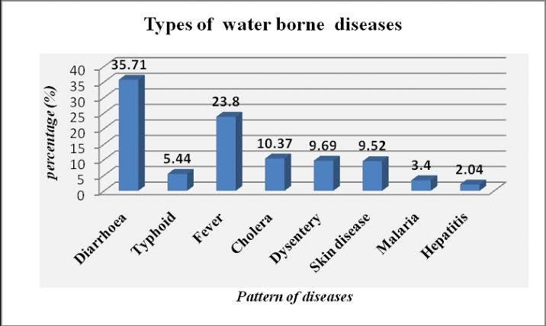

Fig. 4: Shows people waiting to get water from the only functioning tap in the community
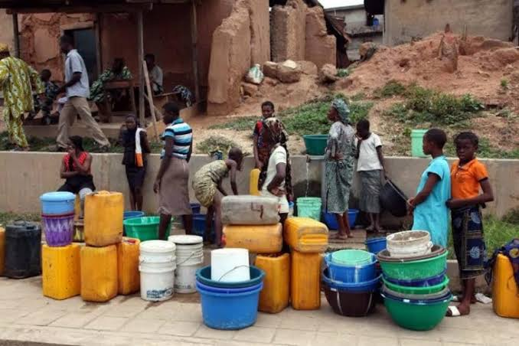
Some of the population relies on pits and open sewers or dispose of human wastes and garbage directly into surface waters and these are contributory factors to the pollution of water. Due to inadequate sewerage, much of the excreta and sullage is disposed of by the drainage of rainwater through open ditches. During the dry season, when the flushing action of rainfall does not exist, drainage channels become blocked with solids, creating stagnant pond of contaminated water. Some people even use this water for household purposes (UN, 2014).

Pix 5: young children waiting to get water from a neighborhood borehole
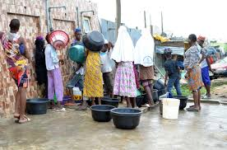
In most houses, only toilet waste is discharged through a septic system and all other household liquids are discharged directly to storm drains where they exist or into the street. In addition, most houses lack indoor plumbing and adequate sources of potable water is limited. The unreliability of water supply from government-owned water board led some of the people to resort to drilling boreholes, or wells. Some buy water from water vendors in tanks. Those who could not afford these obtain their drinking water from shallow wells, less than 5m (16ft) deep. Some of these shallow well water require treatment to meet the WHO drinking water standard (Yusuf, 2007).
Pix 6: A typical street in Bariga
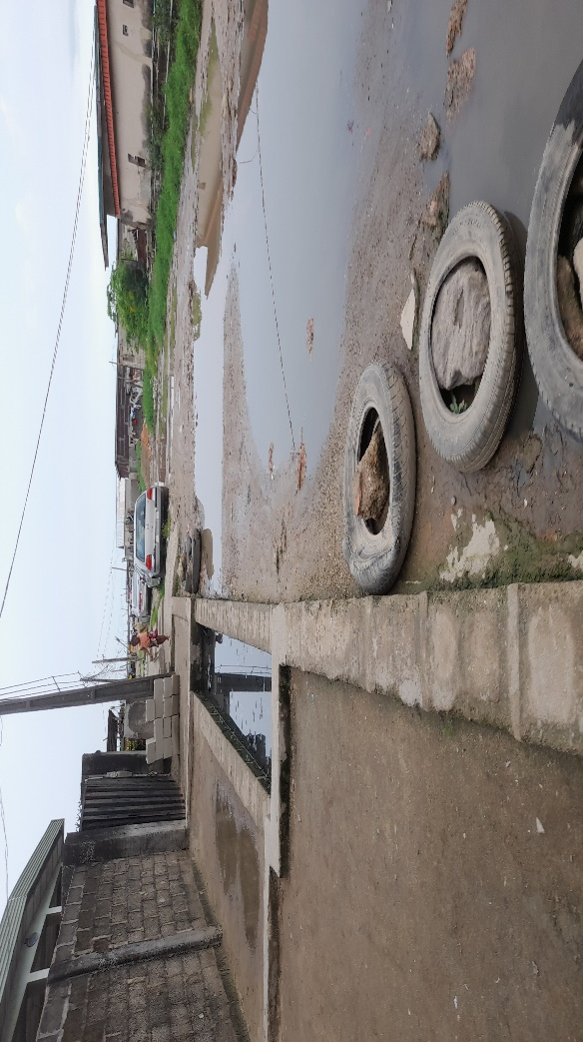
Domestic and Municipal Pollutants: The sewage contains garbage, soaps, detergents, waste food and human excreta and is the single largest source of water pollution. Pathogenic (disease causing) microorganisms (baccteria, fungi, protozoa, algae) enter the water system through sewage making it infected. Typhoid, chloera, gastroenteritis and dysentery are commonly caused by drinking infected water. Water polluted by sewage may carry certain other bacteria and viruses which cannot grow by themselves but reproduce in the cells of host organisms. They cause several diseases, such as, polio, viral hepatitis and may be cancer which are resistant to like the organic matter that are oxygen demanding substances. They are responsible for deoxygenation of waterbodies which is harmful for aquatic life. One of the informed that “all the gutters are blocked because many households dump their wastes in the gutters. Others move down the lagoon to discharge their wastes. It is a big problem in this community”.
Industrial Pollutants: Many industries are located near rivers or freshwater streams. These are responsible for discharging their untreated effluents into rivers like highly toxic heavy metals such as chromium, arsenic, lead, mercury, etc. along with hazardous organic and inorganic wastes (e.g., acids, alkalies, cyanides, chlorides, etc.). River Ganges receives wastes from textile, sugar, paper and pulp mills, tanneries, rubber and pesticide industries. Most of these pollutants are resistant to breakdown by microorganisms (called non-biodegradable), therefore damage the growth of crops and the polluted water is unsafe for drinking purposes and aquatic life. “A 30-year-old resident informed that in the past she could get enough fish and crabs from the lagoon to sell in the evenings to augment her meagre income. But due to pollution fishermen now travel far to get fish and she finds it difficult to travel far because her children are very young”. This has grave implications for family income because many of such women had to stop the fish trade.
Agricultural Waste: Manure, fertilizers, pesticides, wastes form farms, slaughterhouse, poultry farms, salts and silt are drained as run-off from agricultural lands. The water body receiving large quantities of fertilizers (phosphates and nitrates or manures becomes rich in nutrients which leads to eutrophication and consequent depletion of dissolved oxygen. Consumption of water rich in nitrates is bad for human health especially for small children.
Impact of water pollution on urban dwellers (effects on housewives, children)
Water resources in Lagos for domestic, industrial and commercial use is becoming scarce as a result of pollution of water bodies by wastewater, which contains heavy metals, bacteria (pathogenic) etc. The reliability and quality of water supply is often not adequate and sometimes inhabitants especially women and children have to survive without water for days. In many parts of Lagos Mainland, not only is there evidence of lack of access to public water, but also it is not uncommon to see women and children walking for miles carrying containers of diverse shapes and sizes in search of water as alluded to by all the respondents. Even those living in riverine communities also struggle to have potable water.
Pix 7 : A cross section of residents getting water
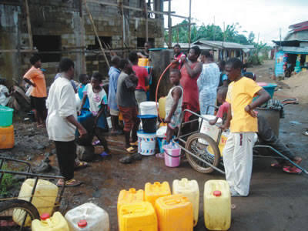
Significant amount of time is spent by adults and school children upon water abstraction from various sources (WWAP, 2015). It is estimated that, in developing countries, women (64%) and girls (8%) spend billions of hours a year collecting water (Hutton, 2016). Two 15-year-old respondents said that “We hardly find time to study after school because we have to look for water for domestic use. Depending on the distance we may spend two to three hours before returning home. When there is no light to pump water, we walk several streets away from home in search water and often return at nigh to eat and sleep”
The major consequences of water pollution in Nigerian communities are socio-economic, health and environmental problems. On one side the government is experiencing terrible and devastating cost inconsistencies. Polluted water containing sediments and parasites is very expensive to treat to the desired standard for any household or even industrial application. This can also be coupled with the financial implications of eradicating the associated diseases. In turn, children and new born babies are mostly affected by these severities, as can be seen from the high infant mortality rate in the country. The erratic supply of safe drinking and domestic water often affects good hygiene practices. In most developing countries of the world, inadequate supplies of drinking water can contribute to the underage death of children (Ezeh, 2014).
The number of diagnosed cases of cholera has increased in Lagos. This is due to drinking water containing chemical and bacterial pollution. The main cases of pollution is the lack of effective sewage systems in the city. Sewage is washed away by rainwater into open drains. This water then carries the pollutants to rivers and the lagoon. Sewage also reaches groundwater sources through leaking septic tanks and pit latrines (pits used to deposit human waste). Pollutants can then contaminate water in wells and boreholes. The water sold by street vendors can also be affected as the water comes from the same sources.
Extensive flooding, during which sewage compounds contamination of water sources, sullage are carried into wells. Also, there may be seepage from soak-aways, industrial, and commercial storage systems into ground water systems. It is obvious in most houses in the metropolis that the disposal of their sullage is unhygienic and inappropriate. For example, only toilet wastes are connected to septic tanks, while other household liquid wastes are discharged directly to storm water drains in front of the houses. Where there is no drain it will be discharged on the street in high-density areas. Unhygienic disposal of industrial and domestic liquid waste (both toxic and non-toxic natures) and faecal matters leads to extensive soil contamination and ground/surface water pollution especially in the coastal city like Lagos (Iwugo, 2003).
Residents of communities with inadequate water supply are left with no alternative other than to find local sources of drinking water for themselves.
The health risks associated with the consumption of unsafe drinking water are not only related to infectious diseases but also to other environmental components such as fluoride, arsenic, lead, cadmium, nitrates and mercury. Excessive consumption of these substances from contaminated drinking water can lead to cancer, dental and skeletal fluorosis, acute nausea, memory lapses, renal failure, anemia, stunted growth, fetal abnormalities and skin rashes (Edokpayi, 2014).

Pix 8 : A woman getting water from a stream
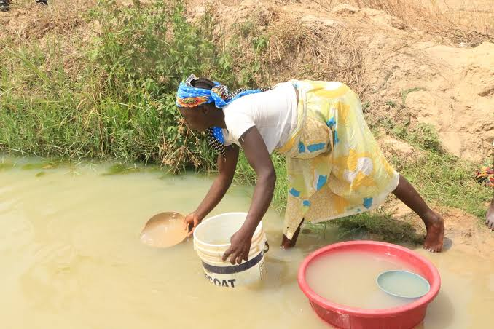
The consequences of this unhealthy situation expose the environment to serious water pollution and the resultant health hazards that may lead to serious epidemic not only in Lagos but also in neighboring coastal areas. The septic tank /soak-aways and pit latrine systems also have negative impacts on groundwater to gradual and steadily increasing pollution from septage indiscriminately discharged into the Lagos logoon system, since the water table of the State is very high, because majority of the land is reclaimed land. (Iwugo, 2003)
Pix 9: Getting water from a borehole
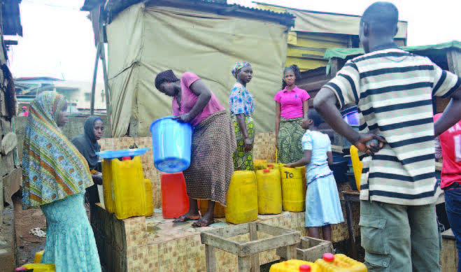
Human excreta contain a lot of organisms, which are major vectors of water-related diseases. These organisms include viruses, which can cause poliomyelitis, viral meningitis, hepatitis, fevers, diarrhea: bacteria, which can lead to cholera, typhoid / paratyphoid, and diarrhea: Protozoa, which cause dysentery, colonic ulcers and diarrhoea: Helminths, which result to guinea worm, round worm, live flukes and schistosomiasis. Consumption of contaminated drinking water is a cause of diarrhoea and typhoid fever, leading causes of child mortality in developing countries with about 700,000 deaths of children under the age of 5 reported in 2011 (Bain, 2014).
The industrial wastewater is full of heavy metals, which results into chemical pollution of the water bodies. Such heavy metals are mercury, arsenic, copper, cyanide, iron, lead, cadmium, chromium, nickel, phenols etc. which cause chronic diseases such as cancer in the inhabitants of the state and neighboring countries using the same coastal waters, because pollution has no boundary.
Theoretical underpinning
High rate of population growth is causing increases in waste water volumes jeopardizing the integrity of river basins. The effect of this action is water pollution which will invariably affect the access to clean water by residents of the urban center. The study employed the adaptive system approach in extrapolating this crisis. The adaptive system approach is a set of interacting or interdependent entities that form an integrated whole that are capable of responding to environmental changes or changes in interacting parts in a manner analogous to either continuous physiological homeostasis or evolutionary adaptation. This approach justifies the bottom-top approach in managing situations among social communities. The approach encourages members of the community to become major stakeholders on issues that affect their community by owning them and playing major roles in such activities. The implementation of this approach will mean that management and operations of events or activities relating to the community is first of all an initiative that is birthed by community members. This initiative will help them to be fully committed to the implementation and success of such engagement.
The adaptive systems approach in relation to managing water in communities within Lagos means that the community members will form a major stakeholder in such project. The interaction of members of the community on issues related to their well-being is better managed when they understand it and buy in as well as manage it. The provision and management of water within community doesn’t end with mere water provision but rather it also covers the sustainability of such development. The only way to adequately sustain such initiative after the initial investment is to get members of the community to own the project by allowing them to determine the best way possible to see that the facility is properly managed and sustained so as to keep enjoying continuous provision of water which will be reliable and functional.
The adaptive system approach which was adopted by the social sciences provides a system that guarantees the sustainability of any activity that is domiciled within a community. The provision of clean and portable water to Bariga community will be better sustained and managed if the people and community members are allowed to become major stakeholders by holding a consultative forum with the government to provide water and ensure that it becomes sustainable. This forum will enable them to suggest how best they can sustain and maintain such project if it is sited in their community for their benefit. This community involvement will see them developing a community-based strategy that will be adaptive to suit the perculiarity of their community. The host community will employ cultural and dynamic systems which will revolve round what they are used to as a community. The aim is to ensure that any investment cited within such community gets a buy-in by members of the community and by implication gets overall acceptance by all within the community. The social implication of the adaptive systems approach is that every investment or social intervention within various communities gets a social approach that is peculiar to the community and encourages the members to play major role in the ownership, implementation, and management of natural resources. This approach is adoptable because of the uniqueness which makes it different from all other systems.
The provision of borehole and water treatment system within the Bariga community of Lagos state can be successful when government, donor agencies and individuals hold a consultative meeting with the community members. This initial forum will allow community members to suggest ideas on how best they can play a major role in the successful implementation of such project. This will then be followed by the proper implementation and the eventual handing over of such project to the community members who will then see to the management of the project based on their arranged plans.
The adoption of the adaptive systems approach ensures that members of the community are allowed to own and implement projects which are targeted at improving the social lives of residents within identified communities.

Discussion of findings
Water is the most important resource needed by humans for survival and for human activities within the society. The availability and access to this all import resource cannot be over emphasized as it drives good health and production of agricultural and other essential items for man. Over the years, human and environmental activities of man has brought about water pollution which is hazardous to the health of man. The implication of polluted water to man is severe health challenges most of which if not properly diagnosed or treated can lead to death. The major consequences of water pollution in Nigerian communities are socio-economic, health and environmental problems. Contamination of surface water sources is a major environmental issue that attracts a lot of interest in Nigeria because of the importance of water quality for human health (Obeta, Ajaero, 2010).
Sediment pollution of Nigeria water bodies is also another serious and widespread problem within the country and this comes to bare as a result of accelerated soil erosion and people’s poor attitude towards refuse disposal. This unhealthy style of living has also been a major source of pollution to water bodies in the country. Iroye, (2008) observed that as a result of urban growth accompanied by high pollution density, waste generation and disposal has become a serious issue of concern in most Nigerian cities most of which lack proper waste disposal plans. People dump refuse into flowing water whenever it rains. The resulting consequences of such actions are blocked drains which will ultimately lead to stagnant water that find their way into ground or piped water channels.
Polluted water containing sediments and parasites is very expensive to treat to the desired standard for any household or even industrial application. This can also be coupled with the financial implications of eradicating the associated diseases. In turn, women, children and new born babies are mostly affected by these severities of water pollution, as can be seen from the high infant mortality rate in the country (Galadima, 2011). Every day, Nigeria loses about 2,300 under-five year olds and 145 women of child-bearing age, making the country the second largest contributor to under-five and maternal mortality rate in the world (UNICEF, 2017). Infant mortality rate symbolizes a measure of a country’s health policy, systems and practices, an aspect of its national development. It is often associated with socio-economic factors of unemployment, poverty, water pollution, income disparity, among others, in a polity (Okwuwa, et al., 2020). The adults are also not exceptions as they suffer from associated killer-poverty. Water related diseases are the most common causes of illness and death, affecting mainly poor inhabitants in local communities around the countries especially poor urban settlements (Galadima, 2011).
Industrial waste is the most common source of water pollution and it increases yearly due to the growth of industries as most countries are getting industrialized. The development of urban areas is hardly controlled and informal settlements within urban conurbations lack sanitation and clean water. Heavy precipitation events pose pressure on urban and rural infrastructure which often get worse with increased population (Ondieki, 2015). The development of industrial activities as a result of urbanization often neglect the resultant impact of pollution which the people within such communities are faced with. The implication is that people continue to suffer from these industrial activities at the expense of their health and social activities.
Inability of the various tiers of government over the years to meet the demand for portable water supply and the cost of drilling boreholes, and the increase in the number of surfaces well in several cities in Nigeria is indication of its social effects. The unfortunate development is that most of these wells are shallow and may not be deeper than 5 m. Consequently, several sources of pollution ranging from microbial, to other sources becomes major contributor to the pollution experienced by members of the communities that use these water well.
The domestic water pollution problems result from the fact that in some areas of the metropolis the water table is very high and even in some areas the water table is near the surface, for example within 3 metres of digging you will get water. The soil is usually porous and this increases the chances of sewage and other wastewater infiltrating and polluting ground water and well water, which are the major sources of water in many areas.
Water has a vital role to play in responding to the socio-economic crisis facing Africa. Although several economic instruments are deployed to address this crisis, the success of these efforts will depend heavily on the availability of sustainable water resources. On the other hand, success in economic development efforts is needed to ensure a sustainable flow of funds for the development of water resources. The social dimension to this myriad of problems within the Bariga area of Lagos state is that women and children are the most hit as they must travel for some distance in search of clean water. The limited availability of clean water within this community poses a lot of hazard to these vulnerable class. The movement in search of clean portable and drinking water makes them loose a lot of time which could have been invested in achieving other things. The study time for the children is reduced as they will have to return to the street in search of water instead of studying and doing their homework after school. When this happens, their academic output will be affected as they can’t compete favorably with their counterparts in other parts of the state who may not have to lose study time in search of water. This reinforces the disparity that exists between the children of the poor and the privileged children of the rich.
The women and mothers are also greatly affected by this search for water which also affect their time for business and ultimately their total income. Time spent looking for water if properly invested in the business or market will translate into more sales for the day. Most women traders or business owners delay the opening of their shop each day because of the search for water activities which is a necessity especially for the food vendors and others within the community. The health of these vulnerable class is another aspect that result from this water search activities. The women and children who walk for miles in search of water always move about with big containers which will be used to carry the water on their head when they do find water. The constant carrying of heavy object on the head and travelling miles will someday come with its own health challenges not forgetting the immediate severe headache associated with the carrying of heavy objects as attested to by one respondent who complained of constant headache and fatigue.
The main cause of deterioration in water quality is lack of proper sanitation, unprotected river sites and high anthropogenic activities including direct and indirect disposal of the solid wastes, domestic and municipal sewage and agricultural run-off to the rivers both from urban and rural areas (Ondieki, 2015).
The general impact of water pollution in Bariga is such that affects all economic and socio facet of the community including its productivity level. Members of the community are constantly faced with the water challenge problem and live with it as they currently do not have access to this all important amenity within their community.
Conclusion
It has been established that, pollution of domestic water is an ongoing problem in most Nigerian communities as it is in Bariga area of Lagos. The effect of non-availability of clean portable and drinking water is majorly felt especially in the government neglected communities where natural and human activities contribute immensely to the menace of pollution which has rendered available water useless. The tragedy of water pollution in residential areas is seriously crippling human development, proper identification of preventive and control measures would be very useful. Safe drinking water is a basic need for all human beings and this must be upheld at all times. Polluted water is highly detrimental to the health of people, especial in poor communities when clean water is akin to gold.
Recommendations
- The government must ensure that they prioritize the provision of safe and potable water to all poor communities within the state to improve access to safe drinking water.
- The government must also ensure that there is proper education of local people on the importance of water sanitation and good waste disposal methods, establishment of water treatment plants and good regulatory strategies.
- The adaptive systemic approach is imperative in communities such as Bariga to ensure that when provided that clean water must be sustainable.
- Adequate budgetary funding is therefore necessary to achieve the above recommendations.

References
Bain, R., Cronk, R., Wright, J., Yang, H., Slaymaker, T. & Bartram, J. (2014). Fecal
Contamination of Drinking-Water in Low- and Middle-Income Countries: A Systematic Review and Meta-Analysis. PLoS Med., 11, e1001644.
Durham, M. (2012). Report From Lagos: Water Crisis. Retrieved from URBim. On May 10,
` 2022.
Edokpayi, J.N., Odiyo, J.O. & Olasoji, S.O. (2014). Assessment of Heavy Metal Contamination
of Dzindi River, In Limpopo Province, South Africa. International Journal of National Science. Resource. 2, 185–194.
Ezeh, O.K., Agho, K.E., Dibley, M.J., Hall, J. & Page, A.N. (2014). The Impact of Water and
Sanitation on Childhood Mortality in Nigeria: Evidence from Demographic and Health Surveys, 2003–2013. Int. J. Environ. Res. Public Health. 11, 9256–9272.
Fasona, M., Omojola, A. & Amogu, N. (2005). Sustainable Water Management Solutions for
Large Cities. UK: IAHS, Wallingford, Oxfordshire.
Galadima, A., Garba, Z. N., Leke, L., Almustapha, M. N. & Adam, I. K. (2011). Domestic Water
Pollution Among Local Communities in Nigeria ----Causes and Consequences. European Journal of Scientific Research ISSN 1450-216X Vol.52 No.4, pp.592-603.
Hutton, G. & Chase, C. (2016). The Knowledge Base for Achieving the Sustainable
Development Goal Targets on Water Supply, Sanitation and Hygiene. International. Journal on Environmental Research and Public Health. 13, 536.
Iroye, K.A. (2008). Effects of Landscape and Climatic Parameters of Basin Management in
Ilorin, Nigeria. Unpublished Ph.D Thesis University of Ilorin.
Iwugo, K.O., D’Arcy, B. & Andoh R. (2003). Aspects of Land-Based Pollution of An African
Coastal Megacity of Lagos. Dublin: Diffuse Pollution Conference.
Obeta M.C. & Ajaero C.K. (2010). The Chemical Composition of Stream Waters in Nsukka
Region of Eastern Nigeria. In: Rural Water Supply in Nigeria. Eds. Igbozuruike, U.M., Ijioma, M.A., & Onyenechere, E.C. Owerri: Cape Pub. Inp. Ltd. p. 136–144.
Ogoko, E. C. & Donald, E. (2018). Water Quality Characteristics of Surface Water and
Accumulation of Heavy Metals in Sediments and Fish of Imo River, Imo State. Journal of Chemical Society of Nigeria. 43, 4, pp. 13 -720.
Okoye, V. (2014). On Clean Drinking Water in Lagos: Many Options, Few Solutions. Lagos:
Sustainable Cities Collective Publications.
Okwuwa, Charles Onuora and Adejo, Simon M. (2020). Infant Mortality, Access to Primary
Health Care and Prospects for Socio-Economic Development in Bwari Area Council of Niger State, Nigeria. Journal of International Women's Studies, 21(1), 289-308.
Ondieki, C. M. (2015). Aspects of Water Quality and Water Pollution Control in Vulnerable
Environments. Journal of Geography and Earth Sciences, Vol. 3, No. 2, pp. 83-93.
Rosenthal, E. (2012). Nigeria Tested by Rapid Rise in Population. New York: New York Times
Publications. Retrieved from Web. 09 Apr. 2022.
Tamasi, G. & Cini, R. (2004). Heavy Metals in Drinking Waters from Mount Amiata (Tuscany,
Italy). Possible Risks from Arsenic for Public Health in the Province of Siena. Science of the Total Environment. 327, 1-3, pp.41- 51.
United Nations (2005). City Profiles: Lagos. Web. 09 Apr. 2022
UNICEF (2017). Nigeria has 3rd Highest Infant Mortality in the World. http:/unicef.org/Nigeria.
World Water Assessment Programme (2015). The United Nations World Water Development
Report 2015: Water for a Sustainable World; Paris: WWAP Publication.
Yusuf, K. A. (2007). Evaluation of Groundwater Quality Characteristics in Lagos-City. Journal
of Applied Science 7(13) p 1780-1784.

