, .

Causal Relationship of Entanglement Between Birefringence Beams of Light Through Chiral Medium.
Imran Ul Haq1, Roidar Khan2, Akhtar Zaman1, Maqsood Iqbal2,
¹Department of Physics Govt Post Graduate College, Timergara, Dir(L) KP, Pakistan, ∗ and
²Department of Physics, University of Malakand, Chakdara Dir(L) KP, Pakistan

The casual relationship between two split rays (left and right) circularly polarized beams through the chiral medium are investigated in this article. Using partial transposition and superposition of bell states to investigate entanglement phenomenon between the left and right circular polarization beams through the negativity of eigenvalues. Measurement of partial transposition shows two fluc- tuated positive and negative eigenvalues with time flow and space variation. The maximum positive and negative value of 0.5 is investigated with the variation of space, time, and system parameters. The existence of negative eigenvalues pointed out entanglement between the birefringent beams. Fluctuation of positive and negative eigenvalues shows fluctuation between separable and entan- gled states. The theoretical results may be useful for super-dense coding, quantum cryptography, quantum bits, and quantum teleportation of optical technology.
±

- INTRODUCTION

Quantum entanglement is the phenomenon that involves the interaction between two or more particles that are connected in such a way that an action on one particle affects the other, even if they are separated by long distance[1]. Quantum entanglement plays important role in various quantum technologies i.e dimension of high entangled state for light[2], correction of quantum error[3], quantum teleportation, computation and communication[4], entanglement- enhanced communication[5]. Recent ideas have argued the quantum information for the manipulations of pairs of photons[6], and the correlation of quantum transport[7]. Entanglement is the mark of the quantum world. One portion of an entangled arrangement has its properties entirely indeterminate yet entirely connected through the properties of its matching part[8]. Einstein’s paper of 1935, where, jointly with Boris Podolsky and Nathan Rosen he introduces the notion of entanglement into the consideration on the fundamentals of quantum mechanics. It had a very attractive reaction. In the establishment, it seemed a few citations, but then it was in effect ignored until John Bell discovered that the predictions of quantum mechanics are in divergence with the confined realistic theory[9].
Firstly entanglement was revealed for microscopic material systems[10, 11]. It is attractive to observe it for intense photonic states [11, 12], since bright light is a good deal more proficient in communications than only photons in a vacuum. Entanglement is discussed theoretically[12, 13] but was never experienced experimentally. chance mea- surements could single reveal entanglement for up to 12 photons. The operation of entanglement in communication, computation, and quantum radar is a very active area of research and development[14]. Yet, the large new improve- ment in cooling atomic systems, in particular, to form Bose-Einstein condensates (BECs), makes such entanglement tests to a great extent more realistic[15].
In the field of quantum information (QI) the achievement of mainly basic quantum communication protocols con- necting bipartite entanglements, such as quantum teleportation[16], super-dense coding[17], entanglement swapping and a number of important quantum cryptographic schemes[18], requires the entire and deterministic detection of the Bell states. The based quantum information technology techniques to a vast extent have been studied[19]. Such aspects of research about the theory of quantum information has been studied and manipulate widely through experimental[20] and theoratical[21]. Every system cannot be represented independently, yet if they are non-local[22]. The photons are travel through an independent root with one particle is manipulated. This ability can be used in quantum network[23]. If the system is casually not correlated to each other then it can be effective immediately the state of one quantum state by another anywhere in the universe which is confirmed from the measurement of physical behaviour[24]. The result is for manipulation of quantum communication[25]. The time-domain and chiral medium between the entangled particles was not explained by the EPR paradox and many more. The complex medium between the entangled particles was discussed by unscrambling entanglement in a complex medium[26].

∗Electronic address: imranphysics1162@gmail.com

A large number research articles have been published for the control and modification of quantum entanglement in which some of the articles are given above. In my knowledge there is no work to modify quantum entanglement between birefringent of light in a chiral medium by applied driving fields. In this article a four level chiral atomic medium driving by electric and magnetic probes field as well as a control field to obtain over the control and modification in birefringence. The bell state of birefringent beams is used to check negativity of the eigenvalues by partial transposition mechanism. Significant oscillation between positive and negative eigenvalues are reported. The work of this article may be fruitful application in quantum teleportation, quantum cryptography, quantum bits, super-dense coding, quantum protocols, and the dimension of high entangled states for the light of optical technology in the modern world.

- MODEL AND ITS DYNAMICS

To control and modified entanglement between the left and right circularly polarized beams a four level chiral atomic medium is under consideration. The four level configuration chiral medium is driving by electric and magnetic probes and a control fields. The electric probe field E_{p} having Rabi frequency Ω_{p} and detuning ∆_{p} = ω_{p} ω₁₄ is coupled between the states 1 and 4 . The magnetic probe field B_{m} having Rabi frequency Ω_{m} and detuning
| ⟩ | ⟩
−
∆_{m} = ω_{m} ω₂₃ is coupled between the states 2 and 3 . A strong control field E_{c} having Rabi frequency Ω_{c} and detuning ∆_{c} = ω_{c} ω₃₄ is coupled between the states 1 and 4 . where Ω_{p} = σ₁₄.E_{p}/¯h, Ω_{m} = µ₂₃.B_{m}/¯h and
— | ⟩ | ⟩
— | ⟩ | ⟩
Ω_{c} = σ₃₄.E_{c}/h¯. The terms Q₁₄, σ₃₄ and µ₁₄ are electric and magnetic dipole matrix element between the two states. Now the states |1⟩ and |2⟩ are initially in the superposition condition, for which |ψ⟩ = √q |1⟩ + 1 − qe^{iφ} |2⟩. The
√
zero order density matrix is written for the superposition states is ρ⁽⁰⁾ = ψ ψ . The decay terms between the two states are written as γ_{ij}.
| ⟩ ⟨ |

Δc
4
Δp
γ43
Ω
3
c
Δ
γ41
m
γ32
Ωm
Ω
p
2
1

FIG. 1: The scheme of proposed energy level diagram of four-level atomic system.

To evaluate the optical response of chiral atomic medium the following Hamiltonian has proceeded in the dipole and rotating wave approximations:
H_{I} = − h¯ [Ω_{p}e^{−i∆}pt |1⟩ ⟨4| + Ω_{m}e^{−i∆}mt |2⟩ ⟨3| + Ω_{c}e^{−i∆}ct |3⟩ ⟨4|] + H.c. (1)
2
where a† is production and a inhalation operators. Using the authority of the following master equation, sixteen equations and density matrix can be evaluated.
d (ρ) = − i [H , ρ] − 1 Σ γ (−2σρσ† + σ†σρ + ρσ†σ) (2)
dt
h¯
int
2
ij

where ρ_{ij} are the density-matrix-operator elements, σ† and σ are raising and lowering operators respectively, while
˜
˜
˜
˜

γij
(i, j = 1, 2, 3, 4) represent the decay rates between the two states. Here ρ˙14
and ρ˙13
are coupled and ρ˙23
and ρ˙24

are coupled with each others. To solve the coupled rates equation the first order perturbation condition is applied. The states |1⟩ and |2⟩ is initially in the superposition condition, for which |ψ⟩ = √q |1⟩ + √1 − qe^{iφ} |1⟩. The zero
order density matrix is written for the superposition states is ρ⁽⁰⁾ = |ψ⟩ ⟨ψ|. The zero order terms are calculated from

the superposition condition as: ρ⁽⁰⁾ = q, ρ⁽⁰⁾ = √q(1 − q)e^{−iφ}, ρ˜(0) = 1 − q, ρ˜(0) = √q(1 − q)e^{iφ}. The coupling-
˜ ˜
rates equations are obtained for the dynamics of the system by using the master Eq.(2). As the probe electric field is between 1 and 4 states and magnetic field is applied between 2 and 3 states. Using the master eq.2, the following two electric and magnetic explicitly time independent coupled rates equations are calculated after first order perturbation and zeroth order superposition:
| ⟩ | ⟩ | ⟩ | ⟩
11
12
22
21
∼· 1 i i

ρ14 = (i∆_{p} − 2 γ₄₁)ρ˜₁₄ − 2 qΩ_{p} − 2 Ω_{c}ρ˜₁₃ (3)
·
i

∼ρ = i(∆
1
— ∆ ) − (γ
+ γ )ρ˜ − Ω √q(1 − q)e^{−iφ} − i Ω∗ρ˜
(4)

13 p

∼·
c 2 41

1

43 13 2 m

i

2 c 14

i ∗

ρ23 = [i∆_{m} − 2 (γ₄₃ + γ₃₂)]ρ˜₂₃ − 2 (1 − q)Ω_{m} − 2 Ωc ρ˜₂₄ (5)
·
˜
24
m
c
2
32
24
2
p
2
c
23

∼ρ = [i(∆
+ ∆ ) − 1 γ ]ρ
— i Ω √q(1 − q)e^{iφ} − i Ω ρ˜
(6)

The following integral is used to evaluated the coupled rates equation by matrix formalism.

( ) = ∫ t
L t

— − ' = −
e
S(t
^{t} ⁾Mdt
S
1M

(7)

−∞

(1)
˜23
˜24 (1)
˜14
˜23

as: P=Nσ₁₄ρ14 and M=Nµ₂₃ρ23 , where µ₂₃ is magnetic dipole moment between the states |2⟩ and |3⟩, while Q₁₄ µ₂₃ = √3c2h¯λ3γ₃₂/8π2 and σ₁₄ = √3¯hλ3γ₄₁/8π2. Calculating the polarization and magnetization from the relation
˜ ˜is electric dipole moment between the states |1⟩ and |4⟩. These dipole moments are related to atomic decays as
coupled equation of ρ˙
and ρ˙
The coherence terms ρ⁽¹⁾. ρ⁽¹⁾ are related to electric polarization and magnetization
Where L(t) and S are column matrices, and M is a 2 × 2 matrix to solve coupled equation of ρ˜˙14 and ρ˜˙13 as well as
P=Nσ
ρ(1)
and M=Nµ
ρ⁽¹⁾, while plugging Ω
= Bµ
/¯h and Ω
= Eσ
/¯h. using the above condition the

14 ˜14
23 ˜23
m 23
p 14

N σ² β_{EE}
14 +
following equation for polarization and magnetization is calculated as:
=
P h¯
Nσ14βEBµ23
¯h B
E

N µ² β_{BB}
= 2¯3 +
M B
h
Nµ23βBEσ14

¯h
E (8)

Using B = µ₀(H + M ) the polarization and magnetization are simplified to the following form in terms of E and H.
= ( N ²µ² σ² β_{EB}β_{BE}µ₀ + (h¯ − Nµ² µ₀β_{BB})Nσ² β_{EE} )
P 23 14 23 14 E
h¯(¯h − Nµ² µ₀β_{BB})
23

+( N ²µ³ σ₁₄µ²β_{EB}β_{BB} + (¯h − Nµ² µ₀β_{BB})Nσ₁₄β_{EB}µ₂₃µ₀ )
(9)

23 0 23 H
¯h(¯h − Nµ² µ₀β_{BB})
23

Nµ2 βBBµ0H
= 23 +
M
Nµ23σ14βBEE

(10)

— Nµ² µ₀β_{BB} ¯h − Nµ² µ₀β_{BB}
23
23
The electric polarization in term of chiral coefficient and electric susceptibility is in the available literatures as:
P = ϵ χ E + ξEH H (11)
0 e c

The magnetization in term of chiral coefficient and magnetic susceptibility is in the available literatures as:

M = ξHE E + χ
H (12)

µ₀ϵ₀ ^{m}
Comparing eq.9 and eq.11 as well as eq.10 and eq.12 the following electric and magnetization susceptibility as well as chiral coefficients are calculated.

= N ²µ² σ² β_{EB}β_{BE}µ₀ + (h¯
— Nµ² µ₀β_{BB})Nσ² β_{EE}

(13)

χe 23 14
23 14
ϵ₀¯h(¯h − Nµ² µ₀β_{BB})
23

and chiral coefficients are given below.
Nµ² β_{BB}µ₀
h¯ − Nµ² µ₀β_{BB}
23
= 23
χ_{m}

(14)

ξEH
= cNµ23µ0βEBσ14
¯h − Nµ² µ₀β_{BB}
23
(15)

where

ξHE
= cNµ23µ0σ14βBE h¯ − Nµ² µ₀β_{BB}

r 3¯hϵ₀λ3γ₄₁
23
σ₁₄ =
(17)
8π2

(16)

And
µ₂₃ =
3c2h¯ϵ₀λ3γ₃₂ (18)
8π2
r

β = − iA₄(1 − q)

(19)

^{BB} 2(A A
+ Ω_{c}Ω∗c )

3 4 4

e^{iφ}s √(1 − q)qΩ∗c
c
β_{BE} =
4(A A
+ ΩcΩ∗ ) (20)
3
4
4

β = − iA₂q

(21)

^{EE} 2(A A
+ Ω_{c}Ω∗c )

1 2 4

e^{−iφ}s √(1 − q)qΩ_{c}
β_{EB} =
+ ΩcΩ∗ ) (22)

4(A A
c

Here the four values of A₁, A₂, A₃, and A₄ are,
1 2 4

1

A₁ = i∆_{P} − 2 γ₄₁ (23)

1
A₂ = i(∆_{P} − ∆_{c}) − 2 (γ₄₁ + γ₄₃) (24)

1
A₃ = i∆_{m} − 2 (γ₄₃ + γ₃₂) (25)

Along with
1
A₄ = i(∆_{m} + ∆_{c}) − 2 γ₃₂ (26)

Ω_{c} = Re^{iφ} (27)

Ω∗c = Re^{−iφ} (28)
and N in eq.16 represents the atomic number density. The complex refractive index for chiral medium is written as:

(±) r
nr =
(1 + χ_{e})(1 + χ_{m}) −
4 ± 2 (ξ_{EH} − ξ_{HE}) (29)
(ξ_{EH} + ξ_{HE})2 i

The propagation vectors of the left and right circularly polarized are written as:
k(±) = k0n(±)
r
Now supposing the bell states with k space and distance L by partial transposition we will get the relation is,

(30)

where
|ψ⟩ = α₁|ψ₁⟩ + α₂|ψ₂⟩ + α₃|ψ₃⟩ + α₄|ψ₄⟩ (31)

and
α₁ = cos((k + k⁺ − k⁻)L − ωt) (32)
α₂ = sin((k + k⁺ − k⁻)L − ωt) (33)
α₃ = cos((k + k⁻ − k⁺)L − ωt) (34)
α₄ = sin((k + k⁻ − k⁺)L − ωt) (35)

|x₁x₂⟩ + |y₁y₂⟩

|ψ₁⟩ = √2 (36)

|ψ ⟩ = |x₁x₂⟩√− |y₁y₂⟩

(37)

2

|ψ₃⟩ =
2

|x₁y₂⟩ + |y₁x₂⟩
√ (38)
2

|ψ ⟩ = |x₁y₂⟩√− |y₁x₂⟩

(39)

4 2

ρ = |ψ⟩⟨ψ| (40)
By partial transposition we can change the basis with respect to each other, and we get the matrix which is,

2 0 0 β₁β4∗
β

1
0 β² β β∗ 0
β₄β1∗
β₃β2 β3
0 0 β²
ρ^{PT} =  0 2 ∗ 2 23 0  (41)
4

β = cos((k₀ + k₁ − k₂)L − ωt) + sin((k₀ + k₁ − k₂)L − ωt)
1
2

β = cos((k₀ + k₁ − k₂)L − ωt) − sin((k₀ + k₁ − k₂)L − ωt)
2
2

β = cos((k₀ + k₁ − k₂)L − ωt) + sin((k₀ + k₂ − k₁)L − ωt)
3
2

β = cos((k₀ + k₁ − k₂)L − ωt) − sin((k₀ + k₂ − k₁)L − ωt)
4
2

(42)

(43)

(44)

(45)

The four eigenvalues which we have derived from the given matrix are,
3
2
3

λ 1 f + f
₁ = 2 ( ₂
- qf ² − 2f f

+ f ² + 4β β β β ) (46)
2
3
2
3
3
2

λ 1 f + f
₂ = 2 ( ₁
- qf ² − 2f f

+ f ² + 4β β β β ) (47)
1
4
1
4
4
1

λ 1 f + f
2
4
₃ = 2 ( ₂
- qf ² − 2f f

+ f ² + 4β β β β ) (48)
4
2
3
2
3
3
2

λ 1 f + f
3
2
3

— qf ² − 2f f + f ² + 4β β β β ) (49)

where
4 = 2 ( 1 4
2 1 4 4
1 4 4 1

f₁ = Abs[β₁]2, f₂ = Abs[β₂]2, f₃ = Abs[β₃]2 and f₄ = Abs[β₄]2

- RESULTS AND DISCUSSIONS

In this work, the analytical results and their graphical simulations are discussed for the birefringence beams of light and the corresponding entanglement phenomena between birefringent beams. The representation of superposition and bell states of separability and corresponding negative and positive values of the eigenvalues are discussing in this works. Using the partial transposition of the density matrix of eqs.40 and 41, from which four eigenvalues are calculated. These values are λ₁, λ₂, λ₃ and λ₄. Among these four eigenvalues two eigenvalues λ₃ and λ₄ are positive. The other two eigenvalues λ₁ and λ₂ fluctuated in time between positive and negative values. The fluctuation of eigenvalues between positive and negative values with time shows rapid oscillation between separability and entanglement between the left and right circularly polarized beams. The decay rate is taken to γ = 1GHz and other frequencies and detunings parameters are scaled to this decay rate γ. The speed of light is taken c = 3 108m/s. The constant h¯ = 1.02 10−34Js, ϵ₀ = 8.85 10−12F/m and µ₀ = 1.25663 10−6. The free space wave-vector of light is taken as k₀ = 2πc/λ, where λ = 2πc/ω and ω = 1000γ. Further q = 0.5 and atomic number density N = 1023atom/cm³
× ×
× ×

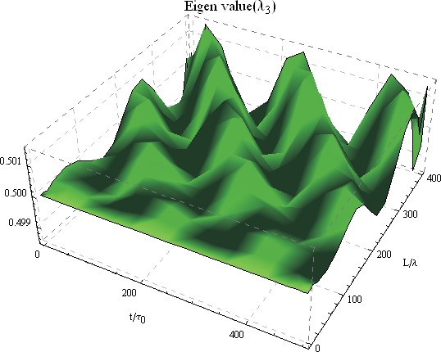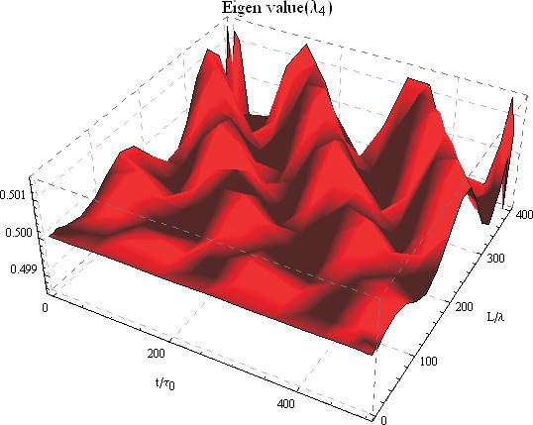

FIG. 2: Fluctuation of eigenvalues λ1,2,3,4 versus t/τ0 and L/λ, such as γ41,43,31,32 = 2γ, Ωc = 5γ, ∆c,p = 0γ, ∆m = 0.001γ,
| |
ϕ = 0 and ϕs = 0, τ0 = 0.001s
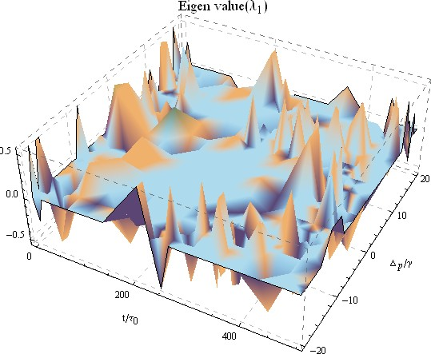
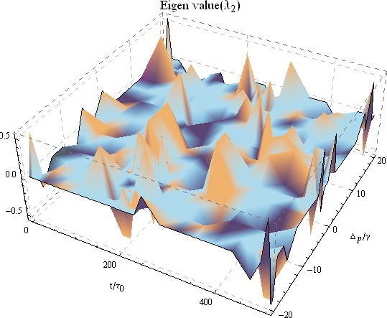
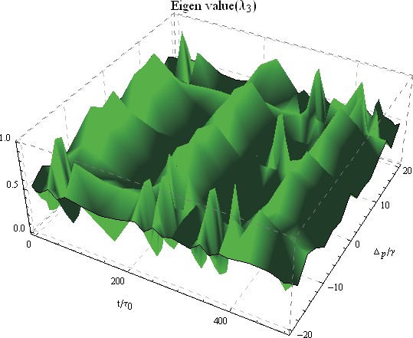
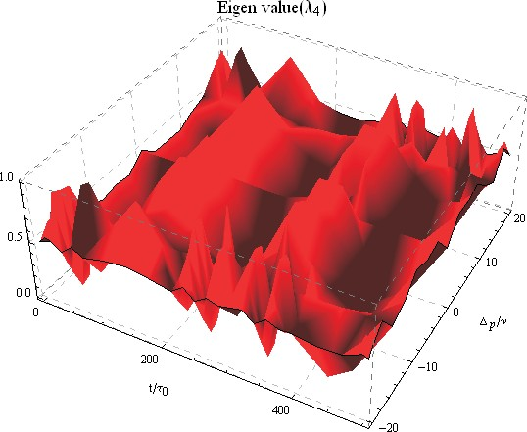

FIG. 3: Fluctuation of eigenvalues λ1,2,3,4 versus t/τ0 and ∆p/γ, such as γ41,43,31,32 = 2γ, Ωc = 5γ, ∆c = 0.005γ, ∆m = 0.001γ,
| |
ϕ = 0 and ϕs = 0, τ0 = 0.001s, L = 5λ

In FIG.2, the plots are traced for the eigenvalues λ₁ and λ₂, λ₃ and λ₄ versus t/τ₀ and L/λ. The eigenvalues of λ₁ and λ₂ are strong oscillating function of t/τ₀ normalized to beam width τ₀ and space L/λ normalized to wavelength λ. The eigenvalue λ_{1,2} show maximum positive and negative value of 0.5 at different point of t, L. It some point of the (t, L) the value is negative and other points of t, L) its value is positive. Positive value show separability of the two beams and negative value show entanglement between the two beams as shown FIG.2(a,b). The value of other two eigenvalues λ₃, λ₄ has positive and oscillated with t/τ₀ and L/λ. These two eigenvalues have no negatively both with time and space variation as shown in FIG.2(c,d).
±
In FIG.3, the plots are traced for the eigenvalues λ₁ and λ₂, λ₃ and λ₄ versus t/τ₀ and ∆_{p}/γ. The eigenvalues of λ₁ and λ₂ oscillated with time t/τ₀ and probe detuning ∆_{p}/γ normalized to decay rate γ. The eigenvalue λ_{1,2} show maximum negative and positive value of 0.5 at different point of t, ∆_{p}. Some point of(t, ∆_{p}) its value is negative and other points of t, ∆_{p}) its value is positive as shown FIG.3(a,b). The other two eigenvalues λ₃, λ₄ has positive value and oscillated with t/τ₀ and ∆_{p}/γ as shown in FIG.3(c,d).
±
In FIG.4, the plots are traced for the eigenvalues λ₁ and λ₂, λ₃ and λ₄ versus t/τ₀ and Ω_{c} /γ. The eigenvalues of λ₁ and λ₂ are also oscillated in time t/τ₀ and control field Rabi frequency Ω_{c} /γ. The eigenvalue λ_{1,2} show maximum negative and positive value of 0.5 at different point of t, Ω_{c}. It is positive value at some point (t, Ω_{c}) and negative value at other points of t, Ω_{c}) as shown FIG.4(a,b). The value of other two eigenvalues λ₃, λ₄ has positive and oscillated with t/τ₀ and Ω_{c} /γ as shown in FIG.4(c,d).
±
| |
| |
| |
In FIG.5, the plots are traced for the eigenvalues λ₁ and λ₂, λ₃ and λ₄ versus t/τ₀ and ∆_{c}/γ. The eigenvalues of
λ₁ and λ₂ oscillated with time t/τ₀ and control field detuning ∆_{c}/γ normalized to decay rate γ. The eigenvalues λ_{1,2}

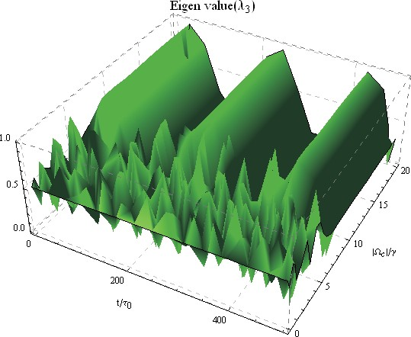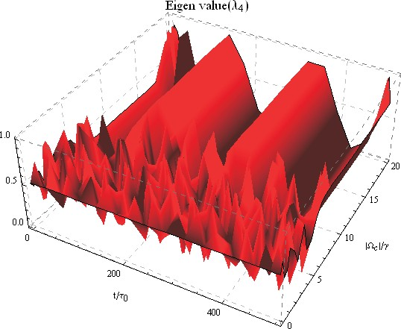

FIG. 4: Fluctuation of eigenvalues λ1,2,3,4 versus t/τ0 and Ωc /γ, such as γ41,43,31,32 = 2γ, Ωc = 5γ, ∆c = 0.005γ, ∆p = 0.5γ,
| | | |
∆m = 0.001γ, ϕ = 0 and ϕs = 0, τ0 = 0.001s, L = 5λ
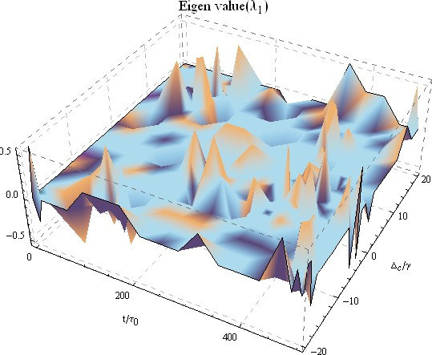
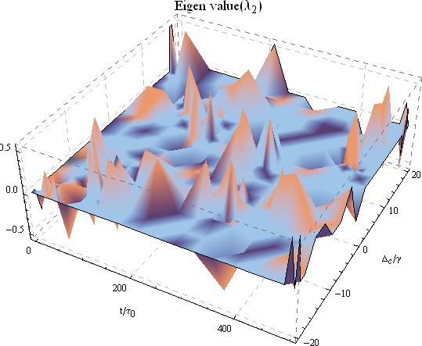

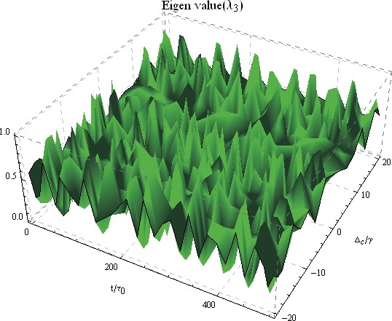
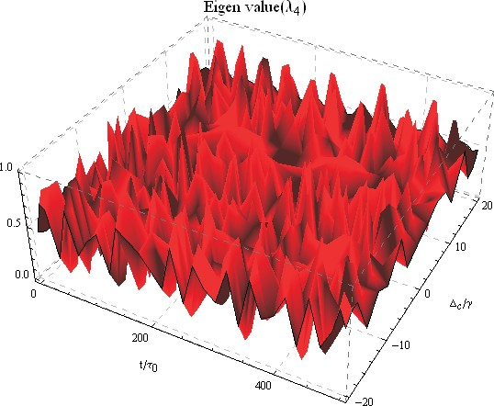

FIG. 5: Fluctuation of eigenvalues λ1,2,3,4 versus t/τ0 and ∆p/γ, such as γ41,43,31,32 = 2γ, Ωc = 5γ, ∆p = 0.5γ, ∆m = 0.001γ,
| |
ϕ = 0 and ϕs = 0, τ0 = 0.001s, L = 5λ

show maximum negative and positive value of 0.5 at different point of t, ∆_{c}. It has positive value at some point of the (t, ∆_{c}) and negative value at other points of t, ∆_{c}) as shown FIG.5(a,b). The other two eigenvalues λ₃, λ₄ has positive value and oscillated with t/τ₀ and ∆_{c}/γ as shown in FIG.5(c,d).
±

- CONCLUSION

In conclusion, the four-level chiral atomic model is used for the modification of birefringent beams of light. The left and right circularly polarized are controlling with system parameters. The casual relationship between two split rays (left and right) circularly polarized beams through the chiral medium are investigated by bell states formalism. Using partial transposition and superposition of bell states to investigate entanglement phenomenon between the left and right circular polarization beams through the negativity of eigenvalues. Measurement of partial transposition shows two fluctuated positive and negative eigenvalues with time flow, spatial variation, and system parameters. The maximum positive and negative value of 0.5 is investigated with variation of space, time and system parameters. The existence of negative eigenvalues pointed out entanglement between the birefringence of left and right circularly polarized beams. Fluctuation of positive and negative eigenvalues shows fluctuation between separable and entangled states. The theoretical results may be useful for super-dense coding, quantum cryptography, quantum bits, and
±

quantum teleportation of optical technology.

- Unscrambling entanglement through a complex medium Natalia Herrera Valencia 1 , Suraj Goel 1,2, Will McCutcheon1 , Hugo Defienne 3 and Mehul Malik 19 june (2020).
- Krenn, M., Malik, M., Erhard, M. and Zeillinger, A. Orbital angular momentum of photons and the entanglement of LaguerreGaussian modes. Philos. Trans. R. Soc. A 375, 20150442 (2017).
- . Kelly, J. et al. State preservation by repetitive error detection in a superconducting quantum circuit. Nature 519, 6669 (2015)
- M. A. Nielsen and I. L. Chuang, Quantum Computation and Quantum Communication (Cambridge University Press, Cambridge, England, 2000).
- C. H. Bennett and S. J. Wiesner, Phys. Rev. Lett. 69, 2881 (1992).
- Leedumrongwatthanakun, S. et al. Programmable linear quantum networks with a multimode fbre. Nat. Photon. 14, 139142 (2020).
- Defenne, H., Reichert, M. and Fleischer, J. W. Adaptive quantum optics with spatially entangled photon pairs. Phys. Rev. Lett. 121, 233601 (2018).
[8] D.N. Klyshko, Phys. Usp.41, 885 (1998).
- Born.M 1983 Letter from Albert Einstein to Max Born Physik im Wandel meiner Zeit (Berlin: Springer) p 228 (2006).
- J. Este‘ve, C. Gross, A. Weller, S. Giovanazzi, and M. K. Oberthaler, Nature (London) 455, 1216 (2008).
- B. Julsgaard, A. Kozhekin, and E. S. Polzik, Nature (London) 413, 400 (2001)
- F. De Martini, F. Sciarrino, and C. Vitelli, Phys. Rev. Lett. 100, 253601 (2008); F. De Martini, F. Sciarrino, C. Vitelli, and F. S. Cataliotti, Phys. Rev. Lett. 104, 050403 (2010); N. Spagnolo, C. Vitelli, F. Sciarrino, and F. De Martini, Phys. Rev. A 82, 052101 (2010).
- P. Sekatski, N. Brunner, C. Branciard, N. Gisin, and C. Simon, Phys. Rev. Lett. 103, 113601 (2009).
- P. D. Drummond, Phys. Rev. Lett. 50, 1407 (1983), Ch. Simon and D. Bouwmeester, Phys. Rev. Lett. 91, 053601 (2003).
- B.J Dalton, et al Phys. Scr. 92 023004. (2017)
- C. H. Bennett et al., Phys. Rev. Lett. 70, 1895 (1993).
- C. H. Bennett and S. J. Wiesner, Phys. Rev. Lett. 69, 2881 (1992).
- A.Ekert, Nature 358, 14 (1992); N. Gisin, G. Ribordy, W. Tittel, and H. Zbinden, Rev. Mod. Phys. 74, 145 (2002).
- Weedbrook, Christien, S. Pirandola, R. G. Petron, N. J. Cerf, T. C. Ralph, J. H. Shapiro, and S. Lloyd ” Gaussian quantum informatiom ” A. J. Phys. 84, 2, 621-669 (2012).
- T. E. Northup, R. Blatt” Quantum information transfer using photons” Nture Photonics, 8, 356-363 (2014).
- D.Bouwmeester ” The Physics Of Quantum Information” Springer Verlag. 191 (2000)
- R. Horodecki, P. Horodecki, M. Horodecki, K.Horodecki” Quantum Entanglement” Rev Mod. Phys. 81, 865-942 (2009).
- . Epping, M., Kampermann, H., Macchiavello, C. and Bru, D. Multi-partite entanglement can speed up quantum key distribution in networks. New J. Phys. 19, 093012 (2017).
- Zhoudunming Tu ,1,* Dmitri E. Kharzeev,2,3 and Thomas Ullrich. Einstein-Podolsky-Rosen Paradox and Quantum En- tanglement at Subnucleonic Scales. Physical Review Letters 124, 062001 (2020)
- Moreau, P.-A., Toninelli, E., Gregory, T. and Padgett, M. J. Imaging with quantum states of light. Nat. Rev. Phys. 1, 367380 (2019).
- Unscrambling entanglement through a complex medium by Natalia Herrera Valencia 1, Suraj Goel 1,2, Will McCutcheon1
, Hugo Defienne 3 and Mehul Malik Received: 28 November 2019; Accepted: 19 June (2020)

