Selective detection of diethanolamine utilizing LMR/LSPR based optical fiber sensor

Kavita and Jyoti, Department of Physics, Central University of Rajasthan, Ajmer, Rajasthan, India
Shruti Gupta, Kiran Kumar Tejavath, Department of Biochemistry, Central University of Rajasthan, Ajmer, Rajasthan, India
R.K. Verma, Department of Physics, University of Allahabad, Prayagraj, Uttar Pradesh, India

Abstract
Image
In the present study, we have designed a Lossy Mode Resonance (LMR)/LSPR based optical fiber sensor for the detection of diethanolamine (DEA). In order to achieve the required outcomes, two optical fiber probes were fabricated (1) $TiO_{2}$bulk layer coated optical fiber probe and, (2) $TiO_{2}$ / AuNPs bilayer coated optical fiber probe. Characterization such as FESEM, HRTEM and UV-visible spectra are used for the confirmation of the prepared optical fiber probes. Sensitivity of $TiO_{2}$ bulk layer/AuNPs bilayer coated optical fiber probe is numerically observed 16079.63nm/RIU or 0.074nm/mM which is approximately double the sensitivity of the $TiO_{2}$bulk layer coated optical fiber probe. Performance of our sensor is assessed with the calculation of some other parameters such as Limit of Detection, Figure of Merit, repeatability and response time. To make this sensor highly sensitive to DEA a selectivity experiment is also performed. From the best of our knowledge, this is the first attempt for detection of DEA with LMR based optical fiber sensor. Authors believe that this research will be very valuable for the approaching researchers for the development in this field. Further research should concentrate on the use of nano-structures for enhanced optimization and capability.

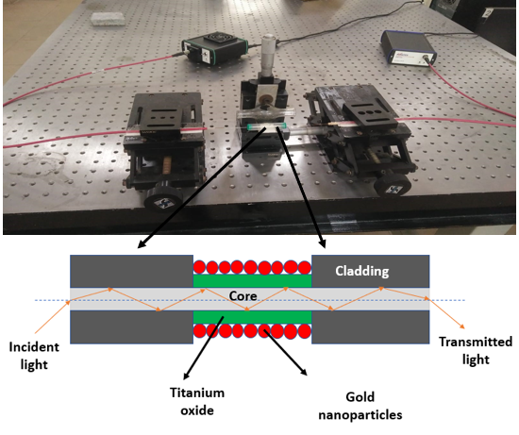
Fig.1. Pictorial representation of proposed optical fiber probe
Recent Publications
1. Kavita & Verma, R. K. Simulation of localized surface plasmon resonance of silver nanoparticles with graphene coating utilizing maxwell-garnett theory. J. nano Electron. Phys. 13, 2020–2023 (2021).
2. Kavita, Jyoti, Gupta, S., Tejavath, K. K. & Verma, R. K. Selective detection of diethanolamine utilizing an LMR/LSPR-based optical fiber sensor. R. Soc. Chem. 147, 4587–4597 (2022).
3. Jyoti, Kavita & Verma, R. K. Selective detection of urea as milk adulterant using LMR based Fiber Optic Probe Journal of Food Composition and Analysis Selective detection of urea as milk adulterant using LMR based Fiber Optic Probe. J. Food Compos. Anal. 114, 104825 (2022).
4. Kavita et al. Detection of alcohol content in food products by lossy mode resonance technique. J. Electrochem. Soc. 169, (2022).



Biography
Kavita has expertise and passion in her field of research. She is very focused and sincere about her work. She has one and half years’ experience of working in a project. She has experience of working with some software like Origin, MATLAB, COMSOL, and LaTex etc. She is working theoretically and experimentally both, on the fabrication of sensor and biosensor. She has successfully fabricated a selective ethanol/methanol detection sensor, used the enzymes and co-enzyme technique for urea detection in milk which is her another publication. DEA was selectively detected by her using optical fiber sensor utilizing LMR/LSPR technique that is currently published in RSC Journal. This conference will be a platform for her to present her work and skills. This will be helpful to get more knowledge and collaborate with the researchers from all over the world and make more effective sensors for the detection of adulterants in food.
Email: rkverma@curaj.ac.in

Notes/Comments:

Presenting author details
Full name: Kavita
Contact number: 7056891125
Twitter account:
Linked In account:
Session name/ number: 16th International Conference on Optics, Photonics & Laser, March 13-14, 2023 Frankfurt, Germany
Category: (Oral presentation/ Poster presentation)

