Histopathological Grading of Oral Squamous Cell Carcinoma Using Artificial Intelligence/Digital Pathology

Dr Manal Rauf, Dr Sidrah Omair, Hasan Nasir Khan, Dr Ahson Ahmad ,Dr Momina

Habib,Dr Ahmareen Khalid Sheikh

Pakistan Institute of Medical Sciences, Islamabad Pakistan

Email: manalrauf25@gmail.com

Phone number : +923176032687

Title: | Histopathological Grading of Oral Squamous Cell Carcinoma Using Artificial Intelligence/Digital Pathology.
Objectives /Introduction: | Oral squamous cell carcinoma is the most frequent histological neoplasm of head and neck cancers. The standard procedure for the diagnosis of oral cancer is based on histopathological examination. However, the main problem in this kind of procedure is tumor heterogeneity where a subjective component of the examination could directly impact patient-specific treatment intervention. The indication of neo-adjuvant therapy is majorly dependent on histopathological grade and stage of oral squamous cell carcinoma. To avoid this heterogeneity, artificial intelligence (AI) algorithms are widely used as digital and computational aid in the diagnosis for classification of tumors. In this research, a two-stage Histoapthology/AI-based system for automatic multiclass grading is proposed in order to assist the clinician in oral squamous cell carcinoma diagnosis. 1st stage comprises of sharing histological grade assigned image which was being analyzed using AI/ Deep learning methods in the 2nd stage.
Material and Methods: | This study is being carried out in Pakistan Institute of Medical Sciences (PIMS) in collaboration with COMSATS University (CUI), Islamabad from April, 2022 till 30th September, 2022. Histopathological grading of Oral squamous cell carcinoma was done in 3 grades namely Well differentiated, Moderately differentiated and Poorly Differentiated squamous cell carcinomas, by a qualified Histopathologist using microscope Olympus 22X CLED Microscope. The images were taken and shared with the AI team which analyzed the results using state-of-the-art deep learning algorithms naming “DenseNet101”. A good balance between true positive rate and false positive rate was achieved in the model, and the performance of the proposed system is improved by the use of transfer learning.
Results: | - The study was performed on 650 Histopathology Images.  - State-of-the-art deep learning-based models were trained on these images.  - Normalization techniques are applied in the preprocessing stage for better convergence.  - Overall 82.03 % accuracy was achieved by the model on testing data.  - The average precision of all classes was achieved by 80%.  - The average recall of all classes was achieved by 81%.  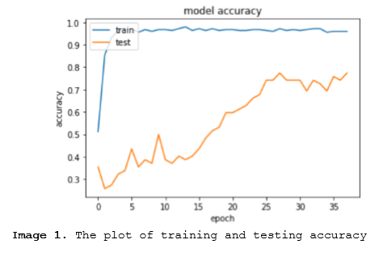  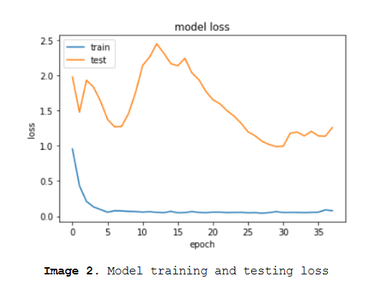  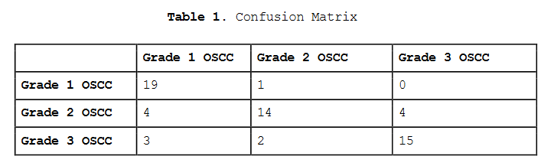  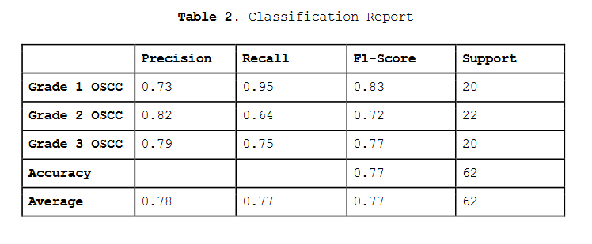
Conclusion: | In a continuously evolving era, inter- and intra-observer variability in assigning a histological grade to the most prevalent carcinoma can be reduced by the promising results of Digital Pathology, hence aiding in patient management. These revolutionary and need of the hour Digital Pathology innovations can be extrapolated to other problematic areas of pathology.
References: | - Mahmood H, Shaban M, Rajpoot N, Khurram SA. Artificial Intelligence-based methods in head and neck cancer diagnosis: An overview. British journal of cancer. 2021;124(12):1934-40.  - Musulin J, Štifanić D, Zulijani A, Šegota SB, Lorencin I, Anđelić N, et al., editors. Automated Grading of Oral Squamous Cell Carcinoma into Multiple Classes Using Deep Learning Methods. 2021 IEEE 21st International Conference on Bioinformatics and Bioengineering (BIBE); 2021: IEEE  - Musulin J, Štifanić D, Zulijani A, Ćabov T, Dekanić A, Car Z. An enhanced histopathology analysis: An ai-based system for multiclass grading of oral squamous cell carcinoma and segmenting of epithelial and stromal tissue. Cancers. 2021;13(8):1784  - Rahman TY, Mahanta LB, Choudhury H, Das AK, Sarma JD. Study of morphological and textural features for classification of oral squamous cell carcinoma by traditional machine learning techniques. Cancer Reports. 2020;3(6):1293.

