Effect of laser surface remelting on the microstructure, mechanical, tribological and corrosion properties of the Ti40Nb25Zr25Ta10 (with 0.5 at.% O) medium entropy alloy (MEA)
L. Mustafi, RMIT University, Australia
A. Jones, RMIT University, Australia
V.T. Nguyen, University of Queensland, Australia
Q. Deng, RMIT University, Australia
X. Chen, RMIT University, Australia
T. Song, RMIT University, Australia
D. M. Fabijanic, Deakin University, Australia
M. Qian, RMIT University, Australia

Abstract
High-entropy alloys (HEAs)/ medium-entropy alloys (MEAs) provide a novel design concept for metallic biomaterials. A non-equiatomic bio- applicable as-cast Ti40Nb25Zr25Ta10 (with 0.5 at. % O) MEA was surface remelted by laser. The consequent effect on the constituent phases, microstructures, mechanical properties, tribological and corrosion resistance properties was investigated. The alloy exhibited a stable body-centred cubic phase after laser surface remelting with a significant decrease in grain size from about 106 μm to 12 μm, accompanied by an increase in hardness from 4.44 ± 0.29 GPa to 7.58 ± 0.15 GPa. Accordingly, the wear rate decreased by 22.5% at applied loads in the range of 200-600 μN load. The corrosion current density of the laser surface remelted MEA (0.013 ± 0.06 μA/cm2) was reduced compared to the as-cast microstructure (0.034 ± 0.08 μA/cm2) in Hank’s solution. The improved corrosion resistance can be attributed to the resulting finer grain sizes. Laser surface remelting offers a potential approach for modifying the Ti40Nb25Zr25Ta10 MEA for biomedical applications.

Image
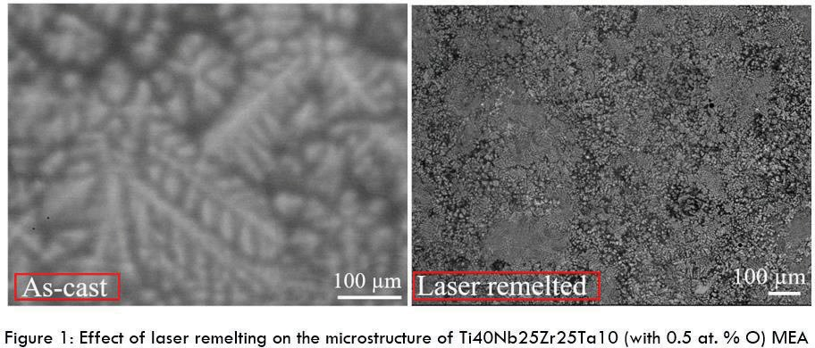
Recent Publications
- L. Mustafi, V. T. Nguyen, S. L. Lu, T. Song, B. J. Murdoch, D. M. Fabijanic, M. Qian (2021) Microstructure, tensile properties and deformation behaviour of a promising bio-applicable new Ti35Zr15Nb25Ta15 medium entropy alloy (MEA). Materials Science and Engineering A 824:1-11.
- Labani Mustafi, M. M. Rahman, Mohammad Nur E Alam Al
Nasim, Mohammad Asaduzzaman Chowdhury, M. H. Monir (2018) Deposition behavior and tribological properties of diamond-like carbon coatings on stainless steels via chemical vapor
deposition. International Journal of Minerals, Metallurgy and Materials 11:1335-1343.
- Mohammad Nasim, Labani Mustafi and Harun Chowdhury (2022)
A Review on Few-Layer Graphene Flakes Deposition by Kinetic Spray Process for Energy Storage Devices. The 3rd International Conference on Energy and Power (AIP Conference Proceedings) 2681:020070.
- Mohammad Nasim, Truong Quoc Vo, Labani Mustafi, BoHung Kim, Caroline Sunyong Lee, Won-Shik Chu, Doo-Man Chun (2019) Deposition mechanism of graphene flakes directly from graphene particles in the Kinetic spray process studied using molecular dynamics simulation. Computational Materials Science
169: 109091
- Labani Mustafi, Mohammad Nur E Alam Al Nasim (2017) A study of isotheremal phase transformation behaviour of TC6 titanium alloy during heat treatment process. Journal of Mechanical and Mechanics Engineering 3:3.



Biography
Labani Mustafi is a Higher Degree Research Candidate at Centre for Additive Manufacturing, School of Engineering, RMIT University, Melbourne, Australia. She completed her M. Eng. degree in materials science from Harbin Institute of Technology, China and B.Sc (Hons) degree in Materials Science and Engineering, Rajshahi University, Bangladesh. Her research focuses on the design and development of strong and ductile high entropy alloys and medium entropy alloys for biomedical applications. Her research also spans on the development of titanium alloys for high temperature applications, 2D and Diamond Like Carbon (DLC) materials for tribological applications. She has an expertise on materials design and fabrication via conventional casting, additive manufacturing, chemical vapour deposition (CVD), thermomechanical heat treatment methods, simulating phase diagram using different software, characterizing samples using advanced microscopy techniques, mechanical and tribological performances testing and electrochemical corrosion testing. Her research outputs have been published/presented in prestigious scientific journals and international/national conferences.

Email:s3676020@student.rmit.edu.au or, labanimustafi@gmail.com

Notes/Comments: Could you please inform me the abstract acceptance outcome as soon as possible, so that I could proceed with my university formalities for the conference registration and visa?

Presenting author details
Full name: Labani Mustafi
Contact number: +61406102939 Twitter account: N/A
Linked In account: https://www.linkedin.com/in/labani-mustafi-95447850/ Session name/ number: Biomaterials and Bio Devices/ Track 17
Category: Oral presentation

