Extent of Knowledge, Preparedness and Perception on Telemedicine among Family Medicine Resident Physicians in Different Training Institutions in Cebu City during COVID-19 Pandemic
Kristine Joy Y. Sumanga
MD, VSMMC, Cebu, PH

Abstract
Background: Telemedicine is the delivery of health care services at a distance using electronic means, the diagnosis of treatment, and prevention of disease and injuries, research and evaluation, education of health care providers. The role of telemedicine in this time of COVID19 pandemic is vital especially to the practice of medicine.
General Objective: To determine the extent of knowledge, preparedness and perception on telemedicine among Family Medicine Resident Physicians in different training institutions in Cebu City during COVID 19 pandemic.
Methods: A descriptive, cross-sectional, survey research study conducted in four hospital training institutions in Cebu City. A total of 41 respondents gave their consent and were given the online survey questionnaire pertaining to the extent of knowledge, preparedness and perceptions on telemedicine, including respondents’ demographic data and problems encountered in Telemedicine.
Results: Out of the 41 respondents, 56.10% were young adults (26 to 30 years old), mostly females (70.73%), single (68.29%), first year residents (43.90%), employed at a government hospital (70.73%) and are in the traditional residency pathway (82.93%). On relevant experience, 82.93% experienced telemedicine during residency, with 100% on follow up consultations, and 95% were consulted due to infections. Respondents’ extent of knowledge were average while extent of preparedness and perception were high. Problems on low connectivity (80.48%) was noted by most of the respondents.
Conclusion: Resident physicians moderately understood the information about telemedicine but with a high extent of preparedness and perception. They are always prepared for telemedicine modality because they are fully aware of its existence and need in the delivery of health care services among their patients at the time of pandemic. Challenges on low connectivity and handling patients’ data privacy were the major concerns met by the resident physicians in the use of telemedicine.

Recent Publications
- [1] Kay M and Takane J. Telemedicine: Opportunities and development in member states [Internet]. Who.int. 2010 [cited 2021 Jan 12]. Available from: https://www.who.int/goe/publications/goe_telemedicine_2010.pdf
- [2] Serper M and Volk ML. Current and future applications of telemedicine to optimize the delivery of care in chronic liver disease. Clinical Gastroenterology and Hepatology. 2018 Feb 1;16(2):157-61.
- [3] Doh.gov.ph [Internet]. DOH BOOSTS TELEMEDICINE SERVICES FOR NCR; SERVICE TO EXPAND TO OTHER REGIONS SOON | Department of Health website 2020 (cited 2021 Feb 12). Available from: https://doh.gov.ph/doh-press-release/DOH-BOOST-TELEMEDICINE-SERVICES-FOR-NCR-SERVICE-TO-EXPAND-TO-OTHER-REGIONS-SOON
- [4] Judi HM, Razak AA, Sha’Ari N and Mohamed H. Feasibility and critical success factors in implementing telemedicine. Information Technology Journal. 2009 Mar;8(3):326-32.

Biography

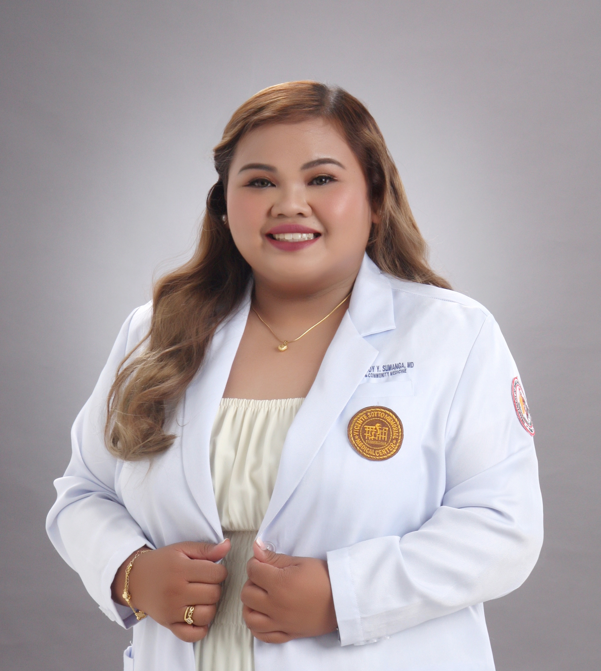
Dr. Kristine Joy Y. Sumanga had her residency training in Family and Community Medicine in Vicente Sotto Memorial Medical Center, Cebu City, Philippines. During her residency, the COVID19 pandemic changed the course of health service delivery due to community quarantines and isolation. This was one of the challenges faced by family medicine residents who are in the frontlines in patient care. Together with her Medical Specialist Consultant, Dr. Clarissa Mae D. Derecho, the above research was conducted. Dr. Sumanga’s passion is focused towards public health and health service delivery to the community and using technology for this cause will be a great stepping stone for a better and healthier tomorrow.

