Follow your heart: the dearth of data regarding cardiovascular outcomes in transgender patients
Emiry Dodds, University of Oxford, UK Dr Jack Amiry, University of Oxford, UK Dr Sanah Ali, University of Oxford, UK

Abstract
Focus: This poster examines existing literature regarding cardiovascular outcomes in transgender populations who receive hormone affirming therapy (HAT). In doing so, we consider the rationale for encouraging the establishment of prospective observational studies of HAT-receiving transgender populations to delineate if an elevated risk of cardiovascular disease is truly present.
Background: It is estimated 0.3-0.8% of the population identify as transgender, of which 75% will utilise hormone affirming therapy (HAT). Trans populations are posited to be at a higher risk of negative health outcomes due to elevated psychosociological pressures and increased levels of substance use. Due to elevated risk in this population, there are concerns regarding the long-term safety profiles of cross-sex hormones. Short-term and medium-term safety profiles are established but there is some evidence to suggest that HAT can be associated with increased risk of cardiovascular events later in life. Little guidance exists on whether cardiovascular screening is necessary to optimise trans healthcare following HAT initiation. The transgender population is growing as society becomes more accepting of gender minorities. As such, there is increased demand to provide evidence-based quality care for trans patients.
Recommendation: With few high-quality long-term data sets present on the subject, it is difficult to determine long- term safety profiles for HAT. Developing prospective observational studies of HAT-receiving individuals has the potential to tackle unanswered questions in this field. HAT is lifesaving for many trans people, and full understanding of its impacts is necessary to empower gender minority groups to live as freely as possible.
Image

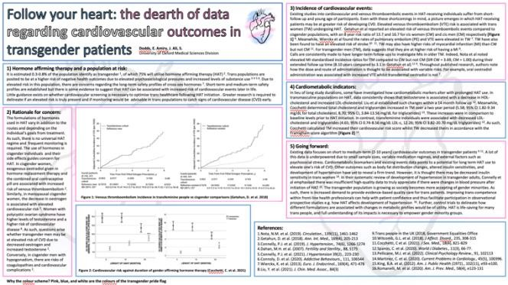



Biography
Emiry Dodds is a 5th year medical student at the University of Oxford. They identify as non-binary and have an interested in differential healthcare outcomes for minority groups. They are currently involved in an equality, diversity, and inclusivity (EDI) project run by a group of their peers. The project aims to provide an EDI online resource for incoming medical students at the University of Oxford. The project will cover how characteristics such as race, religion, sex, gender, sexuality, disability, and class impact healthcare outcomes. As part of the project, Emiry has written regarding feminism and transgender health.
Email: emily.dodds@new.ox.ac.uk

Notes/Comments:

Presenting author details
Full name: Emiry Dodds
Contact number: +447530 910969 Twitter account:
Linked In account: Emiry Dodds
Session name/ number: 4th Global Summit on Diabetes and Endocrinology Category: Poster presentation

