Utilization and compliance with iron supplementation and predictors among pregnant women in Southeast Ethiopia
Girma Beressa¹*, Bikila Lencha¹, Tafese Bosha², Gudina Egata³
¹School of Health Sciences, Madda Walabu University, P.O.Box 302, Goba, Ethiopia,
²School of Nutrition, Food Science and Technology, Hawassa University, P.O.Box 05, Hawassa, Ethiopia,
³School of Public Health, Addis Ababa University, P.O.Box 1176, Addis Ababa, Ethiopia
Email Addresses: ¹gberessa@gmail.com,¹lenibikimule@gmail.com,²tafese.bosha@gmail.com,³ gudina_egata@yahoo.com
*Corresponding author: Girma Beressa
Email: ¹gberessa@gmail.com
Telephone: +251912824210
Postal address: Madda Walabu University, Goba, Ethiopia
Presentation type: (Oral presentation)
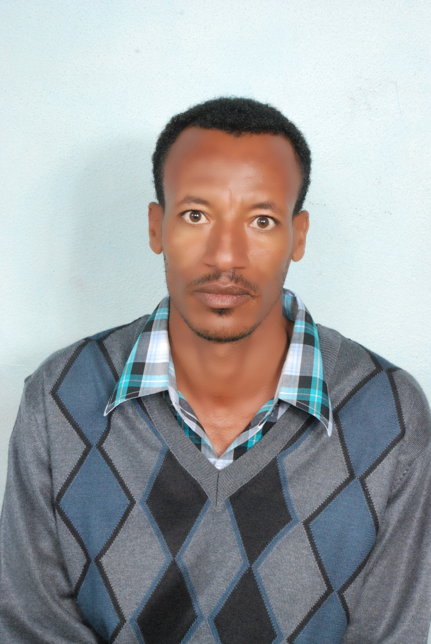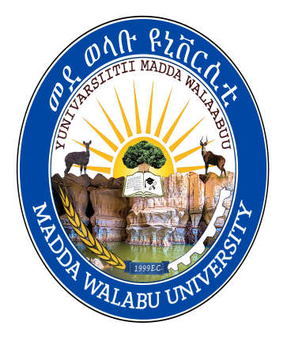

Abstract
Anemia is predicted to affect 38% of pregnant women worldwide. However, evidence for utilization and compliance with iron supplementation and predictors during pregnancy in Ethiopia, is inconclusive. Therefore, we aimed to assess utilization and compliance with iron supplementation and predictors among pregnant women in Robe Town, Southeast Ethiopia. A community-based cross-sectional study was employed among randomly selected 445 pregnant women attending antenatal care. Systematic random sampling was used. Data were collected using a pre-tested, interviewer-administered, structured questionnaire. Bivariable and multivariable logistic regression analyses were used. In this study, 54% (95% CI: (49.4, 58.4%), 45.2% (95% CI: (40.9, 49.4%), 4.3% (95% CI: (2.5, 6.3%), and 2.2% (95% CI: (1.1, 3.6%) of women received iron supplements during their first, second, third, and fourth antenatal care visits, respectively. The compliance with iron supplementation was 92.4% (95% CI: (89.9, 94.6%). Having a formal education (AOR = 4.45, 95% CI: 1.41, 13.99), being in the high wealth quintile (AOR = 0.18, 95% CI: 0.05, 0.68), receiving iron supplements for free (AOR=3.77, 95% CI: 1.33, 10.69), not experiencing discomfort related to iron supplements intake (AOR = 2.94, 95% CI: 1.17, 7.39), having comprehensive knowledge about anemia (AOR=2.62, 95% CI: 1.02, 6.70), being knowledgeable about iron supplements (AOR=3.30, 95% CI: 1.12, 9.76), having information about importance of iron supplementation during pregnancy (AOR=2.86; 95% CI: 1.04, 7.87), and ever being visited by urban health extension workers (AOR=0.31; 95% CI: 0.12, 0.83) was significantly associated with compliance with iron supplementation during pregnancy. The utilization of iron supplementation during pregnancy was low, with relatively high compliance with the supplements. Thus, comprehensive nutrition education and free provision of iron supplementation are crucial tools to increase utilization and compliance with iron supplementation during pregnancy. Further research with a strong study design using golden standard methods is warranted.
BIOGRAPHY:
Girma Beressa undertakes research in nutrition, epidemiology, public health, and medicine. He has published more than 13 articles in peer-reviewed international reputable journals. His leading research focuses on maternal and child nutrition. He employs health behavior models and theories in his work. He also has vast expertise in providing evidence via systematic JBI and Cochrane reviews. Nevertheless, he is most interested in what happens to research findings after they are generated, such as information dissemination into policy, practice, and the general community.

