Sleep Quality and Associated Factors Among Type 2 Dm Patients and Non-Dm Individuals in Bahir Dar Governmental Hospitals: Comparative Cross-Sectional Study
Dagmawit Zewdu, MSc in Adult Health Nursing, College of medicine and health science, Bahir Dar University, Bahir Dar, Ethiopia

Abstract
Background: Multiple factors may contribute to sleep disruption among individuals with type 2 diabetes mellites. Sleep disruption among individuals with type 2 diabetes mellites is frequently associated with long-term damage, dysfunction, and failure of different organs. Nevertheless, literature in this regard is scanty in Ethiopia. Therefore, this study aimed to assess and compare the prevalence of poor sleep quality and associated factors among type 2 diabetes mellites patients and non-diabetes individuals in Bahir Dar governmental hospitals.
Methods: Comparative cross-sectional study was employed among 292 individuals with type 2 diabetes mellites and 291 non-diabetic individuals in Bahir Dar governmental hospitals from March 01- to April-01. A two-stage cluster sampling method was employed to select participants. Pittsburgh sleeps quality index was used for assessing sleep quality. For analysis, descriptive statistics and binary logistic regression models were used.
Result: The prevalence of poor sleep was 50.7% (95% CI; 44.9-56.2) and 31.8% (95% CI 26.5-37.5) among individuals with type 2 diabetes melilites and non-diabetic, respectively. Among the overall participants, type 2 diabetes melilites patients were also significantly associated with poor sleep quality than non-diabetic individuals (AOR=1.89; 95% CI; 1.19-2.87). Comorbidity, duration of DM>10 years, Poor glycaemic control, depression, low physical activity, and poor social support were factors significantly associated with poor sleep quality among individuals with type 2 diabetes melilites. Among non-diabetic individuals, low physical activity, poor social support, depression, and age group (>50 years) were factors significantly associated with poor sleep quality.
Conclusion: In this study, poor sleep among individuals with type 2 diabetes melilites was higher than non-diabetes individuals.
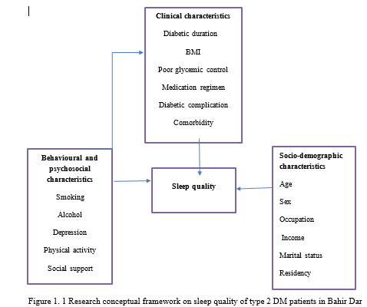

Recent publication
1, Zewdu, D., Gedamu, H., Beyene, Y. et al. Sleep quality and associated factors among type 2 Dm patients and non-Dm individuals in Bahir Dar governmental hospitals: comparative cross-sectional study.
Submitted papers

2. Prevalence of Attention Deficit Hyperactivity Disorder, and Associated Factors among School-Aged Children in Bahir Dar City, Northwest Ethiopia submitted to BMC Psychiatry

3. Dagmawit Zewdu, Tadios Lidetu, * et al. Incidence and Predictors of Post Stroke Seizure among Adult Stroke Patients in Western Amhara Region, Ethiopia, 2021: A Retrospective Follow up Study, 19 August 2022, PREPRINT (Version 1) available at Research Square [https://doi.org/10.21203/rs.3.rs-1975834/v1]
4. 'Incidence and Predictors of Dysphagia among Admitted Stroke Patients in Western Amhara Region, Ethiopia: A Prospective Follow-up Study' to 'International Journal of Africa Nursing Sciences'

 Biography
My name is Dagmawit Zewdu born in 1996, a lecturer as well as health practitioner in Bahir Dar University in Department of Adult Health nursing, College of medicine and Health Science, Bahir Dar, Ethiopia. I have got my BSc in comprehensive nursing and MSc in adult health nursing from Bahirdar University. I received three awards on my educational achievement in my undergraduate study program. Currently I am still working for the University in charge of teaching and advising graduate and undergraduate students. I am also engaged in conducting various researches focusing on chronic illness where I have authored and co-outer of five scientific papers. Furthermore, I also member of Ethiopian nursing association and actively participating in different community service provision.
Email; dagmawitzewdu4@gmail.com
Full name: Dagmawit Zewdu Wuletaw
Contact number: +251941301001
Category; oral presentation

