Gut Microbiota and Plasma Metabolites Alterations Associated with Parkinson's Disease
Puqing Wang, PhD, Hubei Clinical Research Center of Parkinson’s disease, China
Qiang Zhao, Hubei Clinical Research Center of Parkinson’s disease, China
Shujia Zuo, Hubei Clinical Research Center of Parkinson’s disease, China
Jing Tian, PhD, Hubei Clinical Research Center of Parkinson’s disease, China

Abstract
Patients with clinical diagnosis of parkinson’s disease (PD) often develop gastrointestinal tract symptom before onset of motor symptoms. Gut microbiota can produce a variety of metabolites, some of which can enter the bloodstream and impact host health. In recent years, many researchers have found that gut microbiome composition and plasma metabolome has been disturbed both in PD patients and in PD animals. However, there is lack of systematically study the shotgun metagenomic genome and blood metabolome in PD. The aim of this study was to investigate the relation of gut microbiota and metabolome composition in PD patients. Methods: Fecal DNA samples and blood plasma from 30 patients diagnosed with PD (PD group) and corresponding mates (HP group) were analyzed by shotgun next-generation sequencing of whole genomes and LC/MS untargeted metabolomic mass spectrum separately. Differential expression analysis of species and MetaCyc pathway metabolites were applied separately. With pathway-metabolite info relation recorded in MetaCyc database, the integrative correlation network was constructed with species, pathways, metabolites and PD.
Results: The univariate analysis found 109 species, 193 pathways abundance were significantly altered in PD group and two cluster with 94 metabolites were correlated with PD. Some of species like Prevotella corporis were reported to be altered in PD groups in previous research. The species-PD correlation analysis also found that some of species like CAG−411 sp000437275, UBA9502 sp003478505, CAG−83 sp900555735 were correlated with UPDRS-Ⅲ and Hoehn-Yahr stage consistently. The integrative correlation analysis shows that 55 species contribute to PD through PWY0-381, P101-PWY, PWY-6516 pathways by affecting Mannitol, 2,4-diaminobutanoic acid metabolism.

Image
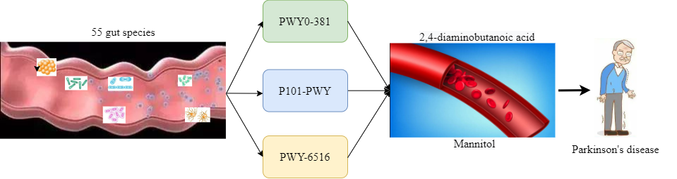

Recent Publications
- Pereira PAB, Trivedi DK, Silverman J (2022) Multiomics implicate gut microbiota in altered lipid and energy metabolism in Parkinson's disease. NPJ Parkinsons Dis 8(1):39.
- Chen SJ, Chen CC, Liao HY (2022) Alteration of Gut Microbial Metabolites in the Systemic Circulation of Patients with Parkinson's Disease. J Parkinsons Dis 12(4):1219-1230
- Szu-Ju Chen, Chieh-Chang Chen, Hsin-Yu Liao (2022) Association of Fecal and Plasma Levels of Short-Chain Fatty Acids With Gut Microbiota and Clinical Severity in Patients With Parkinson Disease. Neurology 98(8): e848–e858.
- Xingzhi G, Peng T, Chen H (2022) Integrated Microbiome and Host Transcriptome Profiles Link Parkinsons Disease to Blautia Genus: Evidence From Feces, Blood, and Brain. FRONTIERS IN MICROBIOLOGY 13:875101.
- Zheng SY, Li HX, Xu RC (2021) Potential roles of gut microbiota and microbial metabolites in Parkinson's disease. AGEING RESEARCH REVIEWS 69:101347.

 Biography
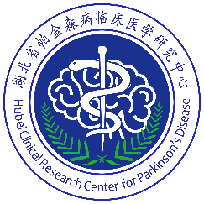
Puqing Wang is the director of depatment of Neurology， Xiangyang No.1 People's Hospital, Hubei University of Medicine, and has long been involved in clinical and research in Parkinson's disease. The main study direction was the association between gut microbiota and Parkinson's disease and articles were published in the journal “Parkinsonism and Related Disorders” and “Frontiers in Microbiology,” respectively.
Email: 1956342976@qq.com

Notes/Comments:

Presenting author details
Full name: Puqing Wang
Contact number: 15072288918
Twitter account:
Linked In account:
Session name/ number:
Category: (Oral presentation/ Poster presentation)

