Dental Education –

An essential step to create an awareness amongst Public and educating them about the importance of maintaining good oral hygiene.

Abstract (300 word limit)

Dental Education

Dental Education is very essential to create an awareness amongst Public and educating them about the importance of maintaining good oral hygiene which will lead to overall good health.

Dental Education aims to upgrade the knowledge and skills in Dentists and to provide regularly revised and updated techniques so that it’s an ease and to provide best treatment for the patients.

Foremost important step towards successful dental practice is to create an awareness in public about the importance of Dental checkup and educating public so that it’s easy for them to know the importance of maintaining good hygiene is mandatory step towards healthy life.

Lack of dental Education should be avoided and all the dentist should do awareness activities to create clear image amongst the public to clear all the doubts.

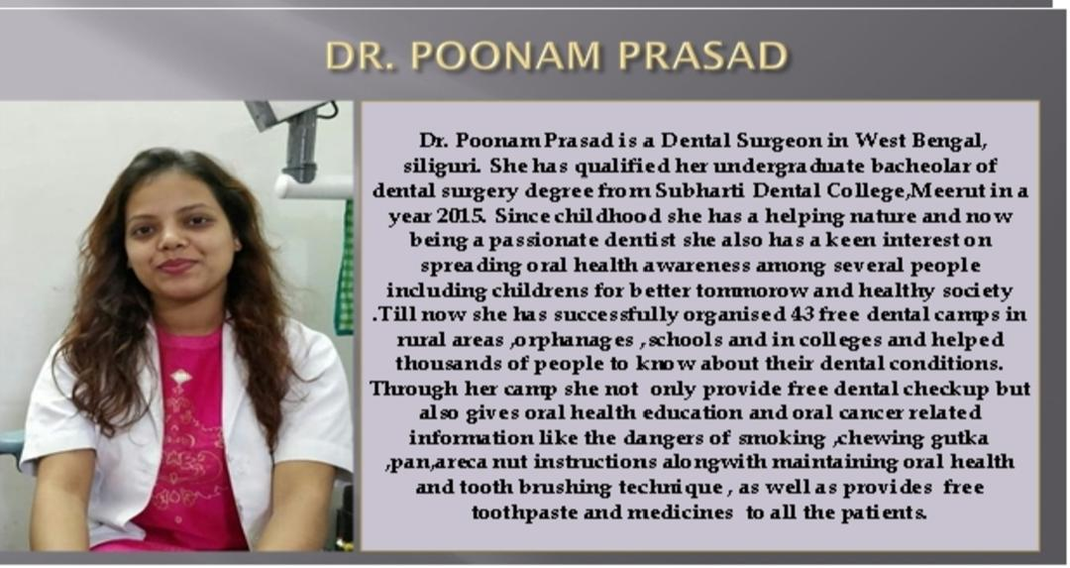Biography
Dental Education
Dental Education is very essential to create an awareness amongst Public and educating them about the importance of maintaining good oral hygiene which will lead to overall good health.
Dental Education aims to upgrade the knowledge and skills in Dentists and to provide regularly revised and updated techniques so that it’s an ease and to provide best treatment for the patients.
Foremost important step towards successful dental practice is to create an awareness in public about the importance of Dental checkup and educating public so that it’s easy for them to know the importance of maintaining good hygiene is mandatory step towards healthy life.
Lack of dental Education should be avoided and all the dentist should do awareness activities to create clear image amongst the public to clear all the doubts.

Email : drpoonamprasad54@gmail.com

Notes/Comments:

Presenting author details
Full name: Dr. Poonam Prasad
Contact number: 8348379696
Category: Oral presentation
Address – Prasad Multispeciality Dental clinic
Salugara bazar opposite DTDC courier office
West Bengal, India 734008

