Microalgae: a promising tool for bioremediation and a feedstock for recovering of high-value compounds under a biorefinery approach
Serena Lima, PhD, Engineering Department, University of Palermo, Palermo, Italy

Abstract (300 word limit)
Microalgae are a class of photosynthetic microorganisms that aroused interest in the scientific community over the last twenty years. They are characterized by a huge variety in terms of species and for this reason may be employed in several fields, accordingly to the characteristics of the produced biomass. Microalgae accumulate high levels of high-value compounds, such as carotenoids and omega 3.
These compounds find application in the nutraceutics, pharmaceutics and aquaculture fields and own an interesting commercial value. The remaining fractions of algal biomass are composed by lipids, carbohydrates and proteins and may be exploited as well in several other applications. As an example, the protein fraction may be employed as biostimulant, the carbohydrate fraction may be employed as a source of fermentable sugars or of furfuralic compounds and the lipid fraction may be employed as a source of biodiesel or as feedstock for biocatalytic processes.
Microalgae, furthermore, are able to use flue gasses CO2 as carbon source and to grow in wastewaters. For instance, they employ inorganic compounds such as nitrates and phosphates for their growth. For this reason, they may be employed in wastewater treatment with great results. They are also able to treat emerging contaminants and to decrease the metals from the waters in which they grow. In the last years, scientific community defined the concept of biorefinery applied to microalgal biomass. In fact, the processes of cultivation, harvesting and downstream treatment of the biomass require a significant energetic expense. It is therefore necessary to exploit every fraction of the obtained biomass in order to make the entire process economically feasible and to fulfill a circular process.
Image

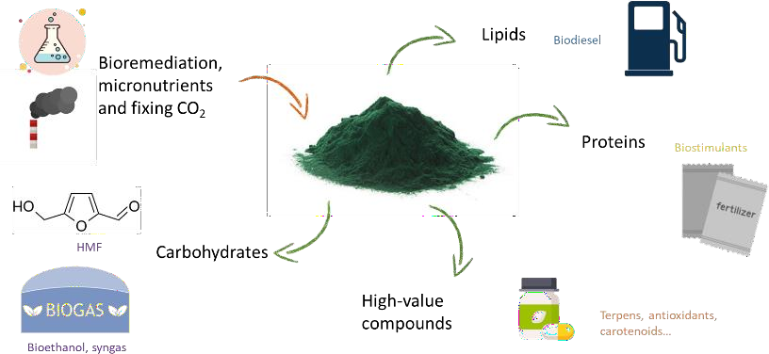

Recent Publications (minimum 5)
- S. Lima, A. Brucato, G. Caputo, L. Schembri, F. Scargiali, Modelling Nannochloropsis gaditana Growth in Reactors with Different Geometries, Determination of Kinetic Parameters and Biochemical Analysis in Response to Light Intensity, Appl. Sci. 12 (2022) 5776. https://doi.org/10.3390/app12125776.
- S. Lima, A. Brucato, G. Caputo, F. Grisafi, F. Scargiali, Inoculum of indigenous microalgae / activated sludge for optimal treatment of municipal wastewaters and biochemical composition of residual biomass for potential applications, J. Water Process Eng. 49 (2022) 103142. https://doi.org/10.1016/j.jwpe.2022.103142.
- R. Arena, S. Lima, V. Villanova, N. Moukri, E. Curcuraci, C. Messina,
A. Santulli, F. Scargiali, Cultivation and biochemical characterization of isolated Sicilian microalgal species in salt and temperature stress conditions, Algal Res. 59 (2021) 102430.
https://doi.org/10.1016/j.algal.2021.102430.
- V. Villanova, C. Galasso, F. Fiorini, S. Lima, M. Brönstrup, C. Sansone, C. Brunet, A. Brucato, F. Scargiali, Biological and chemical characterization of new isolated halophilic microorganisms from saltern ponds of Trapani, Sicily, Algal Res. 54 (2021) 102192. https://doi.org/10.1016/j.algal.2021.102192.
- S. Lima, P.S.C. Schulze, L.M. Schüler, R. Rautenberger, D. Morales- Sánchez, T.F. Santos, H. Pereira, J.C.S. Varela, F. Scargiali, R.H. Wijffels, V. Kiron, Flashing light emitting diodes (LEDs) induce proteins, polyunsaturated fatty acids and pigments in three microalgae, J. Biotechnol. 325 (2021) 15–24. https://doi.org/10.1016/j.jbiotec.2020.11.019.
- S. Lima, V. Villanova, F. Grisafi, G. Caputo, A. Brucato, F. Scargiali, Autochthonous microalgae grown in municipal wastewaters as a tool for effectively removing nitrogen and phosphorous, J. Water Process Eng. 38 (2020) 101647. https://doi.org/10.1016/j.jwpe.2020.101647.5.
- S. Lima, V. Villanova, F. Grisafi, A. Brucato, F. Scargiali, Combined effect of nutrient and flashing light frequency for a biochemical composition shift in Nannochloropsis gaditana grown in a quasi‐ isoactinic reactor, Can. J. Chem. Eng. 98 (2020) 1944–1954. https://doi.org/10.1002/cjce.23776.
- S. Lima, C. Webb, E. Deery, C. Robinson, J. Zedler, Human Intrinsic Factor Expression for Bioavailable Vitamin B12 Enrichment in Microalgae, Biology (Basel). 7 (2018) 19.
https://doi.org/10.3390/biology7010019.


Biography (150 word limit)
Serena Lima started working in the microalgal field in 2014. She has a master degree in Industrial Biotechnology and a PhD in Chemical Engineering. Currently she is Assistant Professor at the University of Palermo, Italy. Several topic were addressed by her research such as in situ biodiesel production, production of transgenic proteins, pilot plant design and set up, isolation of authochtonous strains of industrial interest, employment of flashing light for triggering high value compound production. More recently, she worked on employment of microalgae for wastewater remediation and valorisation of the residual biomass through various procedures.
Email: serena.lima@unipa.it

Notes/Comments:

Presenting author details
Full name: Serena Lima
Contact number: +393804614556 Twitter account:
Linked In account:
Session name/ number:
Category: (Oral presentation/ Poster presentation) Keynote

