Estimation of the effect of sound on the phobic dental patient: Practices and Recommendations.
Tziovara Panagiota*
Dental School, National and Kapodistrian University of Athens, Greece
Abstract (300 words limit)
Statement of the problem: Dental staff and patients in the dental office are exposed to a barrage of sounds. Sound is inextricably linked to the human senses and is therefore directly related to the general health of the individual. Anxious and phobic patients are common phenomena in dental healthcare units. Dental anxiety has been already defined as a state of worry, nervousness, or unease for a dental procedure with an uncertain outcome that can worsen with loud noise. The aim of the present study is to collect data on the effect of two dimensions of sound, music, and noise from an emotional and functional point of view towards the phobic patient.
Methodology and theoretical orientation: For this extensive narrative review, we collected articles from the databases PubMed and Google Scholar through keywords that were related to noise, music and effects on phobic people in healthcare settings.
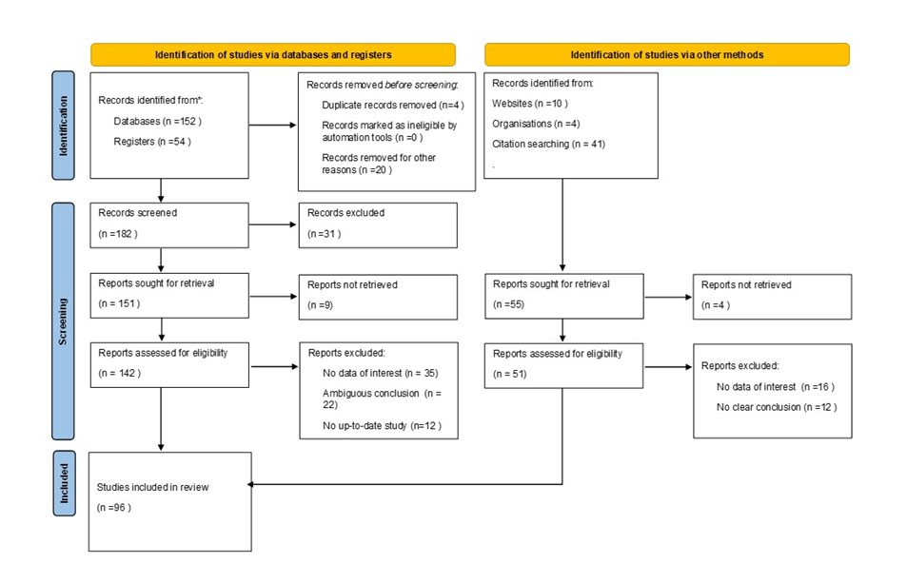
Figure 1. Schematic view of the methodology process.
Findings: Noise has a negative impact on emotional state and behavior, while music is associated with positive outcomes ranging from emotional state improvement to therapeutic approaches. Noise levels in the dental office are high enough to cause negative effects, such as annoyance, anxiety, irritation, conversation interference and concentration difficultly. Music listening offers an effective, nonpharmacologic alternative to reducing preprocedural dental anxiety in patients, especially those with intellectual and developmental disabilities (IDD) and those with mild forms of anxiety.
Conclusions: There is controversial evidence as to whether music really helps to manage negative emotions and whether it can be applied as therapy or whether it acts as a placebo and is just a pleasant company in the dental office. Most studies, however, suggest that sound control in the dental office will enhance communication, feeling of safety and relaxation to all age groups.
References
- Hodge, B.; Thompson, J.F. Noise pollution in the operating theatre. Lancet 1990, 335, 891–894.
- Antoniadou, M.; Tziovara, P.; Antoniadou, C. The Effect of Sound in the Dental Office: Practices and Recommendations for Quality Assurance—A Narrative Review. Dent. J. 2022, 10, 228. https://doi.org/10.3390/dj10120228
Biography
Dr Panagiota Tziovara DDS, attended the National and Kapodistrian University in Athens, Greece, where she graduated from the Dental School. She currently works as a dental clinician in Athens and assists at the Department of Operative Dentistry of the Dental School.

