Evaluation of bacterial contamination of radiology sections and comparing the antibacterial effect of two disinfectant solutions in the radiology department of the faculty of dentistry, Aja University of Medical Sciences
Dr. Hadi Hamidi Shishvan, Assistant professor of Oral and Maxillofacial AJA University of medical sciences, Tehran, Iran

Abstract (300 word limit)
The dental work environment can be a way of transferring diseases. Therefore, infection control in dentistry is a necessity. So far many disinfectants have been made by different companies. Therefore, it is very difficult to select a suitable disinfectant. . The purpose of this study was to compare the different levels of the radiology department in terms of type and number of bacteria and compare the antibacterial effect of two disinfectant solutions used in the department of radiology. In this descriptive-analytical study, the correlation coefficient test was used for statistical analysis.
In this study, samples of the control panel, radiographic head, lightbox, door handle, and working desk of the radiology department were taken. Samples were taken for 4 times each day. Before working hour starts, right after starting the working day, and when the working day finishes, and after disinfecting the environment. 60 samples were taken. In order to compare the type of disinfectant, the ‘Septi Surface’ was used to disinfect in the first two days and the ‘Surfo-Septi” was used to disinfect over the second two days. From 60 samples collected in 15 cases of bacterial colony growth. The overall level of bacteria in some surfaces is high such as the door handle and the working desk. At some surfaces there was a high incidence of infection with Staphylococcus epidermidis, Streptococcus viridans, Staphylococcus aureus, and Bacillus subtilis. Due to the greater contact of patients with the door handle, there was a higher level of infection than on the rest of the surfaces. On the other hand, the radiographic head has less bacterial growth than the other parts due to proper coverage.

Image
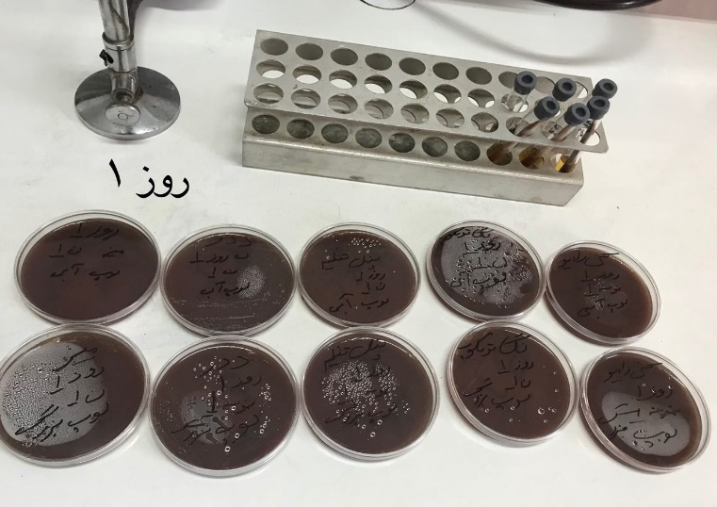
Recent Publications (minimum 5). Negahdar ah. evaluate the knowledge and the attitude of Shiraz dentists about infection control during intraoral radiographies preparation. Journal of Fasa University of Medical Sciences / Majallah-i Danishgah-i Ulum-i Pizishki-i Fasa. 2017; 6 I(4):446-56. 11p.
2. valian a, shahbazi r. Evaluation of the Bacterial Contamination of Dental Units in Restorative and Peridontics Departments of Dental School of Shahid Beheshti University of Medical Sciences. 2013;37: 345-56_2.
3. GH. F. Protection of dentist against of infection Diseases. Esfahan university of Medical science. 1992:111-17.
4. Decraene V, Ready D, Pratten J, Wilson M. Air-borne microbial contamination of surfaces in a UK dental clinic. J Gen Appl Microbiol 2008; 54: 195-203.
5. Khorakian F, Movahed T, Ghazvini K. Evaluation of Frequency of Microbial Contamination in Clinical Setting Surface in Dental School of Mashhad University of Medical Sciences. 2017:209-18



Biography (150 word limit)
Dr. Hadi Hamidi Shishvan is an assistant professor of Oral and maxillofacial department at faculty of dentistry at Aja University of medical sciences. He completed his dental education at Shahid Beheshti University of medical sciences and Oral and maxillofacial radiology residency at Tabriz University of medical sciences. He is interested in academic activities as a clinician-researcher and have different publications in field of maxillofacial radiology.
Email: hadihamidi1336@gmail.com

Notes/Comments:

Presenting author details
Full name: Dr. Hadi Hamidi Shishvan DDs, MCs
Contact number: +989143461336
Twitter account:-
Linked In account: Hadi Hamid
Session name/ number:
Category: (Oral presentation/ Poster presentation)

