Percutaneous auricular vagus nerve stimulation prevents the oxaliplatin-induced neuropathic pain in rats by modulating the spinal neuronal and glial hyperactivation

Helena MRC Freire¹, Letícia N Guimarães¹, Ana Carolina P Campos¹, Yunsan Meas², Yves Rouxeville³, Liaw W Chao⁴, Fernando M Sant’Anna⁵, and Rosana L Pagano¹
1 Laboratory of Neuroscience, Brazil
2 Centre d’évaluation et de traitement de la douleur (CETD) and Centre Hospitalier Universitaire de Nantes, France
3 International College of Auriculomedicine and Auriculotherapy, France
4 University of São Paulo Medical School, Brazil
5 Federal University of Rio de Janeiro, Brazil

Abstract
Oxaliplatin-induced neuropathic pain (OINP) negatively impacts the patients' quality of life. OINP preventive or symptomatic treatments are generally ineffective, so the investigation of new therapeutic approaches are required. In this sense, we aimed to investigate the preemptive effect of percutaneous auricular vagus nerve stimulation (paVNS) on OINP in rats.
Male Wistar rats were injected with oxaliplatin (OXA) or saline (i.p) for two weeks, three times per week. paVNS was applied for 30 min, in a non-sequential random low frequency previously to each OXA session. maVNS had the needles inserted, but without stimulation. Animals were evaluated for hyperalgesia and allodynia, mechanical and thermal, before, immediately and after the end of treatments. Depressive-like behavior was evaluated six days after the end of treatment. The neuronal (Egr-1), microglial (Iba-1) and astrocytic (GFAP) immunoreactivity was investigated in the spinal dorsal horn (SDH). Study approved by the Ethics Committee on the Use of Animals at Hospital Sírio-Libanês (CEUA 2021-03).
The OXA sessions induced thermal (p ˂ 0.0092) and mechanical (p ˂ 0.0005) hyperalgesia; thermal (p ˂ 0.0113) and mechanical (p ˂ 0.0049) allodynia and depressive-like behavior (p ˂ 0.0001) in the rats immediately, 3, 5 and 7 days after the OXA treatment when compared with saline rats. paVNS treatment prevented all OPIN phenomena and the depressive-like behavior. maVNS therapy attenuated the painful behaviors, which was not maintained over time. Also, paVNS treatment reduced the OXA-induced hyperactivation of neurons (p ˂ 0.0001) microglia (p = 0.0043) and astrocyte (p ˂ 0.0001) in the SDH, comparing with OXA and saline groups.
The preemptive use of paVNS inhibited the OXA-induced painful and depressive behaviors, which was accompanied by reversion of spinal glial and neuronal hyperactivation. Our findings contribute to a better understanding of the functional mechanisms of vagal stimulation, elucidating its potential therapeutic value in OINP management.

Image

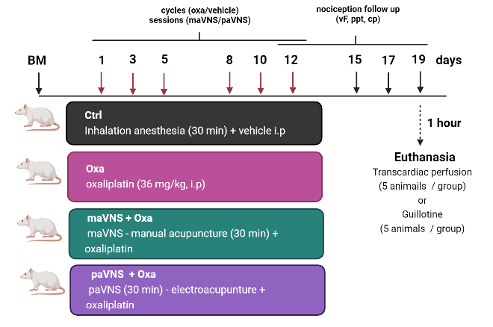

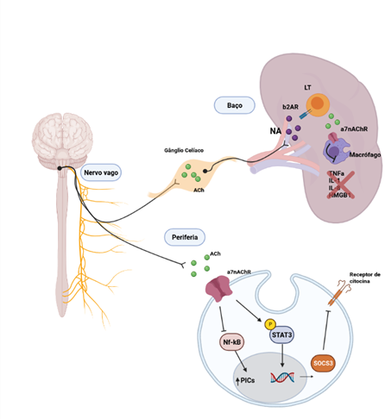Representative scheme of the experimental design. Rats were evaluated on nociceptive tests before (baseline measurement, MB), after cycles of oxaliplatin (Oxa) or vehicle (days 1, 3, 5, 8, 10 and 12) and after the end of vagal treatment (days 15, 17 and 19). maVNS: vagal auricular manual acupuncture. paVNS: vagal auricular electroacupuncture. MB: baseline measurement; cp: cold plate. ppt: paw pressure test; vF: von Frey filaments.

Recent Publications (minimum 5)
- Campos ACP, Berzuíno MB, Barbosa GR, Freire HMRC, Lopes PS, Assis DV, Fonoff ET, Pagano RL. Motor cortex stimulation reversed hypernociception, increased serotonin in raphe neurons, and caused inhibition of spinal astrocytes in a Parkinson’s disease rat model. Cells 2021, 10:1158.
- Almeida LD, Silva ASF, Mota DC, Vasconcelos AA, Camargo AP, Pires GS, Furlan M, Freire HMRDC, Klippel AH, Silva SF, Zanelli CF. Yeast double transporter gene deletion library for identification of xenobiotic carriers in low or high throughput. Mbio, 2021, 12:e03221-21.

Biography:
Helena MRC Freire brings her expertise in physiology and cell biology to improve health and well-being. His therapeutic proposal of electrical vagal stimulation in the model of neuropathic pain induced by responsive chemotherapy creates new ways to improve health. She built this model and is evaluating the analgesic potential of paVNS (percutaneous auricular vagus nerve stimulation) in the neuroscience laboratory of Hospital Sirio Libanes.

