Black mulberry (Morus nigra) fruit extract alleviated AD-Like symptoms induced by toxic A β protein in transgenic Caenorhabditis elegans via insulin DAF-16 signaling pathway
Yan Liu
Massachusetts General Hospital, Athinoula A. Martinos Biomedical Imaging Center, Building 149, 13th street, Charlestown, MA 02129, School of Pharmacy, Lanzhou University, China
Abstract
Alzheimer’ s disease (AD) is one of the most severe neurodegenerative disorders. Recently, there is no effective treatment drug for AD. Morus nigra (M. nigra) is a black mulberry and widely distributed fruit in the Moraceae family with various undiscovered biological activities. The study aimed to investigate the potential anti-AD effect of M. nigra. Mulberry fruit extract (MF) was obtained from M. nigra and treated up to 1.00 mg/mL on transgenic AD Caenorhabditis elegans (C. elegans) models. MF inhibited Amyloid-β (Aβ)-induced paralysis symptoms by about 55.65 %, reduced Aβ accumulation more than 50 % via immunoblotting, and suppressed over-sensitivity to exogenous serotonin in C. elegans. Furthermore, MF decreased the A β oligomeric depositions in worm CL2006. MF activated the DAF-16 nuclear translocation and its downstream SOD-3 and GST- 4. AD is a major age-related disorder. Therefore, MF treated or an aging test and proved to be expanded the lifespan of the worms up to 34.7 %. Besides, we have evaluated the MF in vivo antioxidative properties, where MF reduced reactive oxygen species (ROS) generations in C. elegans and remitted the activation of HSP-16.2 induced by the oxidative action of Juglone. Gene knockout and extended the lifespan of AD worms. However, RNA interference (RNAi) successfully silenced the daf-16 on the A β phenotypic paralysis proved by MF effect. Our results indicate that MF alleviates AD-Like symptoms by activating the DAF-16 insulin signal pathway in C. elegans. Therefore, this MF study may provide new insights for mulberry application in safe AD treatment and clinical study.
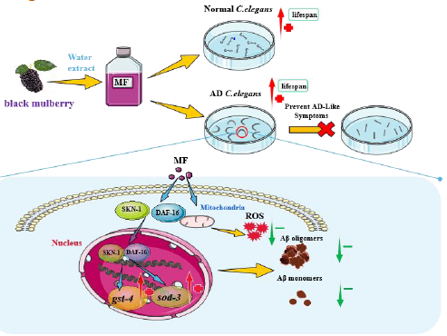
Recent Publications
- Liu, Y., et al., Shengmai Formula suppressed over-activated Ras/MAPK pathway in C. elegans by opening mitochondrial permeability transition pore via regulating cyclophilin D. Scientific Reports, 2016. 6(1): p. 38934.
- Liu, Y., et al., Kushui Rose (R. Setate x R. Rugosa) decoction exerts antitumor effects in C. elegans by downregulating Ras/MAPK pathway and resisting oxidative stress. International Journal of Molecular Medicine, 2018.
- Bai, P., et al., Design, Synthesis, and Evaluation of Thienodiazepine Derivatives as Positron Emission Tomography Imaging Probes for Bromodomain and Extra- Terminal Domain Family Proteins. Journal of Medicinal Chemistry, 2021. 64(19): p. 14745-14756.
- Bai, P., et al., Synthesis and Characterization of a Positron Emission Tomography Imaging Probe Selectively Targeting the Second Bromodomain of Bromodomain Protein BRD4. Bioconjugate Chemistry, 2021. 32(8): p. 1711-1718.
- Bai, P., et al., Discovery of a Positron Emission Tomography Radiotracer Selectively Targeting the BD1 Bromodomains of BET Proteins. ACS Med Chem Lett, 2021. 12(2): p. 282-287.
Biography
Yan Liu has completed her PhD from Lanzhou University and postdoctoral studies from Massachusetts General Hospital, Athinoula A. Martinos Biomedical Imaging Center. She is also a Lecturer at the School of Pharmacy, Lanzhou University. She has published more than 20 papers in reputed journals that have been cited over 70 times.

