

PhD Candidate in ERASMUS+ Mobility Students Programme

Erasmus+ Programme–KA107 project n. 2020-1-IT02-KA107-078816, co-ordinated by the Università degli Studi della Tuscia (Italia) and funded by the European Commission,

Ph.D. Proposal Project

(Nov 26^{th,} 2022)
Principle Investigator: Ghazwan Ahmed M. Raouf- Ph.D. Student in Toxicology, Prof. ( ).

Project Title:

Toxic impacts of SARS-CoV-2 variants and anti-viral potential effects in hospitalized patients in Duhok Province-Kurdistan Region
Severe acute respiratory syndrome coronavirus 2 (SARS-CoV-2) is a novel coronavirus that emerged in 2019 and is causing the coronavirus disease 2019 (COVID-19) pandemic. There is no current standard of care. Clinicians need to be mindful of the toxicity of a wide variety of possibly unfamiliar substances being tested or repurposed to treat COVID-19 including poly-pharmacy. Novel coronavirus is an infection characterized by flu-like symptoms, progressing in some cases to acute respiratory distress syndrome (ARDS) that eventually lead to death. Toxic impacts of coronavirus increase the probability of developing life-threatening systemic inflammatory syndromes called cytokine storm that suddenly deteriorates patient's status to the severe or critical condition and might evoke oxidative stress, therefore, raises the mortality rates. Oxidative stress can be measured indirectly by measuring the levels of DNA/RNA damage, lipid peroxidation, and protein oxidation/nitration, rather than a direct measurement of reactive oxygen species. It has been confirmed that oxidative stress is involved in a variety of diseases, such as pneumonia, pancreatitis, diabetic nephropathy, cardiovascular disease, nervous system disease, and cancer. Therefore, the total oxidant status (TOS) is usually used to estimate the overall oxidation state of the body. Similarly, the total antioxidant capacity (TAC) is used to measure the overall antioxidant capacity of the body. The oxidative stress index (OSI), which is the ratio of TOS to TAS, might be a more precise index of oxidative stress in the body because it is a comprehensive measurement of total antioxidant status (TAS) and TOS. TOS, TAS, and OSI are oxidative stress parameters used to evaluate the overall oxidative stress status in the body tracking genetic variations from positive SARS- CoV-2 samples yields crucial information about the number of variants circulating in an outbreak related to the severity of the disease and the possible lines of transmission but sequencing every positive SARS-CoV-2 sample would be prohibitively costly for population-scale test and trace operations. Genotyping is a rapid, high-throughput and low-cost alternative for screening positive SARS-CoV-2 samples in many settings. Single-nucleotide polymorphism (SNP) identification pipeline isolated from coronavirus has been designed to identify genetic variation using sequenced SARS-CoV-2 samples. Pipeline identifies a minimal marker panel that can define distinct genotypes. This the genotyping panel will be applied on 120 stored qRT-PCR positive SARS-CoV-2 clinical samples that had been collected across the north west of the Kurdistan during June 2020-February 2022. Fig. 1 shows how this technique could be incorporated into diagnostic pathways.

RNA from positive samples, from individuals with COVID-19, could be further screened with a SARS-CoV- 2 genotyping panel to identify variants, thereby providing valuable genomic data to investigate outbreaks, potentially identifying transmission pathways linking local and regional cases and helping to inform possible interventions. Notably, efficient methods for tracking transmission of certain lineages could be vital in situations where mutations are associated with increased transmission, severity of disease or vaccine failure. Collected samples will propagated in Vero E6 cells cultured in minimum essential medium and treated with anti-viral therapy in order to estimate their potential effects Fig. 2. And Swiss Target Prediction website will be conducted to evaluation the poly-pharmacy effects and predict the potential impacts of multi-therapy drugs. Determination of choline esterase activity and its suitability to inhibitors will be conducted in the study to check the inhibitors effect against isolate SARS-CoV-2 patients culture cells at molecular basis.

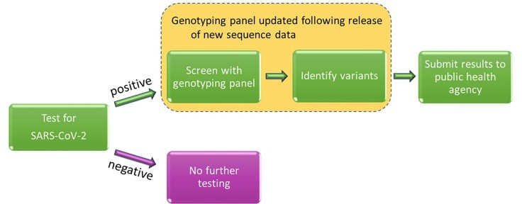
Fig 1. How the SARS-CoV-2 genotyping panel can be used to identify circulating SARS-CoV-2 variants.
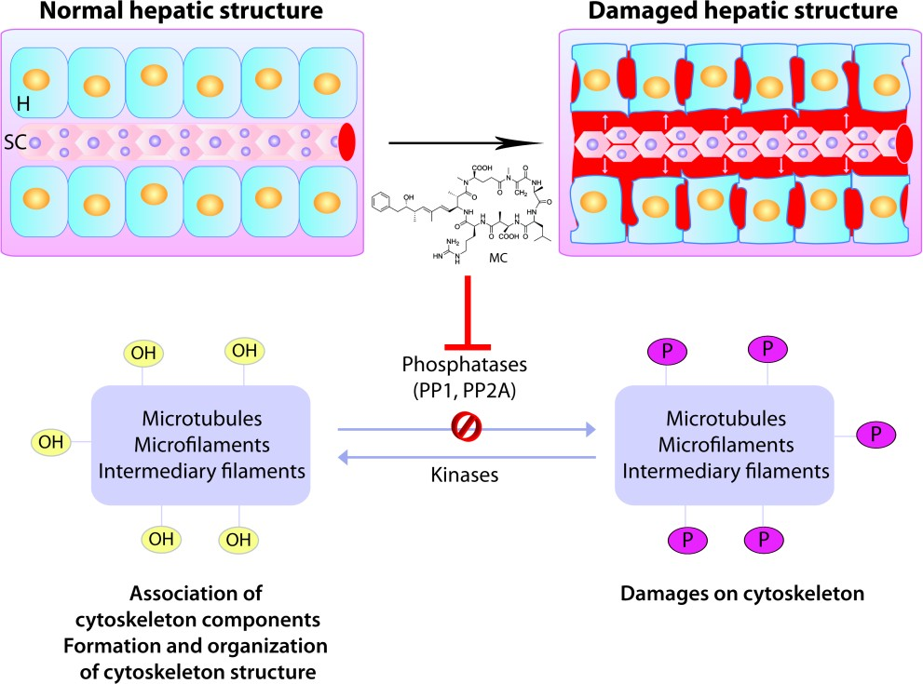

Figure 2. Representation of the effects of microcystins in cytoskeleton, namely the changes of the hepatocytes and sinusoidal capillary structure, and intrahepatic bleeding, mediated by the inhibition of protein phosphatases PP1 and PP2A. Legend: H – hepatocyte; SC – Sinusoidal capillary; MC – microcystins; OH – hydroxyl group; P – phosphate group; PP1 – protein phosphatase 1; PP2 – protein phosphatase 2.

Research objectives

Our hypothesis is that detecting the different types of SARS-CoV-2 variants through single nucleotide polymorphism (SNP) genotyping that induces oxidative stress and affects the immunity/health status through its toxic impact in hospitalized Covid-19 patients, and evaluating anti-viral therapy using vero E6 cell line exposed to the different variants of coronaviruses.
The study will be conducted by performing the following laboratory tests:
- Detecting SARS-CoV-2 variants with SNP genotyping. (Proposed to be done when funded)
- Genome sequencing of the 160 selected SARS-CoV-2 samples. (Proposed to be done when funded)
- Evaluation of antiviral efficacy assay: Remdesivir: Using Vero E6 cells

(Proposed to be done when funded)
- Evaluation of poly-pharmacy potential impacts using Swiss Target Prediction website.

(An article: under processing to be done on January)
- Detection of coronavirus by RT-PCR. (Completed)

The following evaluation of toxic effects of coronavirus by analytical instrumentation have been done:
  - Clinical pathological changes to detect toxic effects (e.g., Cytokines “IL-6”, Liver function tests, Renal function test, C-Reactive protein “CRP”, Lactate dehydrogenase, Serum ferritin, D-Dimer, Complete blood Count, and Serum electrolyte). (Completed)
  - The oxidative stress has been assessed using the following measurements:
    - Serum total antioxidant status (TAS). (Completed)
    - Serum malondialdehyde (MDA). (Completed)
  - Cholinesterase activity in the blood and its susceptibility to inhibitors. (Completed).

