Cortical pain induced by optogenetic cortical spreading depression: From whole brain activity mapping
Yu Shengyuan*
Chinese PLA General Hospital, China
Abstract
Background: Cortical spreading depression (CSD) is an electrophysiological event underlying migraine aura. Traditional CSD models are invasive and often cause injuries. The aim of the study was to establish a minimally invasive optogenetic CSD model and identify the active networks after CSD using whole-brain activity mapping.
Methods: CSD was induced in mice by light illumination, and their periorbital thresholds and behaviours in the open field, elevated plus-maze and light-aversion were recorded. Using c-fos, we mapped the brain activity after CSD. The whole brain was imaged, reconstructed and analyzed using the Volumetric Imaging with Synchronized on-the-flyscan and Readout technique. To ensure the accuracy of the results, the immunofluorescence staining method was used to verify the imaging results.
Results: The optogenetic CSD model showed significantly decreased periorbital thresholds, increased facial grooming and freezing behaviours and prominent light-aversion behaviours. Brain activity mapping revealed that the somatosensory, primary sensory, olfactory, basal ganglia and default mode networks were activated. However, the thalamus and trigeminal nucleus caudalis were not activated.
Conclusions: Optogenetic CSD model could mimic the behaviours of headache and photophobia. Moreover, the optogenetic CSD could activate multiple sensory cortical regions without the thalamus or trigeminal nucleus caudalis to induce cortical pain.

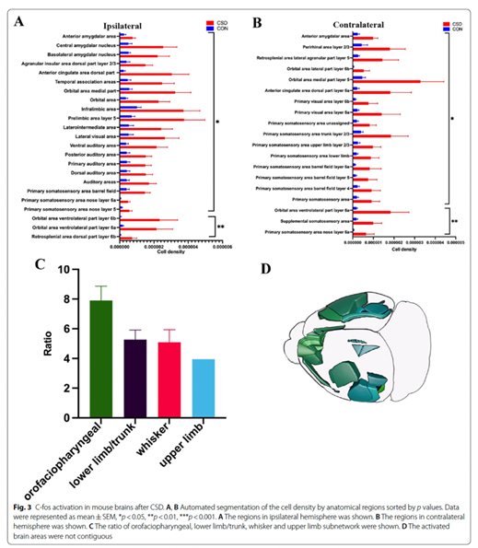
References:
1. Charles A, Baca S. Cortical spreading depression and migraine. Nat Rev Neurol. 2013;9(11):637–44. https:// doi. org/ 10. 1038/ nrneu rol. 2013. 192.
2. Zhang X, Levy D, Kainz V, Noseda R, Jakubowski M, Burstein R. Activation of central trigeminovascular neurons by cortical spreading depression.Ann Neurol. 2011;69(5):855–65. https:// doi. org/ 10. 1002/ ana. 22329.
3. Zhang X, Levy D, Noseda R, Kainz V, Jakubowski M, Burstein R. Activation of meningeal nociceptors by cortical spreading depression: implications for migraine with aura. J Neurosci. 2010;30(26):8807–14. https:// doi. org/10. 1523/ jneur osci. 0511- 10. 2010.
4. Noseda R, Constandil L, Bourgeais L, Chalus M, Villanueva L. Changes of meningeal excitability mediated by corticotrigeminal networks: a link for the endogenous modulation of migraine pain. J Neurosci.2010;30(43):14420–9. https:// doi. org/ 10. 1523/ jneur osci. 3025- 10. 2010.
5. Lambert G, Truong L, Zagami A. Effect of cortical spreading depression on basal and evoked traffic in the trigeminovascular sensory system. Cephalalgia. 2011;31(14):1439–51. https:// doi. org/ 10. 1177/ 03331 02411422383.
Biography:

Prof. Shengyuan Yu (March 1963, M.D., PH.D.) is a neurologist and the director of Department of neurology, Chinese PLA General Hospital. He is expert in diagnosis, treatment and research of headache, and has done massive researches on the mechanism or therapy of headache. As first author or corresponding author, he has published 177 academic papers in SCI cited journals and led 18 scientific research projects sponsored by WHO or government of China, especially the project “Neural network mechanisms and interventions of headache, sleep disorder and negative emotion reflected by stress” with a scientific research funding of 9 million was applied in 2022.

