An unusual case of Chronic Myelogenous Leukemia and Multiple Myeloma co-existence
Victor Alfred H. Cataming, M.D
Teresita E. Dumagay, M.D
Division of Hematology, Department of Medicine University of the Philippines-Philippine General Hospital

Abstract
The co-existence of myeloid and lymphoid malignancies is rare and poorly understood. It is an extremely uncommon disease reported in a very few cases.
We report a rare case of multiple myeloma and chronic myelogenous leukemia co-existence in a 55-year-old male initially presenting with granulocytosis and splenomegaly. Subsequent work-up with BCR/ABL FISH assay and bone marrow aspiration and biopsy revealed chronic myelogenous leukemia. During the first 4 months of his treatment with a tyrosine kinase inhibitor, there was a note of progressive and persistent pancytopenia with increasing creatinine trends. A repeat bone marrow aspiration and biopsy supplemented with serum protein electrophoresis with immunotyping, and serum free light chain assay were done demonstrating multiple myeloma. A BCR-ABL for QRT PCR was also conducted with a result of 3.81%. Hence, the diagnosis of co-existent multiple myeloma and chronic myelogenous leukemia. Triplet anti-myeloma therapy and tyrosine kinase inhibitor are given to this patient.
Multiple myeloma is the neoplastic expansion of plasma cells that produces a monoclonal immunoglobulin. It is a relatively uncommon malignancy. On the other hand, chronic myelogenous leukemia is a form of myeloproliferative neoplasm that results from abnormal production and proliferation of mature and maturing granulocytes associated with the BCR/ABL fusion gene. The abnormal cells involved in these diseases are distinctly different making its co-occurrence extremely rare. In addition, literature regarding the approach to its diagnosis, treatment and outcome is scarce. Increasing recognition and awareness of the co-existence of the two entities is a step closer to optimizing approach to its diagnosis and treatment.

Image

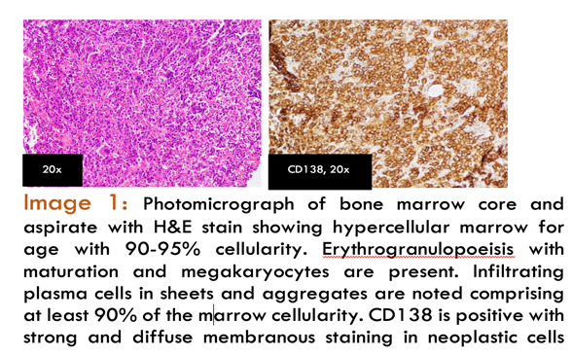

Recent Publications
- Subedi , P., Kate , Y., Syed , M. P., & Siddiqui, A. D. (2021). Lymphoproliferative and subsequent myeloproliferative disorder - A one way street? Balkan medical journal. Retrieved December 10, 2022, from https://pubmed.ncbi.nlm.nih.gov/34142965/
- Bouchla, A., Thomopoulos , T., Papageorgiou , S., Tsirigotis , P., Bazani , E., Gkirkas , K., Vasilatou , D., Glezou , E., Stavroulaki , G., Gkontopoulos , K., Dimitriadis , G., & Pappa , V. (2019). Coexistence of myeloid and lymphoid neoplasms: A single-center experience. Advances in hematology. Retrieved December 10, 2022, from https://pubmed.ncbi.nlm.nih.gov/31781224/
- Mousinho, F., Santos, P. S. E., Azevedo, A. P., Pereira, J. M., Lemos, R., Matos, S., Viana, J. F., & Lima, F. (2018, September). Concomitant myeloproliferative and lymphoproliferative neoplasms, distinct progenitors: A case report and review of the literature. Molecular and clinical oncology. Retrieved December 10, 2022, from https://www.ncbi.nlm.nih.gov/pmc/articles/PMC6109675/
- Hauck 20, G., Jonigk , D., Kreipe , H., & Hussein, K. (2012). Simultaneous and sequential concurrent myeloproliferative and lymphoproliferative neoplasms. Acta haematologica. Retrieved December 10, 2022, from https://pubmed.ncbi.nlm.nih.gov/23257916/
- Pessach, I., Bartzis, V., Tzenou, T., Roumelioti, M., Palaiologou, D., Nikolaou, E., Konstantis, S., Bitsani, K., Panayiotidis, P., & Kyrtsonis, M. C. (2012). Multiple myeloma and chronic myelogenous leukemia; an uncommon coexistence in 2 patients, with literature review. Annals of Hematology & Oncology. Retrieved July 6, 2022, from https://austinpublishinggroup.com/hematology/fulltext/hematology-v2-id1030.php

 Biography
Paste your Logo here
Victor Alfred H. Catambing is a board-certified internist and is currently an adult hematology fellow-in-training from the Philippine General Hospital, Philippines. He is an enthusiastic and innovative fellow-in-training whose life-long goal is provide the best possible care to patients with hematologic conditions in distant areas of the Philippines.
Email: catambingv@yahoo.com
Notes/Comments:
Presenting author details
Full name: Victor Alfred Humilde Catambing
Contact number: +63 9778061826
Twitter account: viccatambing
Linked In account: catambingv@yahoo.com
Category: Poster presentation

