Black mulberry (Morus nigra) fruit extract alleviated AD-Like symptoms induced by toxic Aβ protein in transgenic Caenorhabditis elegans via insulin DAF-16 signaling pathway

Massachusetts General Hospital, Athinoula A. Martinos Biomedical Imaging Center, Building 149, 13th street, Charlestown, MA 02129, School of Pharmacy, Lanzhou University, China

Abstract (300 word limit)
Alzheimer’s disease (AD) is one of the most severe neurodegenerative disorders. Recently, there is no effective treatment drug for AD. Morus nigra (M. nigra) is a black mulberry and widely distributed fruit in the Moraceae family with various undiscovered biological activities. The study aimed to investigate the potential anti-AD effect of M. nigra. Mulberry fruit extract (MF) was obtained from M. nigra and treated up to 1.00 mg/mL on transgenic AD Caenorhabditis elegans (C. elegans) models. MF inhibited Amyloid-β (Aβ)-induced paralysis symptoms by about 55.65 %, reduced Aβ accumulation more than 50 % via immunoblotting, and suppressed over-sensitivity to exogenous serotonin in C. elegans. Furthermore, MF decreased the Aβ oligomeric depositions in worm CL2006. MF activated the DAF-16 nuclear translocation and its downstream SOD-3 and GST-4. AD is a major age-related disorder. Therefore, MF treated for an aging test and proved to be expanded the lifespan of the worms up to 34.7 %. Besides, we have evaluated the MF in vivo antioxidative properties, where MF reduced reactive oxygen species (ROS) generations in C. elegans and remitted the activation of HSP-16.2 induced by the oxidative action of Juglone. Gene knockout and extended the lifespan of AD worms. However, RNA interference (RNAi) successfully silenced the daf-16 on the Aβ phenotypic paralysis proved by MF effect. Our results indicate that MF alleviates AD-Like symptoms by activating the DAF-16 insulin signal pathway in C. elegans. Therefore, this MF study may provide new insights for mulberry application in safe AD treatment and clinical study.

Image
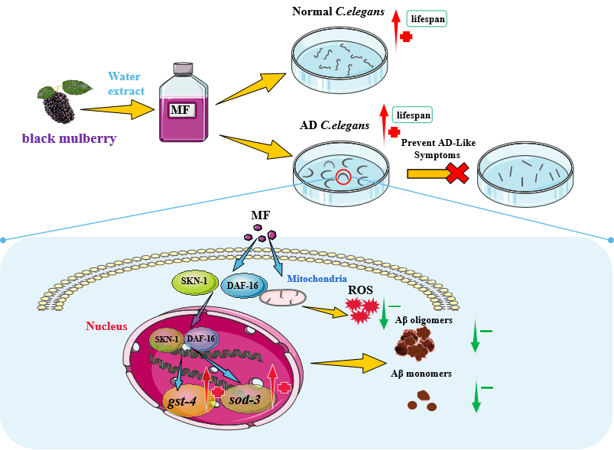
Recent Publications (minimum 5)
1.Liu, Y., et al., Shengmai Formula suppressed over-activated Ras/MAPK pathway in C. elegans by opening mitochondrial permeability transition pore via regulating cyclophilin D. Scientific Reports, 2016. 6(1): p. 38934.
2.Liu, Y., et al., Kushui Rose (R. Setate x R. Rugosa) decoction exerts antitumor effects in C. elegans by downregulating Ras/MAPK pathway and resisting oxidative stress. International Journal of Molecular Medicine, 2018.
3.Bai, P., et al., Design, Synthesis, and Evaluation of Thienodiazepine Derivatives as Positron Emission Tomography Imaging Probes for Bromodomain and Extra-Terminal Domain Family Proteins. Journal of Medicinal Chemistry, 2021. 64(19): p. 14745-14756.
4.Bai, P., et al., Synthesis and Characterization of a Positron Emission Tomography Imaging Probe Selectively Targeting the Second Bromodomain of Bromodomain Protein BRD4. Bioconjugate Chemistry, 2021. 32(8): p. 1711-1718.
5.Bai, P., et al., Discovery of a Positron Emission Tomography Radiotracer Selectively Targeting the BD1 Bromodomains of BET Proteins. ACS Med Chem Lett, 2021. 12(2): p. 282-287.
6.Dang, X., et al., Gastrodia elata powder capsule enhances anti-epileptic effect of carbamazepine by decreasing P-gp expression. Tropical Journal of Pharmaceutical Research, 2021. 18(9): p. 1859-1865.
7.Lan, Y., et al., Visualization of Receptor-Interacting Protein Kinase 1 (RIPK1) by Brain Imaging with Positron Emission Tomography. Journal of Medicinal Chemistry, 2021. 64(20): p. 15420-15428.
8.Muhammad, F., et al., Antioxidative role of Traditional Chinese Medicine in Parkinson's disease. Journal of Ethnopharmacology, 2021: p. 114821.9.Xu, Y., et al., Novel Positron Emission Tomography Radiotracers for Imaging Mitochondrial Complex
I. ACS Chemical Neuroscience, 2021. 12(24): p. 4491-4499.
10.Xu, Y., et al., Discovery of carbon-11 labeled sulfonamide derivative: A PET tracer for imaging brain NLRP3 inflammasome. Bioorg Med Chem Lett, 2021. 34: p. 127777.
11.Zhao, L., et al., Protective effect of Terminalia chebula Retz. extract against Abeta aggregation and Abeta-induced toxicity in Caenorhabditis elegans. J Ethnopharmacol, 2021. 268: p. 113640.
12.Bai, P., et al., Synthesis and characterization of a new Positron emission tomography probe for orexin 2 receptors neuroimaging. Bioorg Chem, 2022. 123: p. 105779.
13.Bai, P., et al., Development of a potential PET probe for HDAC6 imaging in Alzheimer’s disease. Acta Pharmaceutica Sinica B, 2022.
14.Bai, P., et al., A positron emission tomography imaging probe selectively targeting the BD1 bromodomain and extra-terminal domain. Chemical Communications, 2022. 58(69): p. 9654-9657.
15.Muhammad, F., et al., Anti-α-synuclein Toxicity and Anti-neurodegenerative Role of Chrysin in Transgenic Caenorhabditis elegans Models of Parkinson’s Disease. ACS Chemical Neuroscience, 2022. 13(4): p. 442-453.
16.Muhammad, F., et al., Neuroprotective effects of Cannabidiol on Dopaminergic Neurodegeneration and alpha-synuclein Accumulation in C. elegans Models of Parkinson's disease. Neurotoxicology, 2022.
17.Wang, E., et al., Black mulberry (Morus nigra) fruit extract alleviated AD-Like symptoms induced by toxic Abeta protein in transgenic Caenorhabditis elegans via insulin DAF-16 signaling pathway. Food Res Int, 2022. 160: p. 111696.
18.Xu, Y., et al., Preliminary studies of an imidazole-based alcohol derivative for imaging of Heme oxygenase 1. Bioorg Med Chem Lett, 2022. 64: p. 128674.



Biography (150 word limit)
Paste your Logo here
Yan Liu has completed her PhD from Lanzhou University and postdoctoral studies from Massachusetts General Hospital, Athinoula A. Martinos Biomedical Imaging Center. She is also a Lecturer at the School of Pharmacy, Lanzhou University. She has published more than 20 papers in reputed journals that have been cited over 70 times.

Email: yliu103@mgh.harvard.edu, chloe612520@gmail.com

Notes/Comments: This paper has been already published at Food Research International, https://doi.org/10.1016/j.foodres.2022.111696

Presenting author details
Full name: Yan Liu
Contact number:+1 7812197706 or +86 18298416938
Twitter account: None
Linked In account: None
Session name/ number: 31
Category: Oral presentation

