Functionalized biodegradable polymers with antimicrobial for sustainable food packaging
Nathdanai Harnkarnsujarit, PhD, Faculty of Agro-Industry, Kasetsart University, Thailand

Abstract
Biodegradable polymers have been largely produced and utilized for flexible and rigid packaging which support consumers’ requirement on sustainability and environmentally friendly. However, these sustainable materials have poor barrier properties which is a major limitation for utilization as food packaging. Microbial growth is a primary concern for quality deteriorations of packaged food with high water activity. Decontamination of microorganisms on food surface possibly delays quality loss and ensure safety for consumers. The purpose of this study is to demonstrate incorporations of antimicrobial into biodegradable polymers via extrusion process to produce functional packaging. Characterizations of packaging materials including morphology, properties and antimicrobial efficiency are demonstrated. The biodegradable polymers including thermoplastic starch (TPS), Polybutylene adipate terephthalate (PBAT) and poly lactic acid (PLA) were compounded with antimicrobial agents (sodium nitrite, Galangal essential oils) via a twin-screw extruder to produce the compound pellets prior to convert into films with either single-screw blown-film extrusion or cast sheet extrusion. Results showed that nitrite increased disruption of starch granules in TPS/PBAT blends which modified morphology and mechanical properties. Smoother microstructures in nitrite incorporated films reflected improved compatibility between TPS and PBAT polymer blends. Moreover, nitrite plasticized TPS phase due to hydrophilicity. Similarly, Lesser galangal essential oils served as plasticizers in PBAT/PLA blend matrices with slight modifications of morphology. Increasing these active agents commonly gave larger modification of morphology which subsequently impacted packaging properties. The films containing sodium nitrite and Galangal essential oils effectively delayed microbial growth in fresh meat and cooked rice, respectively. The functionalized of antimicrobial agents into biodegradables polymers effectively produced food packaging which can extend the shelf-life of packaged products, reducing food loss for sustainability.

 Biography (150 word limit)

Image
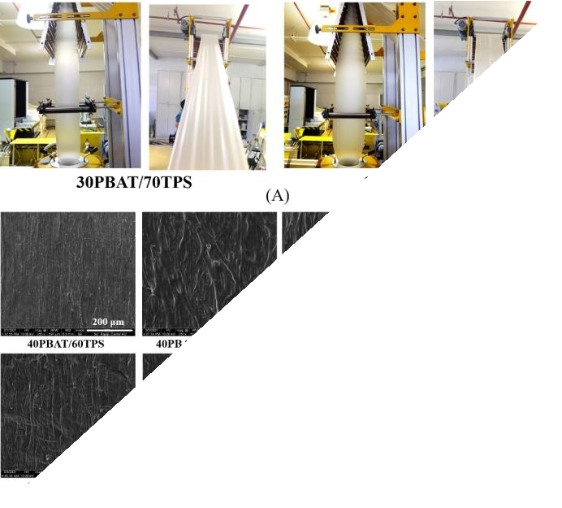
Fig. 1 Structures of the 40PBAT/60TPS and 30PBAT/70TPS blend films containing 0, 1, 3 and 5% nitrite (N) in TPS (A) during blown-film extrusion processing and (B) scanning electron micrographs.

Recent Publications (minimum 5)
- Katekhong, W., Wongphan, P., Klinmalai, P., & Harnkarnsujarit, N. (2022). Thermoplastic starch blown films functionalized by plasticized nitrite blended with PBAT for superior oxygen barrier and active biodegradable meat packaging. Food Chemistry, 374, 131709.
- Srisa, A., Promhuad, K., San, H., Laorenza, Y., Wongphan, P., Wadaugsorn, K., Sodsai, J., Kaewpetch, T., Tansin, K., & Harnkarnsujarit, N. (2022). Antibacterial, Antifungal and Antiviral Polymeric Food Packaging in Post-COVID-19 Era. Polymers, 14(19), 4042.
- Chatkitanan, T., & Harnkarnsujarit, N. (2021). Effects of nitrite incorporated active films on quality of pork. Meat Science, 108367.
- Klinmalai, P., Srisa, A., Laorenza, Y., Katekhong, W., & Harnkarnsujarit, N. (2021). Antifungal and plasticization effects of carvacrol in biodegradable poly (lactic acid) and poly (butylene adipate terephthalate) blend films for bakery packaging. LWT, 152, 112356.
- Laorenza, Y., & Harnkarnsujarit, N. (2021). Carvacrol, citral and α- terpineol essential oil incorporated biodegradable films for functional active packaging of Pacific white shrimp. Food Chemistry, 363, 130252.

Dr. Nathdanai Harnkarnsujarit is an Associate Professor in Packaging Technology. He got Ph.D. in Food Science in 2012 from Kasetsart University, Thailand. During his Ph.D., he did research at University College Cork, Ireland in 2011 about Food Material Science. After getting Ph.D., he went to Tokyo, Japan for post-doctoral research at Tokyo University of Marine Science and Technology from 2012-2014. Then, he started his academic career at Kasetsart University. His current research and expertise are food packaging and biodegradable packaging. He is the authors of more than 40 international publications and 3 Book chapters. He serves as reviewer for several publishers including Elsevier and Wiley and has been an Editor for the Journal of the Science of Food and Agriculture (Q1), Wiley publishing since 2015. He is now Vice Dean for Research and Innovation, Faculty of Agro-Industry, Kasetsart University.
Email:

nathdanai.h@ku.ac.th

Notes/Comments: -

Presenting author details

Full name: Nathdanai Harnkarnsujarit, Associate Professor Contact number: +6685-9197747
Mail id: nathdanai.h@ku.ac.th

Category: Oral presentation (Keynote speaker)

