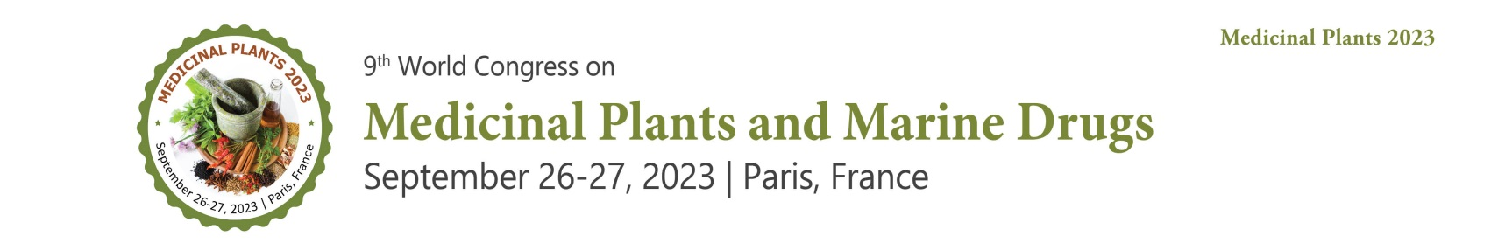

Letter of Acceptance

Date: December 07, 2022
To
Dr. Jun-Li YANG,
Full Professor, Vice Director of CAS Key Laboratory of Chemistry of Northwestern Plant
Resources, Lanzhou Institute of Chemical Physics, Chinese Academy of Sciences (CAS)
Part time Professor of Harbin Engineering University,
China.

We are pleased to inform you that your abstract entitled “Searching anti-Hypoxia Bioactive Materials from Medicinal Plants” has been selected for “9th World Congress on Medicinal Plants and Marine Drugs September 26-27, 2023 Paris, France”. On behalf of the Organizing Committee, we take great pleasure to welcome you to join us at Medicinal Plants 2023
The Conference is designed on the theme “New Trends & Effective Strategies for Medicinal & Natural Products.” The International Conference initiated by Editors of Journal of Research & Reviews: Journal of Medicinal & Aromatic Plants: (ISSN: 2167-0412), Journal of Pharmacognosy & Natural Products: (ISSN: 2472-0992) definitely offer you an unforgettable experience in exploring new opportunities.

For more information: https://medicinalplants.insightconferences.com/
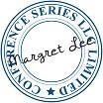
We look forward to your presence at Medicinal Plants 2023

Sincerely,

Margret Lee / Program Manager
Medicinal Plants 2023
47 Church Field Road, W3 6A Y, London. United Kingdom
WhatsApp: +44-1371290000

Disclaimer: This invitation is to attend Medicinal Plants 2023 only.

