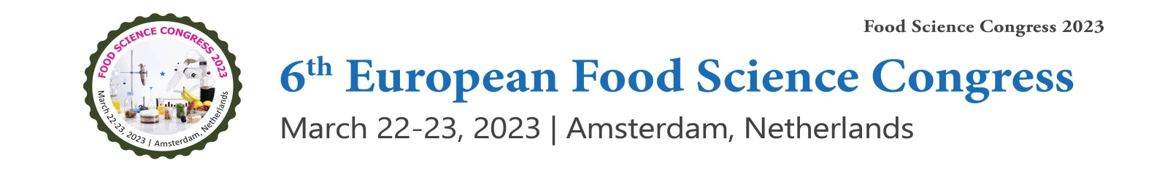

Letter of Acceptance

Date: November 28, 2022
To
Dr. Yan Liu,
Massachusetts General Hospital, Athinoula.
Lanzhou University,
United States
We are pleased to inform you that your abstract entitled “Black mulberry (Morus nigra) fruit extract alleviated AD-Like symptoms induced by toxic Aβ protein in transgenic Caenorhabditis elegans via insulin DAF-16 signaling pathway” has been selected for “6th European Food Science Congress.” which is scheduled for March 22-23, 2023, Amsterdam, Netherlands. On behalf of the Organizing Committee, we take great pleasure to welcome you to join us at food science congress 2023
The Conference is designed on the theme “Recent Research and Invention in Food Science and Nutrition.” The International Conference initiated by Editors of Journal of Research & Reviews: Journal of Food Processing & Technology: (ISSN: 2157-7110), Journal of Nutrition & Food Sciences: (ISSN: 2155-9600) definitely offer you an unforgettable experience in exploring new opportunities.

For more information: https://foodsciencecongress.annualcongress.com/
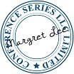
We look forward to your presence at food science congress 2023

Sincerely,

Margret Lee / Program Manager
food science congress 2023
47 Church Field Road, W3 6A Y, London. United Kingdom
WhatsApp: +44-1371290000

Disclaimer: This invitation is to attend food science congress 2023 only.

